WASTE WATER ELECTRICITY GENERATION

CONTENTS

- INTRODUCTION
- Water resources and population
- Waste water treatment
- AIM AND OBJECTIVES OF PROJECT
- Generation of electricity from waste water
- Economical development
- Operational cost
- Transportation cost
- Objectives
- Current requirements
- Over use
- Energy generations
- Developed a renewable, efficient, eco-friendly and sustainable method
- LITERATURE REVIEW
- TECHNICAL DETAILS
- Generating energy
- Generation of electricity from waste water
- concept of hydroelectric power plant
- Physical analysis in lab
- Turbine
- METHODOLOGY
- Sampling
- Collection
- Screening
- Sedimentation
- Surge tank
- Turbine
- Electricity generation
- PROPOSE OUTCOMES
- REFERANCE

CHAPTAR NO: 1

INTRODUCTION:
Water resources are under pressure from continuing population growth and urbanisation, rapid industrialisation, and expanding and intensifying food production, particularly in developing countries and in urban areas. Urban populations may nearly double from current 3.4 billion to 6.4 billion by 2050. Numbers of people living in slums will rise even faster, with most of the rapid expansion in urbanization taking place not in megacities (21 of the world’s 33 megacities are on the coast), but in small and medium sized cities with populations of less than 500 000.
Introduction to Wastewater Treatment provides fundamental knowledge to students about Wastewater and its treatment. Students learn how wastewater is collected, treated, and discarded from residential, industrial and commercial sources. An in depth historical background of wastewater treatment and the effects of wastewater in the environment are explored.
The report reviews how the production and treatment cycle can be better understood and managed so that through better investment and management, major environmental, societal, and economic dividends can be achieved.

CHAPTAR NO: 2

AIM AND OBJECTIVE OF PROJECT:
Aim of the project is to generate electricity from waste water. It will provide electricity to the rural areas. It will enhance commercial and economical development in isolated areas. It can minimize the operational cost, economical cost, transportation cost.
It will also reduced the rising problems of scarcity of electricity.
And following are objectives of the project:
- Current requirements of electricity
- Over use of water resources
- Energy generations from waste water
- We aim to developed a renewable, efficient, eco-friendly and sustainable method for recycling waste water
.

CHAPTAR NO: 3

LITERATURE REVIEW:

- POWER GENERATION FROM KITCHEN AND INDUSTRIAL WASTEWATER USING MICROBIAL FUEL CELLS (MFCS) WITH GRAPHITE CATHODE AND ANODE BY MOSHAMI S SHAH
- Nature fuels and energy are depleting continuously meeting and satisfying the demands of the people globally, with increase in population worldwide, there would be scarcity of fossil fuels and energy.
- Renewable energy will one day be a large portion of global energy production and usage. One such challenge is met by Microbial Fuel Cells (MFCs).This technology represents a new form of renewable energy by generating electricity from what would otherwise be considered waste.
- The MFC’s when connected to the multimeter for evaluating the voltage in the beginning it was found
- to be almost negligible and the resistance was high, after few hours slowly the voltage in MFC’s were
- observed to be increasing without addition of any external substrate .
- After adding external substrate acetate of about 5ml the generation of voltage in all the three MFC’s
- was monitored to check if there was any difference in the voltages. After a week of observation the
- voltages thus obtained was plotted on a graph and it was observed that there was a gradual increase
- in the voltage in all the three MFC’s after adding an external substrate. Although from the graph it was
- concluded that detergent and kitchen waste water produced more amount of voltage than pond water.

- Kitchen waste based Biomass Plant for Power generation: A case study analysis. G.R.K.D. Satya Prasad, Sarat Kumar sahoo Sambit Pritam, Shyama Sundar marandi, Amit Kumar
- The use of renewable energy sources are becoming very necessary due to the limited reserves of fossil fuels and global environmental concerns for the production of electrical power generation and utilization.
- In remote areas, villages, it is easy to get more amount of biomass. Hence by the use of these systems consisting of Biomass to generate methane gas and electrical energy in these remote areas can be more economical
- By utilizing the hostels food waste and other biomass residues can be utilized for better purposes in college campuses. Biogas production requires anaerobic digestion.
- This paper has analyzed a biogas process and how it can be replace the LPG. A 200 Kg food waste per day in a colleg.

- Generating Renewable Electricity from Food Waste M.A.O. Mydin1 , N.F. Nik Abllah2 , N. Md Sani3 , N. Ghazali4 , N.F. Zahari5 1,2,3,4School of Housing, Building and Planning, Universiti Sains Malaysia, 11800 Penang, Malaysia 5 Faculty of Architecture, Planning and Surveying, UiTM Perak, Seri Iskandar Campus, 32610, Seri Iskandar, Perak, Malaysia
- Mini biogas power plant (MBPP) was first used and launched in Malaysia by Universiti Sains Malaysia (USM). USM with the collaboration with Enerbon Sdn Bhd had set up this mini biogas power plant as an education and research and development tools to professionals and researchers and at the same time giving opportunities to people who are interested with this system to witness and experience it themselves by looking at how this mini biogas power plant works.
- There are 2 main objectives of this study being carried out; firstly to determine whether food wastes (canteen and cafeterias wastes) can produce methane gas (biogas) that can generate heat and electricity and secondly to establish how much methane gas (biogas) can be produced with the certain amount of the feedstock. It should be pointed out that this MBPP can generate 600kW electricity per day as this system can generate electricity about 25kW/h. The methane produced per day is approximately 180 cubic metres. The higher the wastes, the higher the amount of methane gas produced. The cow dung is used to increase the bacteria in the tank; the methane gas production will be higher if the bacteria breed.

Electricity generation from wastewater using a microbial fuel cell by usingmixed bacterial culture. Harshal D. Kawale*, Anil C. Ranveer, Abhijit R. Chavan
- A microbial fuel cell (mfc) is a device that uses microorganisms as
- Biocatalysts to transform chemical energy into electricity. This study Demonstrated the electricity generation from the synthetic Wastewater in a two chambered microbial fuel cell (mfc)
- Inoculated with a mixed culture of cellulose degrading bacteria
- (cdb). With an initial addition of a nutrient broth havingoncentration of 13 g/l the power density reached 469.48 w/m2;
- While the maximum voltage reached is 1.0 v. The maximum power For this two chambered mfc was 1.0 w (at current of 1.0 amp).
- These results demonstrated that electricity can be produced from the Synthetic wastewater by exploiting cdb as the biocatalyst. In this Case, the synthetic wastewater consists of cellulosic material and Hence the most suitable mixed culture of bacteria is cellulose Degrading bacteria. The research study of this kind was done first
- Time and provided satisfactory good results. This method suggests That, if the constituents of the wastewater are known then we can use A bacterial culture as per the constituting elements which can give us The maximum output for bioenergy production.

- Electricity generation and treatment of paper recyclingwastewater using a microbial fuel cellLiping Huang & Bruce E. LoganReceived: 7 April 2008 / Revised: 13 May 2008 / Accepted: 14 May 2008 / Published online: 10 June 2008
- Increased interest in sustainable agriculture andbio-based industries requi res that we find more energy-efficient methods for treating cellulose-containing waste-waters. We examined the effectiveness of simultaneouselectricity production and treatment of a paper recyclingplant wastewater using microbial fuel cells. Treatmentefficiency was limited by wastewater conductivity.
- Whena 50 mM phosphate buffer solution (PBS, 5.9 mS/cm) wasadded to the wastewater, power densities reached 501±20 mW/m2, with a coulombic efficiency of 16±2%. Therewas efficient removal of soluble organic matter, with 73±1% removed based on soluble chemical oxygen demand(SCOD) and only slightly greater total removal (76±4%)based on total COD (TCOD) over a 500-h batch cycle.Cellulose was nearly completely removed (96 ±1%) duringtreatment. Further increasing the conductivity (100 mMPBS) increased power to 672±27 mW/m2. In contrast, only144±7 mW/m2was p roduced using an unamended waste-water (0.8 mS/cm) with TCOD, SCOD, and celluloseremovals of 29±1%, 51±2%, and 16±1% (350-h batchcycle). These results demonstrate limitations to treatmentefficiencies with actual wastewaters caused by solutionconductivity compared to laboratory experiments undermore optimal conditions

Electricity generation and treatment of paper recycling wastewater using a microbial fuel cell.
- Increased interest in sustainable agriculture and bio-based industries requires that we find more energy-efficient methods for treating cellulose-containing wastewaters.
- We examined the effectiveness of simultaneous electricity production and treatment of a paper recycling plant wastewater using microbial fuel cells. Treatment efficiency was limited by wastewater conductivity. When a 50 mM phosphate buffer solution (PBS, 5.9 mS/cm) was added to the wastewater, power densities reached 501+/-20 mW/m2, with a coulombic efficiency of 16+/-2%. There was efficient removal of soluble organic matter, with 73+/-1% removed based on soluble chemical oxygen demand (SCOD) and only slightly greater total removal (76+/-4%) based on total COD (TCOD) over a 500-h batch cycle. Cellulose was nearly completely removed (96+/-1%) during treatment. Further increasing the conductivity (100 mM PBS) increased power to 672+/-27 mW/m2. In contrast, only 144+/-7 mW/m2 was produced using an unamended wastewater (0.8 mS/cm) with TCOD, SCOD, and cellulose removals of 29+/-1%, 51+/-2%, and 16+/-1% (350-h batch cycle).
- These results demonstrate limitations to treatment efficiencies with actual wastewaters caused by solution conductivity compared to laboratory experiments under more optimal conditions.

CHAPTAR NO: 4

TECHNICAL DETAILS:
- In addition to wind and solar energy, the so-called biofuels are becoming increasingly common.
- Generating energy through burning, vaporising, or fermenting biomass such as leftover plant material, vegetable waste, and manure are well-tried methods.
- A new shoot on this branch of energy production is the generation of electricity from waste water, which is capable of directly generating energy from substances such as waste water.
- At the present time, this has only been done in the lab, but the first results and applications of this new technology are very promising.
- If we use the concept of hydroelectric power plant, we can generate the electricity by using waste water instead of water which come from natural resources.
- We collect the waste water and transfer it for the process of physical analysis in lab to control its physical characteristics.
- After physical analysis it will transfer to pass through the turbine for electricity generation.
- Due to application of waste water on turbine it will rotate at particular amount of RPM and generate the electricity.
- They are testing organic materials which may act as catalysts on the process. They are also improving the design of the model to enable generating electricity on a larger scale.

CHAPTAR NO: 5

METHODOLOGY:

- We collect the waste water which is generated by kitchen waste or domestic waste or industrial waste. In this we will done the sampling of waste water for the treatment.

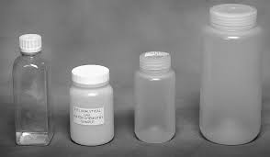
Fig. 1
- After collection of waste water physical analysis of waste water which is generated from kitchen waste, domestic waste and industrial waste is done.
- Screening will be takes place with the help of trash rack. In screening solid suspended matter which are present in waste water will be separated.

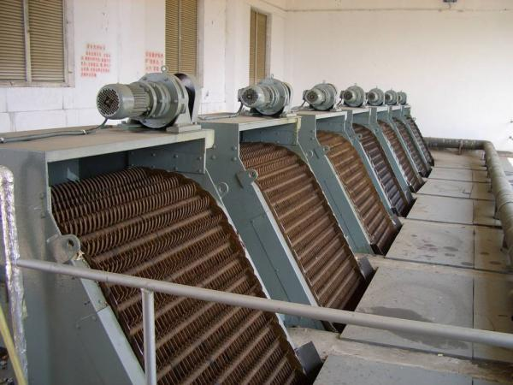
Fig. 2 Screening device
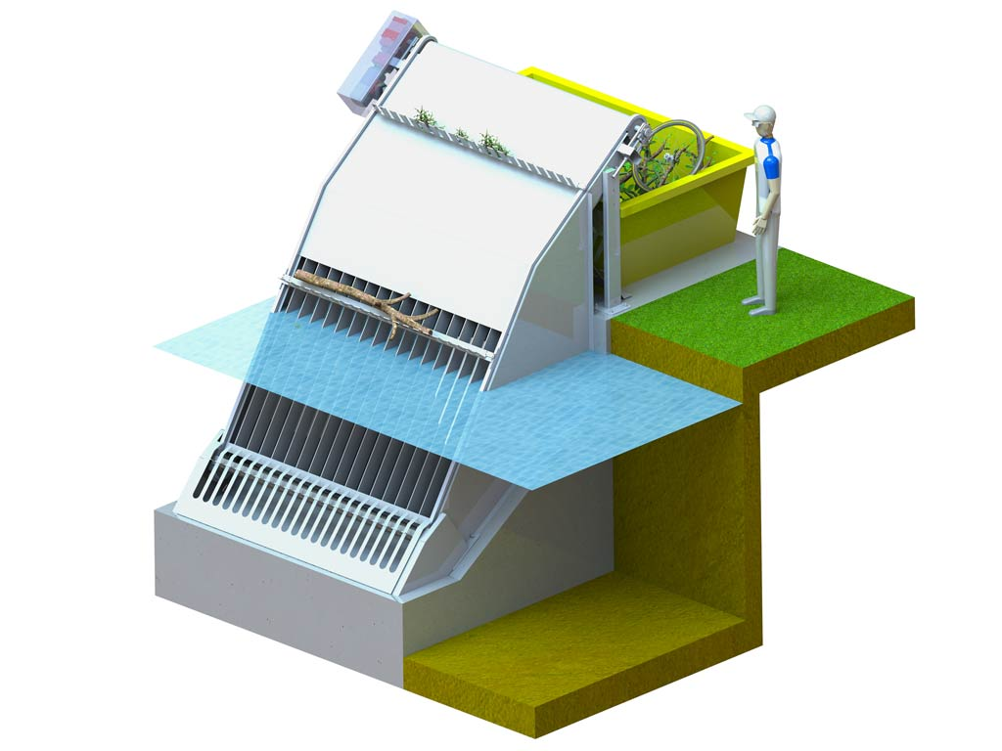
Fig. 3 Trash rack
- After screening process sedimentation of waste water will be takes place. Sedimentation is the process in which small suspended particles will be settled down.
- After the process of sedimentation the waste water is transfer to pass through the turbine.

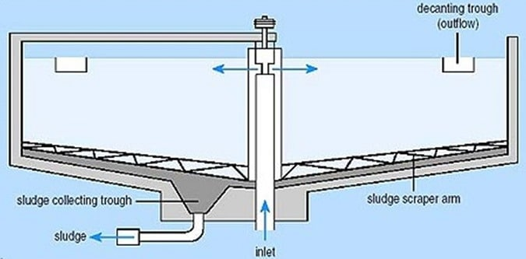
Fig. 4 Sedimentation tank
- Before the waste water passes through the turbine it will pass from surge tank. Due to surge tank the velocity of waste water will be constant. It carries constant flow of waste water.

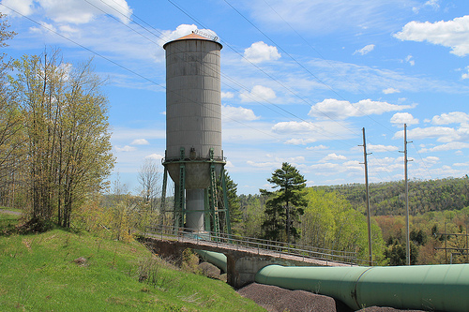
Fig.5 Surge tank

- With the constant flow waste water will be applied on the turbine with high pressure.

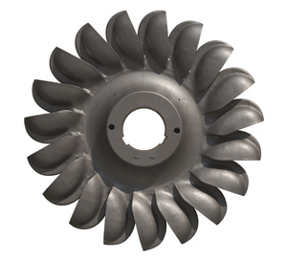
Fig.6 Turbine
- Due to application of waste water the turbine will rotate at particular rotation per minute and generate electrical energy.

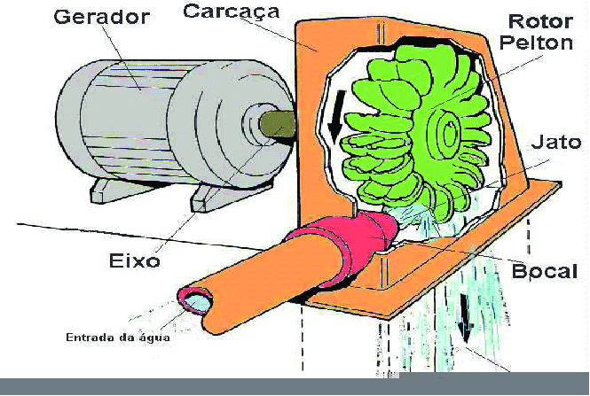
Fig. 7 Application of waste water on turbine

CHAPTAR NO: 6

PROPOSED OUTCOME:
- Feedstock are available
- Lowest investment as well as operational cost
- Suitable for both feebly and highly centralized areas
- High conversion as well as capacity

CHAPTAR NO: 7

REFERENCE:

‘Electricity generation and treatment of paper recyclingwastewater using a microbial fuel cellLiping’ Huang & Bruce E. LoganReceived: 7 April 2008 / Revised: 13 May 2008 / Accepted: 14 May 2008 / Published online: 10 June 2008
- ‘Electricity generation and treatment of paper recycling wastewater using a microbial fuel cell.’ Article (PDF Available) in Applied Microbiology and Biotechnology 80(2):349-55 · July 2008 with 225 ReadsDOI: 10.1007/s00253-008-1546-7} · Source: PubMed

- ‘Power Generation From Kitchen And Industrial Wastewater Using Microbial Fuel Cells’ (Mfcs) With Graphite Cathode And Anode By Moshami S Shah. Conference Paper (PDF Available) · November 2014 with 818 Reads.Conference: ICGTEPC-2014, At National Institute of Technology, Trichy

- ‘Kitchen waste based Biomass Plant for Power generation:’ A case study analysis. G.R.K.D. Satya Prasad, Sarat Kumar sahoo Sambit Pritam, Shyama Sundar marandi, Amit Kumar

- ‘Generating Renewable Electricity from Food Waste’ M.A.O. Mydin1 , N.F. Nik Abllah2 , N. Md Sani3 , N. Ghazali4 , N.F. Zahari5 1,2,3,4School of Housing, Building and Planning, Universiti Sains Malaysia, 11800 Penang, Malaysia 5 Faculty of Architecture, Planning and Surveying, UiTM Perak, Seri Iskandar Campus, 32610, Seri Iskandar, Perak, Malaysia. DOI: 10.1051/ C Owned by the authors, published by EDP Sciences, 2014

‘Electricity generation from wastewater using a microbial fuel cell’ by usingmixed bacterial culture. Harshal D. Kawale, Anil C. Ranveer, Abhijit R. Chavan.31 August 2016 / Received in revised form: 21 August 2017, Accepted: 20 September 2017 Published online: 22 September 2017 © Biochemical Technology Society 2014-2017

