A
PROJECT REPORT ON
EXIM SERVICE IN LOGISTICS INDUSTRY

(SEASHELL LOGISTICS PRIVATE LIMITED, KOLKATA)

Submitted By- Subhalaxmi Sahoo
PGDM 1ST YEAR
REGD.NO.P816004
Guided By- Mr.Mrutunjay Ranasingh
(Branch Manager, Seashell Logistics pvt.ltd)
Prof. Pragnya Paramita Panda
(HR OF AIMS B SCHOOL)
ACKNOWLEDGEMENT

I will remain highly indebted to Mr.Mrutunjay Ranasingh (Branch Manager) of Seashell logistics pvt.ltd, to give me opportunity to do summer internship in the company. I owe this wonderful experience of corporate life from him. I feel deeply honored in expressing my sincere thanks to Mr. Vivek Kumar Pandey (Assistant Manager-Business Development) and Ms. Tanushree Adhikari (Assistant branch manager) for the confidence bestowed in me in completion of my project. I place a deep sense of gratitude to Aman Singh Thakur (Assistant Operation Manager) who was the constant source of inspiration during my two months of internship period. I express my warm thanks to rest of all employees for giving me the ideas about Export & Import procedure.

I express my gratitude to the Director of AIMS B SCHOOL, Mr. Alok Das for arranging my Summer Internship Project in this big and reputed industry . My special thanks to Ms.Pragnya Paramita Panda (HR of Astral Institute of Management Studies), for extending all possible help whenever I need it.

Thank you,
Subhalaxmi Sahoo
DECLARATION
I hereby declare that the project entitled “PROCESS OF EXIM SERVICE IN LOGISTICS INDUSTRY” submitted for the “Summer Internship Project” is my original work guided by SESSHELL LOGISTICS PVT LTD. And project has not been submitted to any other University or Institute or published earlier.
Name – Subhalaxmi Sahoo
Place - Bhubaneswar.

INTRODUCTION OF THE STUDY

THIS PROJECT IS ALL ABOUT TO KNOW THE EXIM (EXPORT&IMPORT) PROCEDURE AND THE DOCUMENTATION DONE BY THE COMPANY.THIS PROJECT IS ABOUT TO PUT MORE FOCUS ON MATERIAL HANDLING, CUSTOME CLEARANCE AND FREIGHT FORWADING PROCESS , DOCUMENT AND DIFFERENT TYPES OF CONTAINER IN SEASHELL LOGISTICS PVT.LTD .

OBJECTIVES OF STUDY

- TO KNOW WHAT ARE THE INCOTERMS & THE APPLICATION OF INCOTERMS.
- TO KNOW THW PROCEDURE AND THE WAY OF EXPORTING AND IMPORTING OF GOOD.
- TO KNOW THE REQUIRED DOCUMENT OF THE PROCEDURE OF EXIM.
- TO KNOW THE TYPES OF CONTAINER AND THE USES.
- ROLE OF CFS & CUSTOM CLEARANCE.
- AND SOME OF THE DOCK WORKS.

SCOPE OF THE STUDY
The aim of this project is to unfold stepwise all complexities involved in the import and export of goods starting from opening the import and export transaction to the closing of that transaction. It also gives the stepwise idea about how to import or export goods ,different departments involved in it and also how CFS & custom clearance plays a measure role in that process. This project gives fair idea about how to start an import-export business.

LIMITATIONS OF THE STUDY
- The study is based on the mixed collection of data i.e. from personal inspection and also from secondary sources of collection.
- The import and export procedure and documents slightly differ from state to state .So it may not be applicable for all states.

INDEX
- Company profile.
- Management profile.
- Vision,mission,business ethics & practices.
- Group companies.
- Services provided by company.
- Customers.
- Types of container.
- Incoterms.
- Some important document.
- Procedure for import.
- Procedure for export.
- Formats of document.
- Conclusion.

COMPANY PROFILE

Seashell Group, through continuous Innovation, relentless pursuit for Excellence, Efficiency, Foresight and un-matched execution capabilities along with personalized services, has emerged as a leading SINGLE WINDOW services provider for Integrated and turnkey services in Shipping, Logistics, Supply Chain Management, Projects – Engineering, Consultancy for DGFT / Customs (own customs license) / Central Excise / other Indirect Taxation matters and International Trade.

Seashell Group is an ISO 9001:2008 certified company & Multi Modal Transport Operator approved by Director General - Shipping, Government of India. Seashell is also a member of International Federation of Freight Forwarders Association, Federation of Freight Forwarders' Association of India, Federation of Indian export Organization, Federal Maritime Commission, World Cargo Alliance, WCA Project Network & Indian Global Logistics Network & World Trade Center.

In Seashell group, we regularly handle shipments of various bulk commodities such as Coal, Minerals Steel, Petroleum, Agricultural products (viz. Rice, Sugar, Wheat, Maize) through our expertise in movement of cargo in racks. In addition to normal merchandise, Seashell Group has emerged as a leading player in handling temperature controlled/perishable shipments by developing own cold chain infrastructure.

In Seashell group, we regularly handle shipments of various bulk commodities such as Coal, Minerals Steel, Petroleum, Agricultural products (viz. Rice, Sugar, Wheat, Maize) through our expertise in movement of cargo in racks. In addition to normal merchandise, Seashell Group has emerged as a leading player in handling temperature controlled/perishable shipments by developing own cold chain infrastructure.

MANAGEMENT PROFILE

Mr Ramesh Babu (Managing Director)
Mr. Ramesh Babu is the co-founder and Managing Director of Seashell Group. Ramesh Babu heads all group companies viz. Seashell Logistics Pvt Ltd, Seashell Overseas Pvt Ltd, and Seashell EXIM Services Pvt Ltd, etc.
He is a post graduate "Masters in International Business" from GIFT (affiliated with IIFT) India.
Mr. Ramesh Babu heads overall working of the group and he is instrumental in making strategic decisions for the group. Under his leadership Seashell group grew to a turnover of US$35 million within a span of 5 years of group's foundation.
Mrs. Kranthi Kumari (Director)
Mrs. Kranthi Kumari is the co-founder and director of Seashell Group since inception.
She is post graduated in MBA from Osmania University, India, with specialization in finance.
Mrs Kranthi Kumari with 10 years of experience is responsible for overall financial management of the group.
Mr. Rajesh Gujjarlapudi (Director )
Mr. Rajesh Gujjarlapudi is the director of seashellgroup and he is one of the guiding forces in groups' phenomenal growth since its inception. He is Post Graduate in International Business from GIFT (affiliated with IIFT) India. He is responsible for overall business development and day to day execution of the company and is instrumental in making marketing strategies.

VISION

Our vision is to be the Earth's most customer oriented Supply Chain Solution Provider; a place where every customer will find the solution for their requirements, through continuous innovation.
We would like to be leader and trend setter in the Industry.

MISSION

Our mission is to continuously provide new solutions to our customers and exceed their expectations. We make this possible by understanding our customer's needs in rapidly changing business environment and developing our team to meet the same.
We share the responsibility in our customer's growth, which makes us a partner of choice.

BUSINESS ETHICS & PRACTICES

The management and the employees strongly believe in a friendly, honest and fair business principles. We believe in practicing values system of strong business ethics and compliance management by ensuring that everybody at Seashell receives comprehensive training of business ethics and fair trade practices. We are committed to anti corrupt practices in the trade.
We feel that unfair shortcuts to success are not long-lasting; only the fundamental competitiveness, positive attitude and constructive behavior can survive long and provide strength to foundations of business, society and the universe.
GROUP COMPANIES

Seashell Overseas Pvt Limited
Seashell Overseas was incorporated in the year 2010 and at present stands to be one of the key Indian player in importing/trading of bitumen required for construction of roads. These imports are done through specially designed containers known as "Bitutainers" which helps in transporting bitumen in parcels of 25 tons each and reduces the wastage which is common in packed bitumen in drums. Bitutainers have internal heating system, allowing bitumen to be heated inside the container itself prior to usage, where the essence of quality and specifications are maintained. Bitutainers are environmental friendly unlike packed bitumen in drums which is hazardous and difficult to handle during and after usage.

Seashell Exim Services Pvt Limited
Seashell Exim Services Pvt Limited was incorporated in the year 2012 and caters to the needs of our clients for availing various Import /Export benefits in accordance with the Foreign Trade Policy, Custom Act, Excise Act. Seashell Exim Services Pvt Limited has established itself as one window solutions for all indirect tax matters.

SERVICE PROVIDED BY SEASHELL
SUPPLY CHAIN MANAGEMENT :
Global supply chain is emerging as a critical success factor for manufacturers and retailers across various industries in face of intense competition.
Seashell group recognizes customers' needs for more effective global supply chain solutions to enhance their ability to expand into new markets, as well as to utilize working capital more efficiently through reduced inventory and facilities investment.
From raw materials to retail distribution, our team of analysts and operations help our customer manage entire supply chain globally.
Taking a holistic view of the supply chain, we focus on efficiencies across all elements. The end results can meet customer's unique business requirement and cost efficiency measurable against pre-set performance indicators.

Phase | Our Services
1. Raw Materials | Global freight management, Consolidation, Warehousing and Storage, Inventory / Materials management, Tracking system.
2. Production & finished Goods | Testing, Sample preparation, Quality control, Warehousing and storage & Inventory management
3. Value-added services | Promotional packaging, Labelling, Ink-jet printing & Component assembly
4. Order processing | Receipt and consolidation of purchase orders, Inventory control & Inspection
5. Distribution | Transport management, Multi-modal transportation, International freight forwarding, Import and export control & Tracking system

CHARTERING, BREAK BULK & BULK :

Chartering:
The Word "chartering", of a ship which is mostly used in break bulk and bulk shipments, in simple terms, is a rental agreement in which one agrees to hire a ship or part of it, from its owner. Part (Break Bulk), Time and Voyage chartering are the commonly used modes of chartering that are generally practiced in core shipping.

Break-Bulk:

We deploy the vessels which are commonly categorized as general cargo ships, with or without RORO facility, to carry break bulk cargoes literally to all corners of the world on tramp arrangement for existing or temporary ports. We also facilitate booking on Semi-liner scheduled Break Bulk operator.
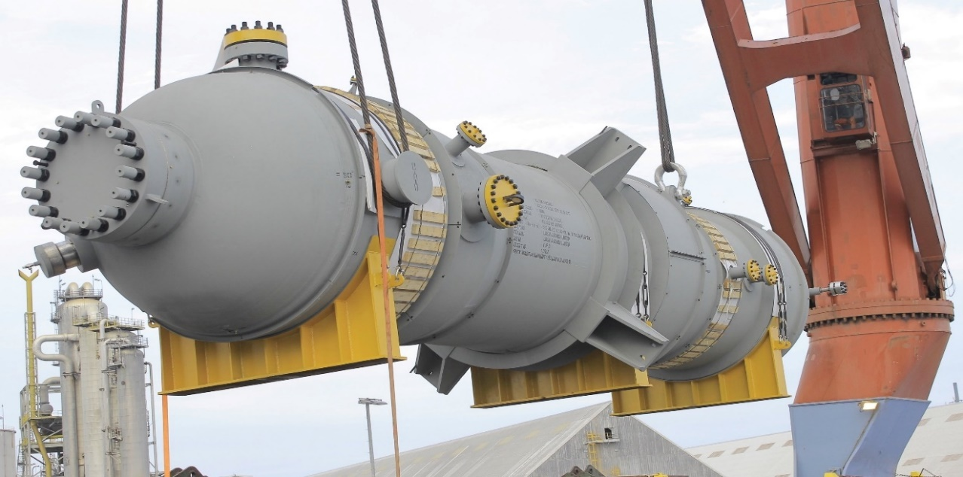
We deploy the vessels which are commonly categorized as general cargo ships, with or without RORO facility, to carry break bulk cargoes literally to all corners of the world on tramp arrangement for existing or temporary ports. We also facilitate booking on Semi-liner scheduled Break Bulk operator.
BULK:
The commodities that are transacted in large volumes like coal, Minerals (Iron ore, Bauxite, Ferro Manganese, Gypsum, Sand etc.) , Agro ( Rice, Maize, Wheat, Soya ,Sugars etc.) , Zinc, Steels, Cement, Fertilizer, Chemicals etc are generally shipped as Bulk either as loose or packed. Seashell is actively involved in arranging these Bulk voyages.
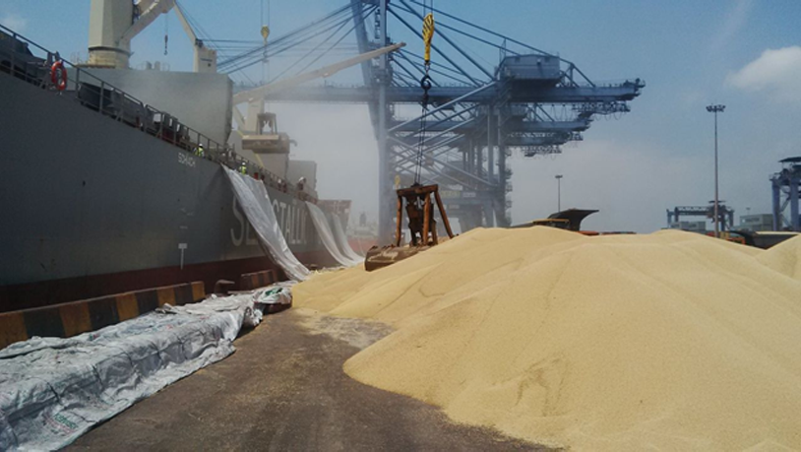

- VOYAGE /TIME CHARTERING :
Seashell is engaged in Voyage / Time chartering, which is one of our core activity. We play a role of Charterers / Brokers/Head Owners/Operators for our clients as per the shipment requirements. Seashell always has open tonnages for Break bulk/Heavy lift/ RoRo Vessels, to fulfill the requirements and employ the suitable fleet required on spot market.
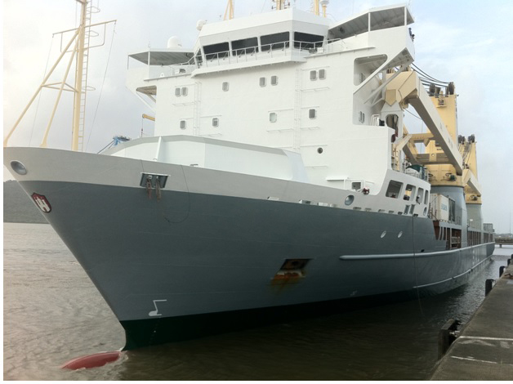

RORO :
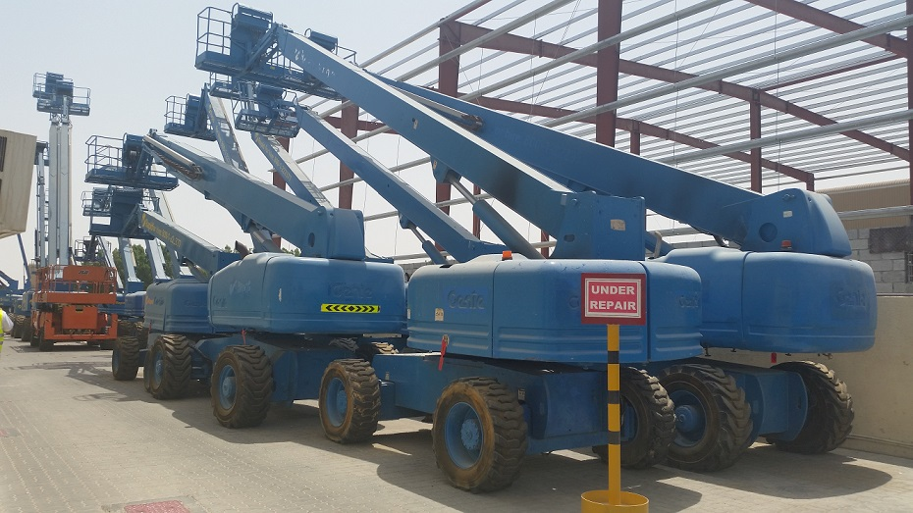
Roll-on/roll-off (RORO or ro-ro) ships are vessels designed to carry wheeled cargo, such as automobiles, trucks, semi-trailer trucks, trailers, self-propelled earth moving equipment’s, and railroad cars, that are driven on and off the ship on their own wheels. Even the static cargo with limited dimensions can be shipped through Ro-Ro vessels using Mafi's. Seashell is associated with all major scheduled carriers in offering competitive packages.

- TOTAL LOGISTICS
Seashell logistics performs door-to-door delivery services wherein scope begins from picking up cargo from shipper's factory and taking it till delivery, at overseas buyer's door, as the case may be, under Incoterms DDP/DDU shipment. Seashell caters to the distribution and supply chain needs of international manufacturers, distributors and retailers from diverse range of industries.
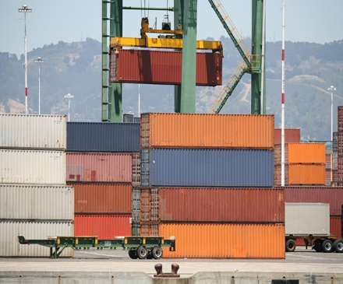

INTERNATIONAL FREIGHT FORWARDING:

Seashell logistics being a member of WCA (World Cargo Alliance) has access and association with over 5000 Agents covering 190 countries. Seashell logistics provides reliable, fast, quality Freight Forwarding Services for sea and air consolidating operator, FCL and LCL Sea Freight. Seashell logistics being an MTO, participate in total logistic solutions which include physical execution under our own offices /associates globally for all international trade requirements and practices.

TANK CONTAINERS:
Seashell Logistics does ISO Tank container (Haz/Non-Haz) shipments and has a dedicated team with complete knowledge and understanding in handling COC & SOC ISO Tank Containers. Seashell logistics has good experience and specialization in handling Bitutainers. A bitutainer is a special type of container that is specially designed to carry bitumen cargo in Bulk.
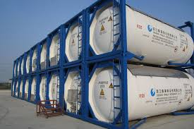

SURFACE TRANSPORTATION:

Seashell Logistics is committed to professionally manage and serve the best quality freight management in surface transportation. The practice of quality services round the clock has earned us trust and respect of our customers. Time management along with immediate status update helps our clients keep track of their freight in no time. Focus on details, provide our clients with delivery reports and proofs and make sure the paperwork is up to date for logistics movement across geographies.

- CUSTOMS CLEARANCE :
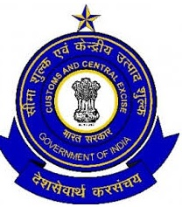
Seashell Logistics has its own CHA license and dedicated team to perform customs related work in all significant Indian ports, for both air and sea cargo clearance. The team includes trained and experienced personnel having good working relations with customs officials and well versed with the rules and regulations governing imports and exports, ensuring quick documentation and trouble free movement of cargos.

- WAREHAUSING & DISTRIBUTION :
Seashell Logistics owns and operate open warehouses with own handling equipment’s. The ware houses are strategically located near Nhava Sheva port and Chennai port. We offer dedicated and shared warehousing and distribution operations that accommodate any particular requirement of our customers business, as well as a number of smart value-added services that improves performance of supply chain.

OFFSHORE SUPPORT :

Seashell group provides comprehensive marketing, technical, commercial & legal support to international leaders in Oil & Gas and Aviation sectors. The Offshore Services team has a very good understanding of the needs and requirements of the principals and has been consistently meeting their expectations.

OVERSEAS OPERATIONS :

Seashell group, being a member of WCA (World Cargo Alliance), has access and association with over 5000 Agents covering 190 countries globally. With this strength Seashell group has the facility to undertake overseas operation or cross country executions as per our customer's requirement.

BITUMEN IMPORT & LEASING OF BITUTAINER
Seashell logistics provides Bitutainers which carries latest technology in transportation of bitumen in bulk. Bitutainers avoids pilferages, contamination, are hazard free and environment friendly. Bitutainers also help in maintaining the quality of bitumen by retaining features of the bitumen during conversion from solid to liquid form.
Bitutainers are also suitable for storage/ transportation of Bitumen Emulsions, PMBs and Heavy Fuel Oils. Each container is constructed with double skin filled with rock wool insulations, heating pipes, baffles, two roof hatches, gate and pressure-vacuum valves. Cargo is filled via roof hatches and discharged via gate valve on the rear. By selecting diesel heater or electric heating kits, bitumen inner pressure can be kept constant by pressure-vacuum valve.
Sample specification of a typical Bitutainers
Nominal Capacity 29,000 liters
ISO 1496 Part 3 - Type 75 Classification
High Performance factory fitted heating tubes
Ideal for Sea, Road and Rail Transport
Baffled design allows Partial Payloads to be carried
High Value Factory Installed Insulation and Pressed Corten Steel Outer Skin
Fully Framed with Corner Twist Locks with Damage Reinforcement Plates
Transported as a Standard 20ft ISO Tank Container with Lloyds Approval .
Heating equipment required: | Ratings: | Measures:
Quick Fit Diesel Burners Set | Max GW 35,000 Kgs | Length 6058mm (20')
Stainless Steel Flame Liners | Payload 22,000 Kgs | Width 2438mm (8')
 | Tare Wt.< 6,000 Kgs | He (8'6")

CFS :

Seashell group is also venturing into establishment and operations of container freight stations across major ports of India.

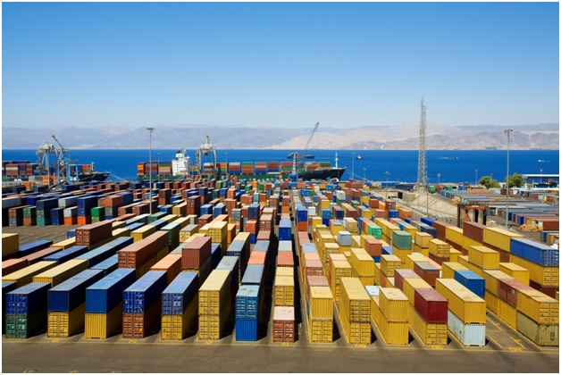

EXIM SERVICES:
Seashell EXIM Services Pvt Limited was incorporated in the 2012 for catering needs of our clients in availing various Import /Export Benefit in accordance with the Foreign Trade Policy, Custom Act, Excise Act, Federal Vat Act and has established ourselves as a "One Window Solutions Provider" for all Indirect Tax consultancy matters.
MAJOR CONSULTANCY SCOPE INCLUDES:
Refund of Applicable Custom Duty : We have expertise in getting refund of legitimate Custom Duty/Special Additional Duty / RD / EDD ,which was paid during import or export process, if eligible as per the act. We also provide consultancy in refund of duty paid for Re-Export, paid under Protest, differential duty paid etc.
Refund of Applicable Excise Duty: We have expertise in getting refund from the Excise Department for the legitimate refund of duty paid on exported item by the Manufacturer as well as Merchant Exporter and also arranging various certificates/permissions for duty free export.
Clearance at Nil /Concessional rate of Duty: Through our complete knowledge of Excise and Custom rules and updated notifications, we assist our clients in availing the legitimate import clearance concessional / Nil rate of duty by providing consultancy on Customs, Excise and FTP.
Obtaining Various Export Import Incentives: We have technical / thorough knowledge and experience in processes of arranging various benefits as per Foreign Trade Policy and are already rendering our service on the following schemes.
Deemed Export Benefit (ie.) Refund of Excise/Custom duty for the Eligible Infrastructure, Power and Drinking Water Projects
Obtaining Authorization (Licenses) as below & our scope of services includes getting the authorization and assisting in redemption (closing) after fulfillment of export obligation.
- Advance Authorisation
- EPCG Authorisation
- DFIA Authorisation
- Served from India Scheme (SFIS) Authorisation
- Focus Market Authorization (FMS) Authorization
- Focus Product Authorization (FPS) Authorization
- Vishesh Krishi Gram Upaj Yojna Authorization
- Permission for Import & Export of Restricted Item.
- Obtaining Status House certificate
- Agri Infrastructure Incentive Scripy
- Incremental Growth Incentive
Sale & Purchase of Licenses:In order to facilitate the trade, we being in EXIM / Shipping services also facilitate the purchase or sale of transferable Licenses. We there by benefit the trade to liquidate the unused or excess authorizations by exchanging with the required companies.
Mandatory Registrations:We are also engaged in getting various registration which are mandatory as per statutory or for execution of commerce.
- Issuance/ amendment of IEC from DGFT
- Issuance & modification of RCMC from all the Export Promotion Council
- Issuance & modification of IEM
- Excise Registration
- VAT Registration
- Service Tax Registration
We also undertake various day to day activities at the port such as AD Code Registration, Drawback Registration, Service Tax, and Factory Stuffing Permission in addition to the above mentioned specialized activities.

SOME OF THE MAJOR CUSTOMERS
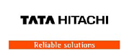
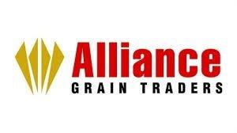

TYPES OF CONTAINER
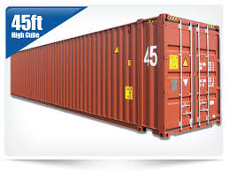
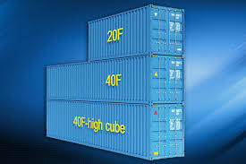
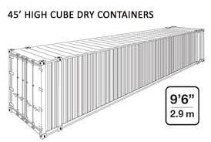
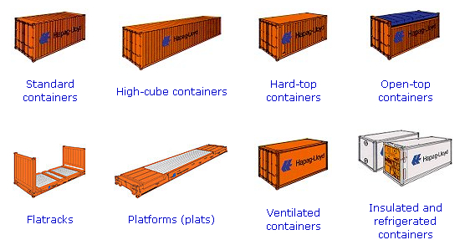
INCOTERMS :
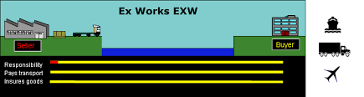
Some of the incoterms uses in our industry :

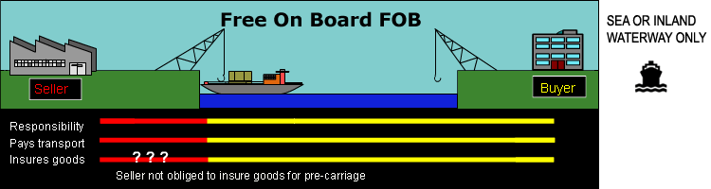

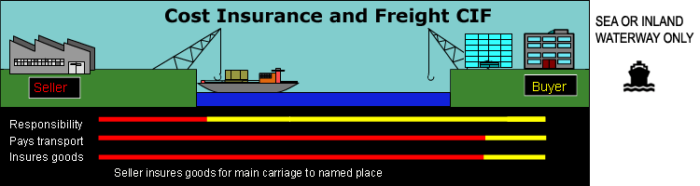

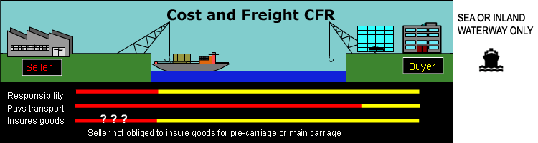

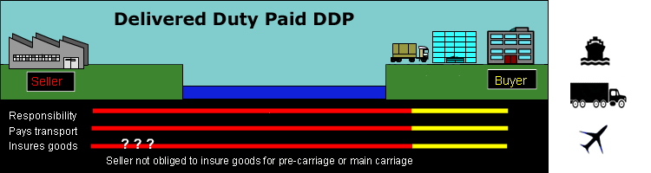

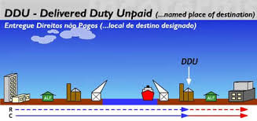

SOME IMPORT DOCUMENT
- PURCHASE ORDER /PROFORMA INVOICE/CONTRACT COPY.
- IEC & AD CODE.
- INVOICE,PACKING LIST,COO,BL.
- CHECKLIST.
- BOE(BILL OF ENTRY).
- BL.
- DELIVERY ORDER/NOC.
SOME IMORTANT EXPORT DOCUMENT
- INVOICE,PACKING LIST,IEC,ADC.
- CHECKLIST.
- PICKUP LETTER.
- CARTIN.
- DRAFT BL.
- SI.
- BL(MBL).
- HBL.
PROCEDURE FOR IMPORT
IMPORTER
EXPORTER

- PURCHASE ORDER OR
- PROFORMA INVOICE OR
- CONTRACT COPY .

SHPPING LINE
INVOICE,PACKING LIST,COO,IEC, AD CODE & BL
CHECKLIST
BL
CFS
BOE(BILL OF ENTRY)
APPROVAL
IMPORTER
FORWARDER

NOC

EXAMINATION/APPRISEMENT

DELIVERY TO IMPORTER

PROCEDURE FOR EXPORT
CHECKLIST
MBL

TO
INVOICE

TO
PAYMENT

TO
SHIPPING LINE
DRAFT BL

TO
SI(SHIPPING INSTRUCTION) ENTERING INTO SHIP

TO
APRISEMENT

TO
CARTIN

TO
STUFFING FACTORY/CFS)

TO
PICKUP LETTER TO TRANSPORTER

TO
COLLECTION OF CONTAINER FROM SHIPPING LINE
BOOKING CONTAINER FROM SHIPPINGLINE
APPROVAL
INVOICE, PACKING LIST, IEC, AD CODE
SHIPPER
FORWADER

CONCLUSION
The growth and development of any country depends upon its industrial trade and foreign trade also. SEASHELL LOGISTICS plays an important role for the growth and development of INDIA’s economy. It also leads to the foreign exchange and helps to create relationship with foreign countries, and intended to give a qualitative service to it’s customer.

BILOGRAPHY
www.google.com
www.seashell group.in

