ON LINE TRANSFORMER FAULT MONITORING SYSTEM

Prof J.S. Bhonsle, Shubham Vairagade and Rahul Barde
Department of Electrical Engineering
Priyadarshini Institute of Engineering and Technology, Nagpur

Abstract: Distribution transformers are one of the most important equipment in power system. Hence it's monitoring plays a vital role. Four parameters are choosen to monitor the health of distribution transformer. They are temperature of transformer, voltage and current, oil level and dissolve gases. Monitoring and control of transformer is done by using various sensors. RF Communication system is used to send the captured data to control room for necessary controlling initiation. This paper present an efficient online method for monitoring and control of distribution transformer through wireless communication.

Keywords: Distribution Transformer, RF Communication , Sensors.

I. Introduction:
A transformer is an electrical device that transfers energy between two or more circuits through electromagnetic induction. These transformers play a vital role in the generation of power and their different types have been used in different sections like generation unit, substation unit and distribution unit based on their need and requirements. It is necessary to keep a track on these transformers to check its working by means of different types of sensors. Various factors may affect the normal working condition of the transformers, such as factors due to ageing, increase in temperature, pressure and environmental conditions. These variations can be sensed by means of different types of sensors which are given as input to the relay unit and converting electrical signal to electromagnetic waves. The signals are transmitted through the RF waves to the receiver unit in the monitoring & control section. In the receiver end, the RF waves are received by the antenna. The RF signal are demodulated and reamplified and then display on LED.
In this paper, four parameters are choosen to monitor the health of distribution transformer. They are temperature of transformer, voltage and current, oil level and dissolve gases. This paper present an efficient online method for monitoring and control of distribution transformer through wireless RF communication which offers many advantages. Main advantage includes easy detection of prefault condition and its clearance at the same time to avoid system failure. Also fault monitoring requires less time as RF gives most accurate and fast response.

II. Literature survey:
Al-ali et al. [1] presents design and implementation of a mobile embedded system to monitor and record key operation indictors of a distribution transformer like load currents, transformer oil and ambient temperature. The designed system is connected to a distribution transformer and is able to record and send abnormal operating parameters information to a mobile device using a GSM network .
Buyung Soﬁarto Munir et al.[2] proposes several methods which are evaluated to determine which method is better in provides consistent and reliable parameters to be used for transformation condition. Basically there are two evaluated methods are used with vibration signals taken sequentially. First used is fast Fourier transform(FFT) which is used to compute discrete Fourier transform. Second evaluated method is Hilbert Huang Transform(HHT) which is used for to separated vibration signal into a finite and a small number of intrinsic mode functions(IMF).
Xiaohui Cheng et al.[3] compares many combinations ways of internet of things and power, the oil based transformer monitoring system is analyzed, but it has high cost, loss data and feedback control of function. This system uses a single bus multi point temperature measurement method and GSM network remote control and data processing combined, so that speed of the temperature and its analysis becomes improved also accuracy of system is also improved, reducing the cost of temperature monitoring system and using the remote control module to avoid the failure of transformer.
Ravishankar Tularam Zanzad et al.[4] presents design and implementation of a system to monitor and record operations of a distribution transformer like over voltage, over current, temperature ,rise or fall of oil level. This system is implemented at the distribution transformer site and measuring above parameters it will help to optimize transformers and identify problems before it failures.

III. Basic Block Diagram:

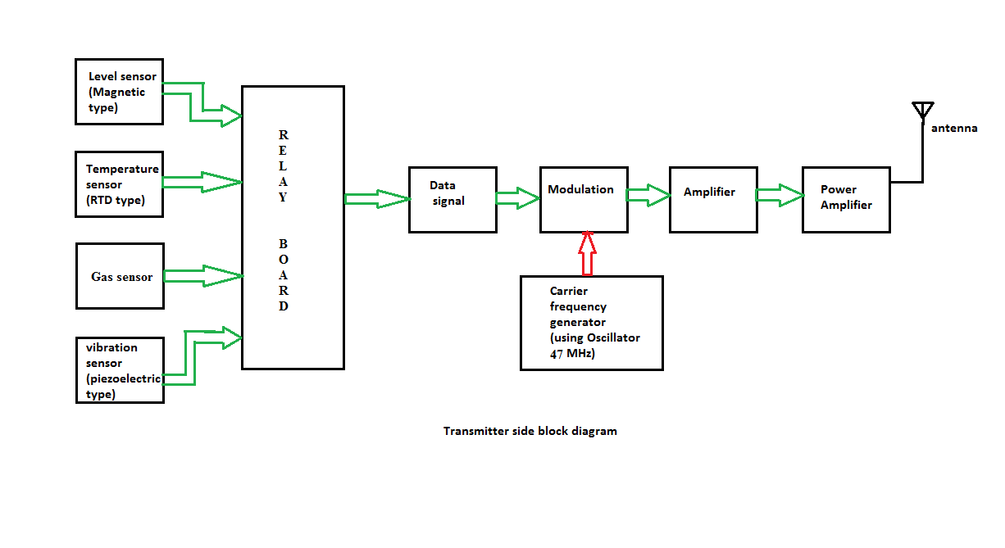

Fig. (1) Transmitter side block diagram

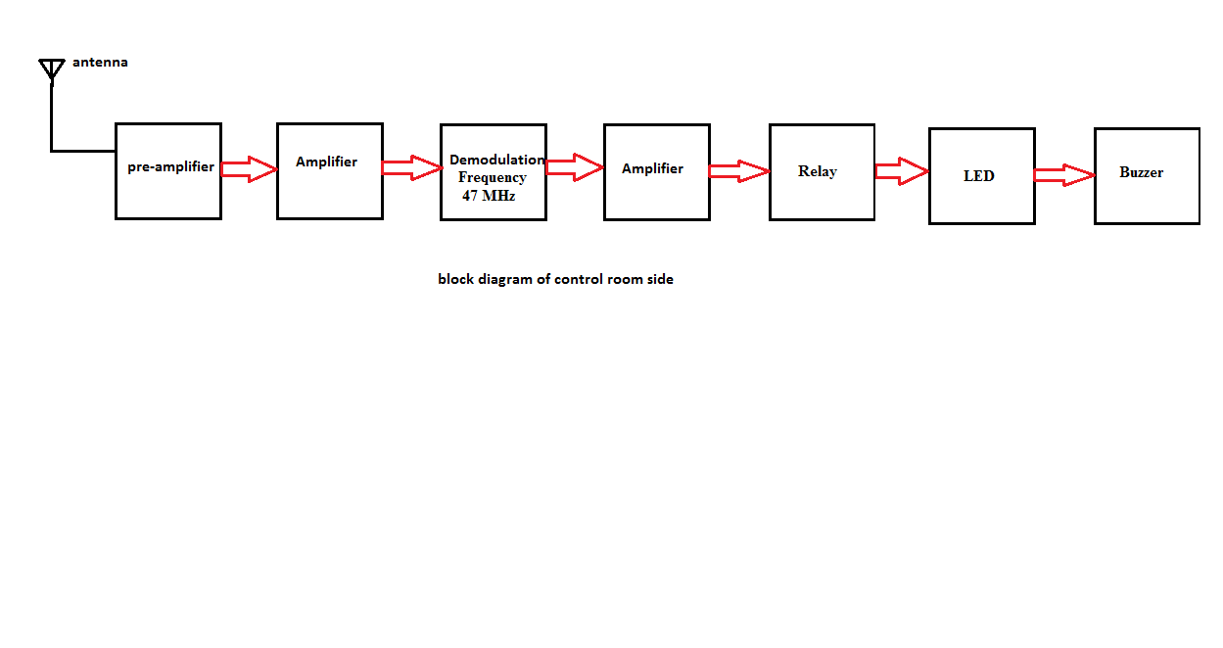

Fig. (2) Block diagram of Control room

Description:
Figure 1 and 2 shows the block diagram of transmitter side and control room. System design is based upon online monitoring of operational parameters of distribution transformers. This can provide useful Information about the health of transformers which will help the utilities to optimally use the transformers and keep the asset in operation for a longer period. This system will help them to identify problems before any catastrophic failure, thus resulting in a long life service for transformers. In transformer monitoring system, four sensors for monitoring that is voltage sensor, current sensor, temperature sensor ,oil level sensor, gas sensor, pizeoelectric sensor sence the data and display it on LED.

Relays:
Three simple electromechanical relays are used and are connected in three phase connection of primary winding of transformer. Each relay is placed on each phase of transformer for detection and tripping purpose.

Sensors:
Sensors are installed on transformer site which reads and measures the physical quantity from the distribution transformer and then it converts it into the analog to digital. Sensor are used for sensing load current, voltage, temperature, oil level and any obstacles. A sensor is a device which receives and responds to a signal when touched or condition occurs in given parameters sensor. A multitude of different measurable variables can be collected for on-line monitoring. However, it is very rarely useful to use the entire spectrum. Therefore, sensor technology must be adjusted to the specific requirements of a particular transformer depending on their age and condition.

Oil Level Sensor:
An oil level sensor is required so that the correct oil level can be maintained. The transformer should maintain the 25°C level, which is the proper oil level at that temperature. Maintaining the exact oil level is much more important because if the oil level falls below the level of the radiator input level, flow inside the radiator will stop and the transformer will overheat. A very low oil level can expose energized and current-carrying components that are designed to operate in oil and could result in overheating or an electrical flipping. If the oil level of the is too high, it could cause over pressurization when the oil expands.

Temperature Sensor:
Temperature controls are required in order to turn on and off the cooling equipment. It measures a temperature gradient produced by a small heater surrounding the thermometer end point of the bulb. This heating element is connected to a current transformer on one of the phases of the secondary leads, so by this means load increases, so does the current flowing through the resistance increases. The heater then becomes a mimic of the actual transformer winding with the winding temperature gauge measuring a temperature that is roughly equivalent to the true winding temperature. These signals are converted into digital signal through the ADC and feed to the microcontroller.

Voltage and Current Measurements:
The voltage and the current are sensed by the potential and current transformer respectively. Potential transformers (PT) are a parallel connected type of instrument transformer, used for metering purpose and protection operations in high-voltage circuits or phasor phase shift isolation. These transformers make the ordinary low voltage instruments suitable for the measurement of high voltages and isolate them for high voltage. Current transformers are used extensively for measuring current and monitoring the operation of the power grid and the transformers. A current transformer isolates the measuring instruments from what may be very high voltage in the monitored circuit. The output of this current transformer and the potential transformer are passed to the signal conditioning unit.

RF Communication:
Radio frequency (RF) is a rate of oscillation in the range of around 3 kHz to 300 GHz, which points to the frequency of radio signal waves and the AC which carry radio signals. RF usually signifies the electrical rather than mechanical oscillations. The distance over which radio communications is useful depends significantly on things other than wavelength, such as power during transmission, receiver power quality, type, size, weight and height of antenna, transmission mode, noise ratio and interfering signals. The output signals from the microcontroller are transmitted to the monitoring side through RF Transmitter module.

Piezo Vibration Sensor:

Piezo sensors are flexible devices that generate electric charge when they’re stressed. This characteristic makes piezos an ideal solution for low-power flex, touch, and vibration sensing.

Gas Sensor:
MQ-4 gas sensor has high sensitivity to Methane, also to Propane and Butane. The sensor could be used to detect different combustible gas, especially Methane, it is with low cost and suitable for different application.

IV. Result / Conclusion:
This paper presents a monitoring system for distribution transformers using Radio Frequency communication. Designed system gives accurate, fast and reliable response that protect transformer and overall system from various faults so it keeps transformer in healthy condition in minimum cost. This technique reduces human effort along with it also gives prefault indication based on real time data wirelessly.

Reference:
[1] Abdul-Rahman AI-Ali, Abdul Khaliq & Muhammad Arshad “GSM-Based Distribution Transformer Monitoring System,” IEEE MELECON 2004, May 12-15, 2004, Dubrovnik, Croatia
[2] Buyung Soﬁarto Munir, Johan J. Smi:”Evaluation of Various Transformations to Extract Characteristic Parameters from Vibration Signal Monitoring of Power Transformer” 2011 Electrical Insulation Conference, Annapolis, Maryland, 5 to 8 June 2011
[3] Xiao-hui Cheng,Yang Wang, “The remote monitoring system of transformer fault based on The internet of Things,” 2011 International Conference on Computer Science and Network Technology
[4] Ravishankar Tularam Zanzad, Prof. Nikita Umare,Prof Gajanan Patle, “ZIGBEE Wireless Transformer Monitoring, Protection and Control System”, International Journal of Innovative Research in Computer and Communication Engineering, Vol. 4, Issue 2, February 2016.

