A

PROJECT REPORT

ON

“A STUDY OF DIGITAL MARKETING WITH SPECIAL REFERENCE GOOGLE ADWORDS”

SUBMITTED TO

SAVITRIBAI PHULE PUNE UNIVERSITY

IN

PARTIAL FULFILLMEWNT OF THE

MASTER’S DEGREE IN BUSINESS ADMINISTRATION

AT

CRYSTAL WEBTECHS.

PRESENTED BY

MR. KSHITIJ .K. BHAD

UNDER THE GUIDANCE OF

PROF. VIKAS DOLE

THROUGH

NEVILLE WADIA INSTITUTE OF

MANAGEMENT STUDIES AND RESEARCH

PUNE- 411001

2017 – 2019

DEDICATION

This report is dedicated to all those who have encouraged, supported, challenged and inspired me. Specially to my beloved parents, honorable teachers, company guide who help me in every problems and encouraging team members, for all their guidance love and attention which has enabled me to commit and follow the best possible route to complete this project.

DECLARATION

I, Kshitij Kishor Bhad. Seat no , student of MBA of Neville Wadia Institute of Management and Research , hereby declare that the project report on “To study digital marketing with refrence to social media”, this report is an original and authenticated work done by me. The project was of 60 days duration and was completed between 20th June to 20th August 2018.

I further declare that it has not been submitted elsewhere by any other person in any of the institutes for the award of any degree.

GUIDE’S CERTIFICATE

This is to certify that Kshitij Bhad, a bonafide student of Neville Wadia Institute of Management Studies and Research, Pune has completed the project, during 20th June 2018 to 20th August 2018 with the title ““ The Study of Digital Marketing with reference to Google AdWords” at CRYSTAL WEBTECHS.
This project was undertaken as partial fulfilment of post-graduate degree of Master of business administration under Savitribai Phule Pune University during academic year 2018-2019.
He carried out this project under our guidance and supervision. His work is found to be satisfactory in all respects to the best of our knowledge and beliefs. This work has not been submitted elsewhere for the award of any other degree.
We wish him the best for his future endeavours.

EXTERNAL

Prof. VIKAS DOLE

PROJECT GUIDE

Dr. Anand Dadas

DIRECTOR

ACKNOWLEDGEMENT

I have pleasure in successful completion of this work titled “To study Digital Marketing campaign with reference to GOOGLE ADWORDS”. The special environment at Neville Wadia Institute of Management and Research, Pune that always supports educational activities, facilitated my work on this project.

I greatly appreciate the motivation and understanding extended for the project work, by Pravin Sonawane and the staff of the Crystalwebtechs, who responded promptly and enthusiastically to my requests for frank comments despite their congested schedules. I am indebted to all of them, who did the best to bring improvements through their suggestions.

I Thank Dr. A.B Dadas, Director, for his encouragement extended for this study.
I am very much thankful to MR. Vikas Dole for her encouragement and guidance for this project work. It would not have been possible for me to complete this work without her suggestion on every part of this work.

I acknowledge the authors, whose works gave me insight and information related to this subject. I am thankful to Library staff and Administrative staff of the NEVILLE WADIA College who directly, or indirectly, have all been helpful in one way or another. I thank my parents who encouraged me to extend my reach with their help and support; I have been able to complete this work.

Date: NAME-

SIGNATURE

EXECUTIVE SUMMARY

I am Kshitij.K.Bhad of N.W.I.M.S.R a MBA student. I have done my internship in CRYSTALWEBTECHS one of leading digital agency in NASHIK. My internship is in Digital Media Marketing. Throughout my internship, I had been working in different clients across NASHIK. This report was written after getting the first hand experience from Digital media marketing. This report explains the importance of digital media marketing (Google Adwords) in present era and this report will help the reader to get an idea about the Industry, Indian population and digital media, concepts of digital marketing,. After reading the whole report the reader can able to understand the reason behind growing digital media marketing.
Title of the Internship Report is “To study the Digital Marketing Campaign with reference to Google AdWords” and Objectives of the Internship are to understand the Google Adwords, building campaign, bidding strategy, etc.
Methodologies used for achieving these objectives are client servicing and a research. For achieving the objectives, I have done client servicing in Crystalwebtechs by doing client servicing I got chance to work with popular brands.
Main findings of this internship are given here. Indian customers are highly information seekers. They collect more information about a product before buying it. Internet penetration in India is key player for this phenomenon. Most of Indians are getting stimulus through advertisements, but they are not reaching to end phase of customers purchase journey, mainly in high involvement purchases. Brands are getting more touch point to reach their target group in this digital era. More details about findings are given this report.
The successful completion of this internship indicates that the future of marketing is in the hands of digital. I conclude my research by quoting again that “Brands can’t sustain without digital presence

CONTENT

Sr. No | Title | Page No.
1 | List of Figures | 9
2 | Introduction | 10
3 | Conceptual theory | 13
3.1 | What is Google AdWords? | 14
3.2 | 10 secrets of Google AdWords | 17
3.3 | Digital Marketing Channels | 23
3.4 | Advantage of Digital Marketing | 26
3.5 | Google AdWords Campaign | 30
4 | Literature Review | 37
5 | Company Profile | 41
6 | Aims and Objectives | 51
6.1 | Steps to Create a Campaign | 53
7 | Research Methodology | 60
8 | Data Analysis and Interpretation | 63
9 | Learnings | 68
10 | Conclusion | 69
11 | Bibliography | 71

1.List of figures

Sr. No | Title | Page No.
8.1 | Overview of Campaign | 64
8.2 | Demographic and Device | 64
8.3 | Keywords | 65
8.4 | Ad copy | 65
8.5 | Making Ad copy | 66
8.6 | Results | 66
8.7 | Searched Keywords | 67
8.8 | Analytics | 67
8.9 | Result for Abatch Campaign | 68
8.10 | Keywords used for Abatch Campaign | 68
8.11 | Adcopy and Display Ads | 69
8.12 | Device and Demographic | 69
8.13 | Network and Hours | 69

2. INTRODUCTION

To begin with, as a part of the curriculum a summer internship programme was to be conducted for a period of two months. Given a choice one was allowed to choose the field in which he/she was interested. As my interest and curiosity was in online or digital marketing I choose to work with a start up company named CRYSTALWEBTECH. It is four year old, Nashik based online marketing & web development firm focused on providing you business-centric strategic solutions to the companies. I choose the start up company because with start I can explore myself and why digital marketing? Because it is booming industry, the growth of digital marketing is tremendous and expected to grow more.

Due to this summer internship, I learnt many aspects of digital marketing including
(GOOGLE ADWORDS ,SEO, SOCIAL MEDIA Marketing, building campaign).One had to identify various sectors in the market that actually have a need of digital marketing services such Google Awords. A good campaign building, targeting right keywords, location, a good bidding strategy help the business to expand and reach their goals more easily.

This report is completely discussing about Google Adwords. There was a time when Television was the most popular medium for Marketer to promote, spread awareness and generate leads for their products but now the trend has changed and Digital media has taken its place. Main reason for this change was

- Traditional methods are expensive. Compared to digital marketing channels, you could end up spending thousands of rupees more.
- Traditional marketing channels fail to provide instant feedback and reports about who saw or heard an ad, and took action. This data is collected long after the initial ad impression is made are exact numbers.

Digital marketing with Google Adwords, on the other hand, refers to marketing methods that allow organizations to see how a campaign is performing in real-time, such as what is being viewed, how often, how long, as well as other statistics such as sales conversions

An extensive literature review is done on the concepts and theories related to web advertising.. It was an amazing experience working virtually and on field. I came to many new terminologies of digital marketing, corporate world etc. The project contain the task which has been done by me during my internship as well as what I have learnt from it.

3. CONCEPTUAL THEORY

3.1 What is Google AdWords?

Google Adwords is the system Google has developed to assist you in marketing your products or services in the Google Search Engine, and its affiliate sites, via the use of a placed text ad that appears when people search for phrases related to your offering, this appears as a “sponsored link”. The system is a “pay per click” system, this means you can dictate where your ad appears through bidding for a series of phrases, but you only pay the amount you have bid for if someone clicks on your ad as a result of a web search, i.e. pay per click!

The ads take the format of a short text ad that includes a title line, two short descriptive lines and a URL link to a website or a specific website page.
The ad will appear on the page of results you decide you want to appear in. For instance page 1 of Google for a search result. The ads appear at the top and to the right of the organic search engine results. You can also pitch at what position on the page your ad will appear, through the amount you bid. Crudely this may mean the more you bid for a phrase, the higher your ad appears on page 1 of the Google Result.
Research shows us that 87% of web users do not scan past page 1 of search engine results. In addition, the higher your website appears on a page will result in more visitors to your website, as web users prefer to click on the ads/search results at the top of the page.

What is Google AdWords exactly?
Google AdWords helps you connect with potential customers looking for products and services like yours. Text-based ads will appear in search results and on Google’s content network based on bids for keywords.
The AdWords keyword tool can help pick the right words and phrases for business, and AdWords does not set a minimum spending requirement, so one can start slow and adjust your budget as business grows.

Why use Google Adwords?
It is now apparent that there is a difference between the types of visitor to a website: “browsing traffic”, or, visitors that may have found a website in a search engines organic result, behave differently to traffic that comes directly from Google Adwords or “pay per click traffic”. The reason for this is simple: traffic via surfing in organic results is simply often browsing for information where as traffic via pay per click knows that when they are clicking on a ad, it is simply that, an ad and that the advertisement is for something they need and want to buy, whether that be a product or services. Therefore, you don’t necessarily need millions of visitors via browsing, rather than specific targeted visitors via Google Adwords.

AdWords Features

IP Address Exclusion
In addition to controlling ad placements through methods such as location and language targeting, ad targeting can be refined with Internet Protocol (IP) address exclusion. This feature enables advertisers to specify IP address ranges where they don’t want their ads to appear.
Up to 20 IP addresses, or ranges of addresses, can be excluded per campaign. All ads in the campaign are prevented from showing for users with the IP addresses specified.
Location-based exclusion is also offered as a method of narrowing targeted users.

Frequency Capping:
Frequency capping limits the number of times ads appear to the same unique user on the Google Content Network. It doesn’t apply to the Search Network. If frequency capping is enabled for a campaign, a limit must be specified as to the number of impressions allowed per day, week, or month for an individual user. The cap can be configured to apply to each ad, ad group, or campaign.

AdWords distribution:

All AdWords ads are eligible to be shown on www.google.com. Advertisers also have the option of enabling their ads to show on Google’s partner networks. The “search network” includes AOL search, Ask.com, and Netscape. Like www.google.com, these search engines show AdWords ads in response to user searches, but do not affect quality score.
The “Google Display Network” (formerly referred to as the “content network”) shows AdWords ads on sites that are not search engines. These content network sites are those that use AdSense and DoubleClick, the other side of the Google advertising model. AdSense is used by website owners who wish to make money by displaying ads on their websites. Click through rates on the display network are typically much lower than those on the search network and are therefore ignored when calculating an advertiser’s quality score.
Google automatically determines the subject of pages and displays relevant ads based on the advertisers’ keyword lists. AdSense publishers may select channels to help direct Google’s ad placements on their pages, to increase performance of their ad units. There are many different types of ads that can run across Google’s network, including text ads, image ads (banner ads), mobile text ads, and in-page video ads.
Google AdWords’ main competitors are Yahoo! Search Marketing and Microsoft adCenter.

3.2 10 Secrets of Google Adwords:

Secret 1 – Only bid on exact match keywords:
Google Adwords has a few different ‘keyword matching options’ available. When a keyword is placed in brackets like this:
[Keyword], it is called an ‘exact match.’ This means that only when someone enters that EXACT keyword phrase will your ad appear. It might occur to you that by limiting your keyword(s) to only exact match, you are eliminating all those people that may be searching for the phrase “cheap widgets” or even “widget” singular, since only the keyword “widgets” plural is an exact match. Believe me, this is exactly what you want. Sure, it will take extra time to create an Ad Group within the Google Adwords system for each keyword phrase you want to bid on, but you will know with 100% certainty which keyword(s) are converting into sales this way.

Secret 2 – Bid to be in position 2 or 3:
When someone searches on Google for your keyword, the first page of search results are going to reach the most people. What you want to do is position your ad in one of the top 3 spots. You don’t want position #1 necessarily, because that position costs the most and doesn’t give you much more benefit than being in position 2 or 3. You pay less for these spots than position 1 and gain most of the benefit. By being in one of these top spots, your ad gets a higher ‘click-thru rate’ (CTR). This is good is because the Google AdWords system actually rewards you for having an ad with a high CTR by charging you less per click! Google AdWords exists to make money for Google. If they have two companies advertising for the same keyword, and your ad pulls a 10% CTR and your competitor’s ad for the same keyword pulls a 5% CTR, then Google AdWords makes more money from your ad. Google

Secret 3 – Negatively qualify your ads:
Admittedly, the problem with having an ad that has a great CTR is that it gets a lot of clicks! Unless your traffic converts into sales, it’s hard to turn a profit on your Google Adwords ads. The key is to put words in the ad that DISCOURAGE people from clicking on the ad unless they ‘pre-qualified’ to convert to a sale.

Secret 4 – Make separate Ad Groups for each keyword within Google Adwords:
Google Adwords lets you create up to 25 campaigns per account, with up to 100 Ad Groups per campaign as of this writing. It’s important to organize your keywords into separate Ad Groups to maintain finer control over the ad text for each keyword. If you had one Ad Group for the following keywords: ‘widgets’, ‘plastic widgets’, and ‘wooden widgets’, then the ads created for that Ad Group would have to apply to all of the above keywords.
If your ad text reads: “50% off all plastic widgets” and this ad is showing for the other keyword phrases in the same Ad Group, then someone searching for ‘wooden widgets’ probably will not be inclined to click on your ad that is focused on people searching for ‘plastic widgets’.

Secret 5 – Run tons of keywords in Google Adwords:
Most people that have Google Adwords accounts find the top keyword phrases for their industry and run ads for only those keywords. This is a big mistake. The top keywords are the ones that have the most competition and also the lowest click-thru rates. Smart Google Adwords marketers know that the more specific a keyword phrase is the more people will click on the ad. People that search for a keyword like ‘widgets’ are more likely to skip over an ad targeting such a broadly targeted keyword.

Secret 6 – Split-test your ads in Google Adwords:
As mentioned in Part 1 of this series of articles on Google Adwords, it is critical to split-test your ads. Google Adwords has a built-in feature that lets you automatically rotate the appearance of your ads so different ads can be shown an equal number of times (or weighted more heavily toward the ad that gets more clicks if you prefer – you can change this in the campaign settings). The benefit of this approach is that you will be able to see which ad gets a better click-thru rate (CTR).
Since Google Adwords rewards a higher CTR with lower cost per click (CPC), it is crucial that you know which ad has a better CTR. Sometimes just swapping the ad text that appears on lines 2 and 3 will make a big difference in your ad performance.

Secret 7 – Improve your ads in Google Adwords:

Chuck the lower CTR ad, keep the winner, and create a new ad to split-test against the current reigning champion. By following this split-test strategy, you will constantly be improving your ads CTR and lowering your CPC.
There is no better marketplace for this steady stream of valuable traffic than with Google Adwords. By employing the tips and strategies outlined in this series of articles, you will be armed to the teeth to convert those hard earned dollars spent on Google Adwords into profits for your online business!

Secret 8 – Track your ads by keyword in Google Adwords:

After spending the time setting up separate Ad Groups within Google Adwords for each keyword as mentioned above, the key is to know which keywords are costing you money and which ones are profitable.

Secret 9 – Put keywords in your ad text in Google Adwords:
If someone searches for “plastic widgets” and your ad text reads “50% off plastic widgets”, then the phrase ‘plastic widgets’ will appear in bold when your ad is displayed. This makes a huge difference in the click-thru rate of your ads!
If you don’t believe me, simply follow the tip mentioned above for split-testing your ads and create two ads, one with the keywords in the ad text and the other without. You will be surprised at how much better the Google Adwords ad with the keyword(s) in the ad text performs.

Secret 10 – Only run ads on the Google ‘Search Network’ in Google Adwords:
When creating a new campaign in the Google Adwords system, the default campaign settings are configured to show your ads on both the ‘Content Network’ and the ‘Search Network’. Google has a pay-per-click affiliate program called Google Adsense. This program pays people for each click on Google Adwords ads that are displayed on their own web sites. The problem for you, the Google Adwords advertiser, is that you do NOT want your ads showing up on any old website that has relevant content to your ad.

Social Networking Growth in India:

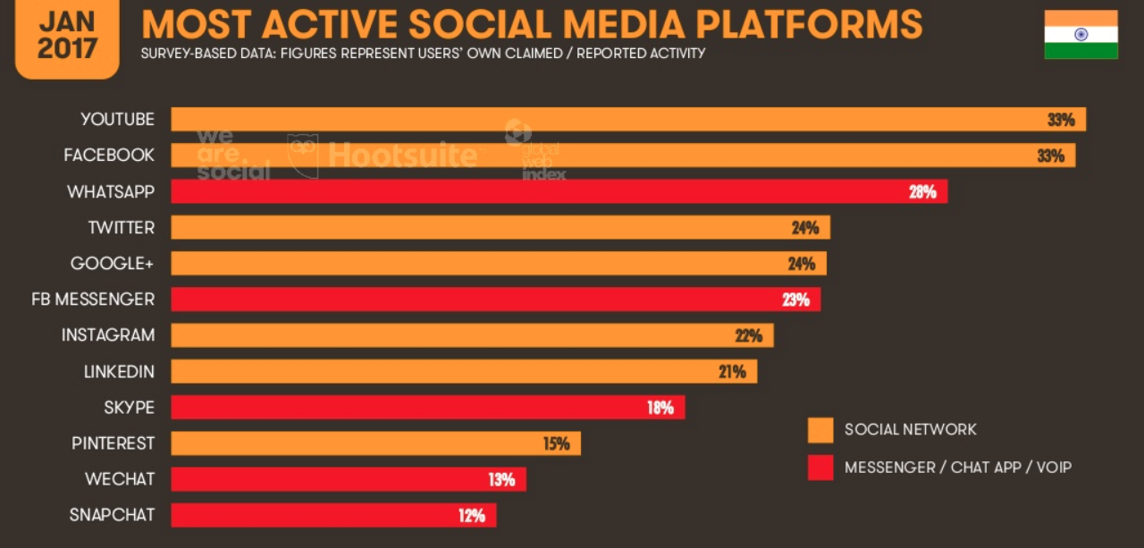

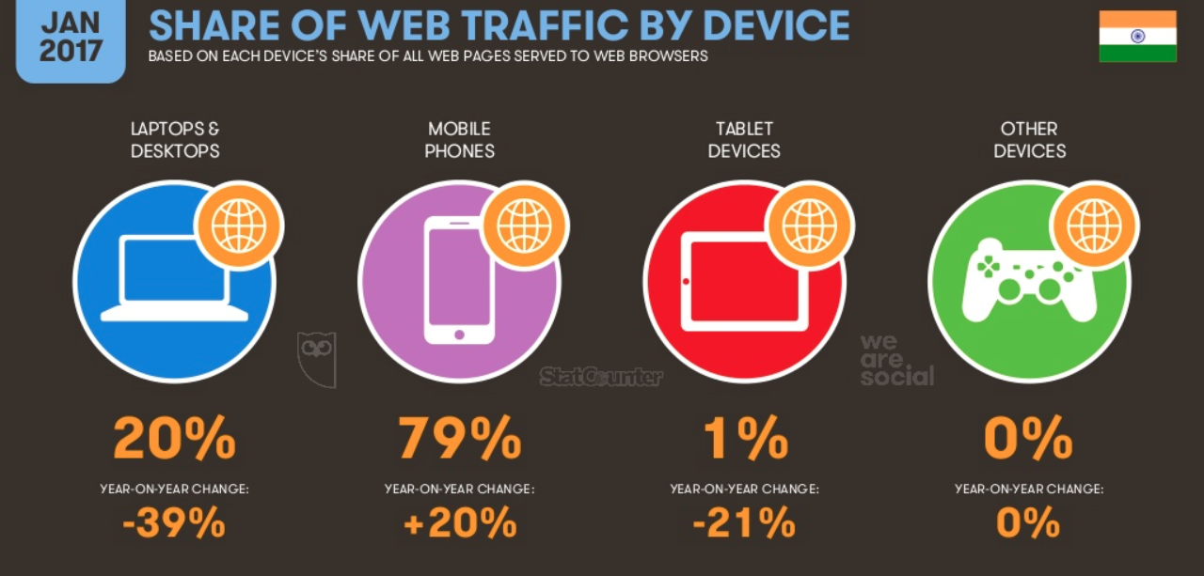

Number of Indian user on Social Networking Platform

Facebook-90Million Twitter –30Million LinkedIn-18Million

Pinterest –15 Million Instagram- 2Million

Entertainment and Online Video:
According to comScore data, the online video audience in India grew an astounding 27 percent in the past years; YouTube continues to be the top video property with more than 55% share. International publishers including Facebook, Yahoo and Dailymotion get a majority of the 54 million who watched videos. YouTube is the most popular with 32,519 visitors.

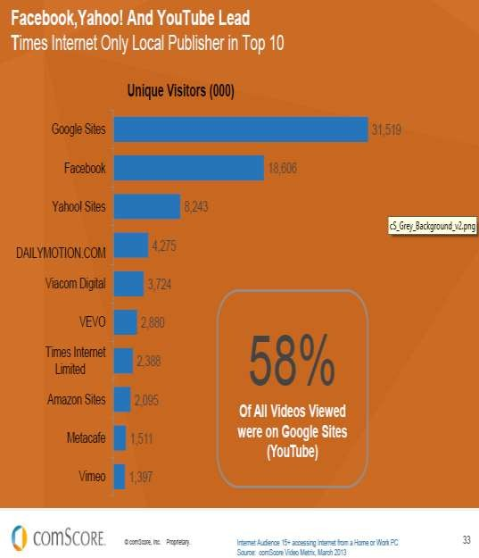
Social Video report saying 46% of internet users watch brand related video every week. 54% watching videos that are informative or entertaining often leads to a number of other positive activities such as visiting the brand website. Peoples are now likely to regularly watch videos using their smart phones. Almost six in ten internet users have gone to purchase an item after seeing it in an online vide

3.3 DIGITAL MARKETING CHANNELS:

1. SEO (Search Engine Optimization)

Search engine optimization (SEO) is the process of affecting the visibility of a website or a web page in a search engine's "natural" or un-paid ("organic") search results. SEO may target different kinds of search, including image search, local search, video search, academic search news search and industry-specific vertical search engines.

As an Internet marketing strategy, SEO considers how search engines work, what people search for, the actual search terms or keywords typed into search engines and which search engines are preferred by their targeted audience. Optimizing a website may involve editing its content, HTML and associated coding to both increase its relevance to specific keywords and to remove barriers to the indexing activities of search engines. Promoting a site to increase the number of back links, or inbound links, social book marking, directory submission is the another SEO tactic.

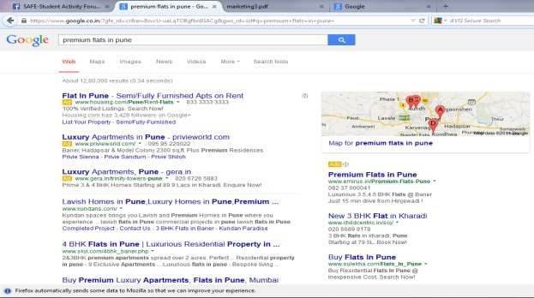
SEO OR
NIC
ORGA

2.Youtube:
YouTube is a video Social Networking site, and the 2nd most popular search site on the Internet after Google, who owns YouTube. YouTube video watching is a significant activity on the Internet, with over 1 billion visits to YouTube daily and over 100 million videos watched daily. And it's easy for anyone who sees your video to rate it and share it with his Social Network.
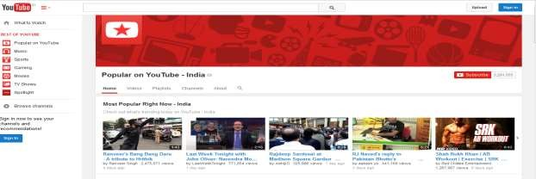

3. ODA (Online Display Ads):
Display advertising appears on web pages in many forms, including web banners. Banner ad standards continue to evolve.
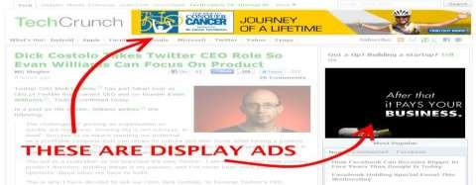

4.MMT (Mobile Marketing):
Mobile marketing is marketing on or with a mobile device, such as a smart phone Mobile marketing can provide customers with time and location sensitive, personalized information that promotes goods, services and ideas.

5. Social Media Marketing
Social Media refers to any software tool that enables and encourages engagement in conversation or sharing. Popular forms of social media include Facebook, Twitter, LinkedIn, YouTube, Pinterest, Google + and blogs. Now all days social media become platform for marketer to make conversation with customers. Brands are now engaging customers through social media.

Analytics:
Analytics is the practice of evaluating data, and the process by which a company arrives at a most advantageous decision. Here marketer analysis the integrate channel to understand the effectiveness of communication. Analysis may be based on numbers of visitor or like in social media pages, Etc.

Content Management:
After analysis the integrate channels marketer can able to understand the problems with current contents. Later he can manage the content to increase the engagement rate, content may be text in banners, images or websites.

Advanced Targeting:
Advanced targeting are techniques involving the sending of targeted messages to a specific audience. It is used to increase the effectiveness of a marketing campaign. Behavioral targeting is also a part of advanced targeting, here marketer can target the customer based on their past behavior in online. Marketer can put ads in other webpage where customer is going.

Creative:
Creative is the artistic component of an ad or website. It usually includes an image and copy present in ads or website. Marketer can make those contents attractive to customers. Marketer will sometimes change the entire design of websites, apps, Etc.

3.4 Advantages of Digital Marketing:

Digital Advertising is increasingly an inherent budgetary component of many organizations today. Organizations of all sizes use the medium to promote their products and services. These are discussed in the paragraphs ahead.

Reach - The ability of the online medium to target a certain demographic of users is one of the greatest advantages of digital advertising. In addition, the geographical reach of the online medium is far greater than that of traditional media. It’s not only cost effective to achieve a wider geographic area but the ads can also be targeted to the desired audience.

Measurement - With various tools becoming available, tracking effectiveness of ad campaigns is becoming possible today. In other words, measuring Return of Investment (ROI) is increasingly possible today. Organizations that were previously reluctant to spend online, now realize that the online medium does offer means to alleviate any such fears. Moreover, when properly designed online marketing campaigns generate the desired results, advertisers are further encouraged to continue advertising online.

Interactive and Engagement- The Internet is arguably the most interactive and engaging medium among various others. Interactive campaigns have become a norm with the power of the online medium. One such advertisement worth mentioning is the campaign by AXE where the end user could alter the smile of a woman as he/she liked to i.e. in an interactive framework. The advertisement struck an instant chord with the youth to which AXE the brand is positioned for Customers are basically just a click away from the advertisers.

Time- Through the Internet, an advertiser can reach a desired target group or demographic in a much shorter time frame. Even otherwise i.e. for regular marketing campaigns, the total time necessary to complete an online advertising campaign is less than that of traditional advertising methods.

Cost- When compared to traditional forms of advertising, digital advertising is cheaper. Various payment models are available between the advertisers and publishers. Many a time, advertisers are charged only when visitors click on their ads. The various payment models are discussed in detail in the next section.

Some of the Basic Terms in Digital Marketing:

- Impression
An impression is a measure of the number of times an ad is seen, whether it is clicked on or not. Each time an ad displays it is counted as one impression.

- Page View
Viewing the page is known as page view. It gets counted once the page loaded.

- Leads
When one person fills his details in the given box is known as lead.

- Conversion
The percentage of people whose activity can be tracked while clicking on an ad or visiting a website to actually purchasing a product or service. A high conversion rate indicates that the link, ad or site was successful.

- Inbound link
Link connecting to your website from a different website.

- Profiling
To build a picture of a target customer based on information from various sources including customer transactions completed forms and demographic data.

- Unique Visitor
Unique IP address accessing a website.

- Landing Page
A custom we page designed to convert visitor into leads or sales. Email, banner ads and even offline outbound marketing campaigns drive traffic to a landing page to capture information or trigger a sale.
Types of ads:

- Above The Fold: Above the fold refer to banners ads which are displayed at the top of a webpage

- Rich- media: Online ads that contain motion, sounds or video are termed as rich media ads

- Interstitial Ads: Ads that appears between web pages.

- Banner Ads: Embedding an ad into a web page- known as a click through due to interactive actions where the consumers clicks and is taken to the banner ad’s company websites
- Pop-up: Ads that displays in a browser window either in the front or behind the current browser window.

Monetary term in Digital Marketing:

- Cost –Per- Action (CPA): Cost of advertising based on a visitor taking some specifically defined action in response to an ad. “Action” include such thing as a sales, transaction, a customer acquisition or a click
- Cost- Per -Click (CPC): Cost of advertising based on the number of clicks received.

- Cost- Per-Thousand (CPM):The standard unit for buying or selling Internet advertising. The thousand stands for ‘thousand advertising impression or views’.
- Pay- Per- Impression: Online advertising where an advertiser pays a pre-agreed price each time a user clicks on their advertisement. The cost for the click is often negotiated through auction, with ad placement determined by the relative size of the bid, as well as other factors.
- Pay-Per-Inclusion: Search engine marketing programs that guarantee web site listing for specific keyword search term for a fee.
- Pay-Per-Lead: Paying to acquire leads from an outside party at a set rate or amount per lead.

3.5 Google AdWords-Campaign:

There are five types of campaigns They are:

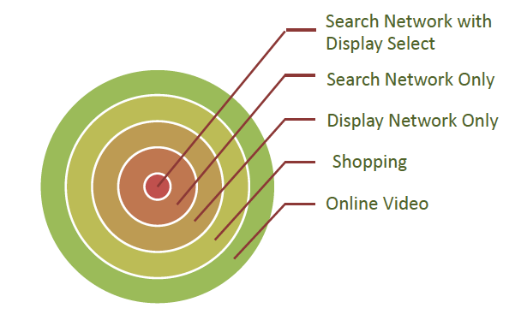

Google AdWords-Definition

Google AdWords is Google's online advertising program.

Google AdWords is a product that you can use to promote your business, help sell products or services, raise awareness, and increase traffic to your website.

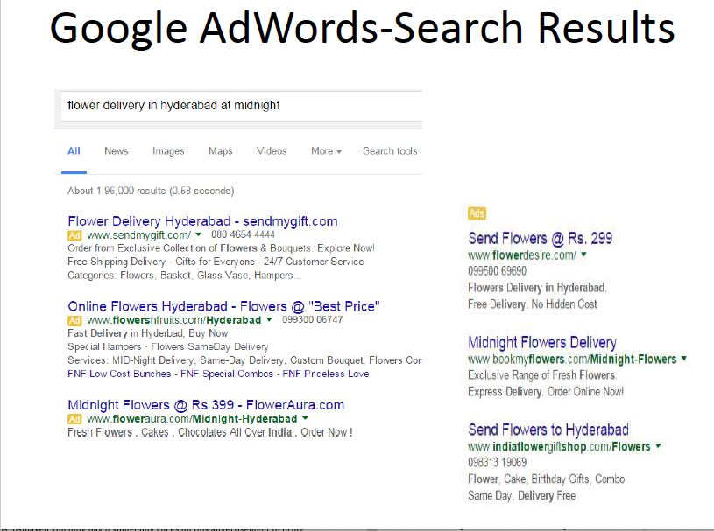

Google AdWords-Layers

AdWords is organized into three layers:

1stLayer-Account.

2ndLayer-Campaigns
3rd Layer-Ad groups
(i) Ad copy.
(ii) Keywords.

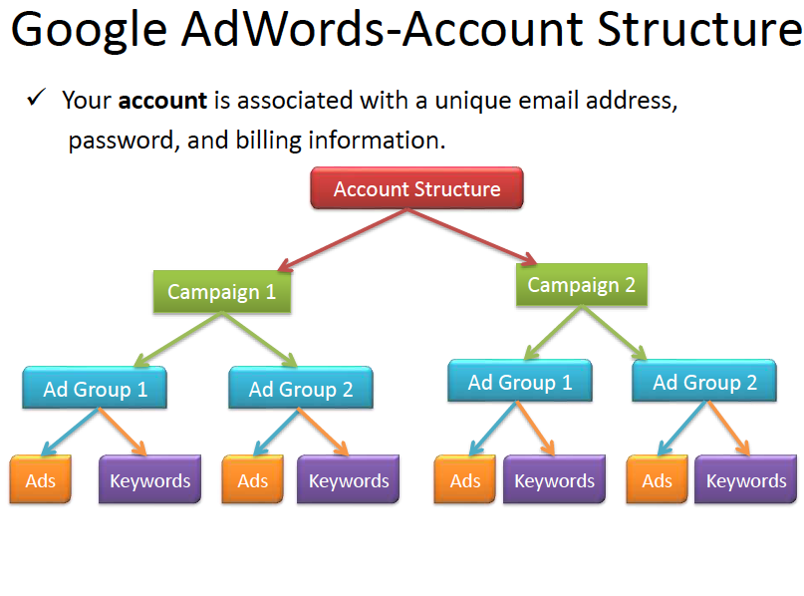

Google AdWords-Ad Group

1. Your ad group contains a set of similar ads and the words and phrases, known askeywords.
2. An Ad Group contains one or more ads which target a shared set of keywords.
3. Each of your campaigns is made up of one or more ad groups.
4. Use ad groups to organize your ads by a common theme.

Google Adwords: Ads types:

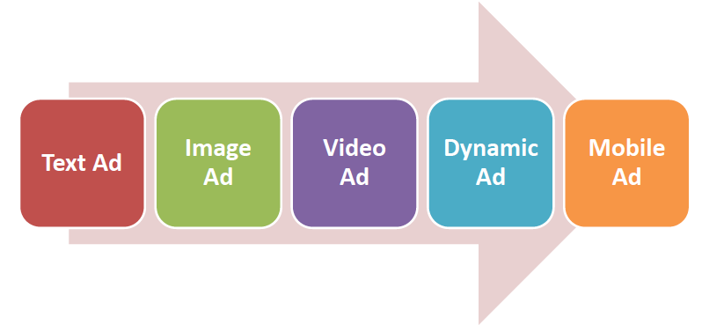

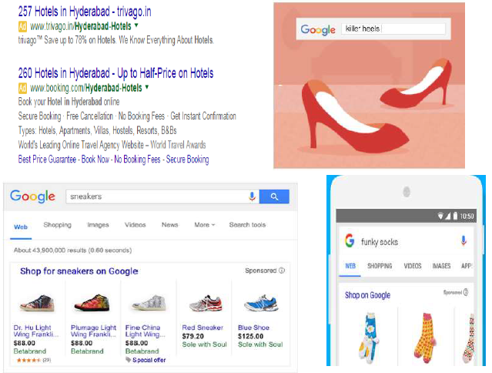

Google AdWords: keywords match types:

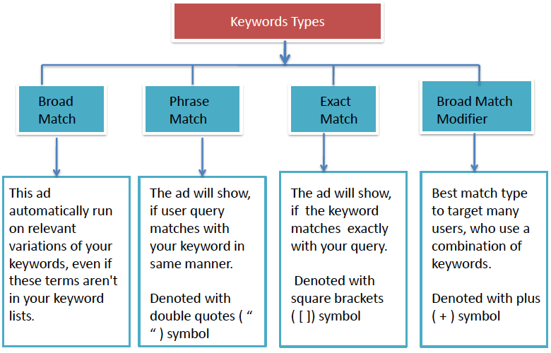

Google AdWords-Ad Rank:
Ad Rank determines your ad Position where your ad shows on the page in relation to other ads and whether your ads are eligible to show at all.
The main components of your Ad Rank are your bids and thequality of your ads and website.
Max CPC:
A bid that you set to determine the highest amount that you were willing to pay for a click on your ad.

Quality Score(QS):
QS is a metric calculated AdWords based on various factors of quality and relevancy. (

Quality score factors:
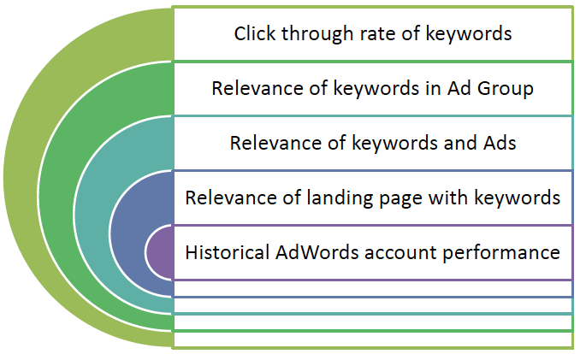

Google Adwords: Extensions:

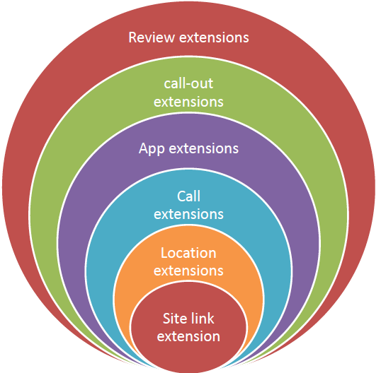

Tools used:

- Google AdWords:
Google Trends is a public web facility of Google Inc., based on Google Search, which shows how often a particular search-term is entered relative to the total search-volume across various regions of the world, and in various languages. The horizontal axis of the main graph represents time, and the vertical is how often a term is searched for relative to the total number of searches, globally. Below the main graph, popularity is broken down by countries, regions, cities and language. Marketer can use Google Trend to know from where highest and low search come from which location for their products.

2) Google Keyword Planner
Keyword Planner is like a workshop for building new Search Network campaigns or expanding existing ones. Marketer can search for keyword and ad group ideas, see how a list of keywords might perform, and even create a new keyword list by multiplying several lists of keywords together.

Get historical statistics and traffic estimates: Use statistics like search volume to help you decide which keywords to use for a new or existing campaign. Get estimates, like estimated clicks, to get an idea of how a list of keywords might perform for a given bid and budget. These estimates can also help guide your decision on which bids and budgets to set.

4. LITERATURE REVIEW

1. J Suresh Reddy in his article “Impact of E-commerce on marketing”.
Marketing is one of the business function most dramatically affected by emerging information technologies. Internet is providing companies new channels of communication and interaction. It also creates positive interaction with customers that can serve as the foundation for long term relationships and encourage repeat purchases.

- Neelika Arora in her research article entitled “Trends in Online Advertising” in advertising Express,Dec2004.
The global online advertising revenues are expected to touch US $10bn by 2006. In India, the revenues at present are estimated to be Rs.80 cr. and are expected to increase six times more within the next five years.
In India, Internet as a medium is accepted by a wider industrial segment that includes automobiles, telecom, education, banking, insurance, credit cards, FMCG (Fast Moving Consumer Goods), apparel/clothing, durables, media, business services and tourism. Out of these it is estimated that the banking, FMCG and insurance sectors together account for 45% of the total advertising spend. In comparison to this, automotive, travel and retail spend 37% of the total advertising revenue and financial service companies spend 12% only. Some of the top spenders in India are automobiles, followed by brands like Pepsodent, Kellogg’s, Cadbury, HDFC (Housing Development Finance Corporation Ltd.) loans and Sun silk. In addition to these the early adopters in the field of finance and IT are also increasing their spending. Globally, the trend is that almost 60% of the revenue goes to five firms- Goggle, Yahoo, Microsoft, AOL(America Online Launchers), and Overture. Approximately, 90% of the Goggle revenues come from advertising. In India, portals like indiatimes.com, exchange4media.com, rediffmail.com, agencyfaqs.com etc. are attracting major onlinespender.

- Sumanjeetin his article on “On Line Banner Advertising”- in Indian Journal of Marketing.
Online banner advertising has great potential as an advertising medium. It is easy to create, place and use. It offers companies targeting well educated, innovative, affluent males/females or students with great potential for success as their segments are highly represented.

Nicholas Ind, Maria Chiara Riondino have originally published their article “Branding on the Web: A realRevolution?”the Journal of Brand Management in September 2001.

In this paper difference in corporate attitudes to the Web are discussed and conclusions as to the way in which branding practice and theory are affected by the new technology are drawn. This article explains the Web is both a distribution and a communications channel that facilitates interaction community building, openness and comparability.

- Jaffrey Grahamin his article entitled “Web advertising’s future Marketing strategy”
Morgan Stanley Dean Witter published an equity research report analyzing the Internet marketing and advertising industry. The report studies research from dozens of companies and calculates the cost and effectiveness of advertising across various media. Branding on the Internet works. For existing brands, the Internet is more effective in driving recall than television, magazines, and newspapers and at least as good in generating product interest.

Advertising in social media: How consumers act after seeing social ads. Adapted from Nielsen (2012:10).
Social media has not only changed how people communicate online, but it has also changed the consumption of other media too. Online social connections are used to filter, discuss, disseminate, and validate news, entertainment, and products for consumption.

Victor Van Valen has published article “Is Your Marketing Smart”
Today advertisers not only need to cater to and directly pinpoint a precise targeted audience, but they need to customize their advertisements as well. In web media, you have an idea of who will see your ads, and it create an impact on your audience.

Vikas Bondar has published his article on “sales and marketing strategies”
Internet is a really good thing. The Internet gives people a greater amount of information as we need. It is the best way to get a comparison of the products that we need. If we are interested in buying, it is best for us to check the Web sites. Also if we would like to make our own Web page we can do this, without paying a lot of money.
This article explains how internet is useful tool for advertisement

Digital marketing:

According to Garder’s survey (2013), the top priority in digital marketing investment will be to improve commerce experiences through social marketing, content creation and management and mobile marketing. Key findings also revealed that a companies’ marketing success relies mostly on their website, social marketing, and digital advertising, which are all parts of digital marketing. In addition, savings made by using digital marketing can be reinvested elsewhere. Normally, companies spend 10 percent of their revenue on marketing and 2.4 percent on digital marketing, which will increase to 9 percent in the future.

5. COMPANY PROFILE

Mission:
Our mission is to provide affordable, accessible, and streamlined Internet and Web services to small businesses. We have developed a system for offering many different types of Web services (site development, hosting, digital marketing, and maintenance) that are exclusively tailored to fit the needs and resources of small companies. Goal is to achieve high level of customer satisfaction by delivering projects within stipulated time.

Vision:

1. Use only accepted and legal means to promote web sites and digital marketing service.

2. Follow recommended practices of search engines and directories and avoid using unaccepted or invalid Search Engine optimization (SEO) techniques.

3. Act in good faith and in an acceptable manner when giving advice about website promotion and brad promotion
.
4. Avoid all false presentations and/or fictitious results that have no basis in reality.

5. Avoid any action that may put the client's website at risk.

6. Keep all client information confidential and private that we receive for the purpose of our SEO work on their sites. Avoid using such information for any other purpose unless we receive prior written consent not all methods we use are listed below as some are “trade secret” and allow us to outrank most average SEO practitioners. We do not use any “black hat” methods that may violate the standards set forth by the search engines. Because we continually monitor the ever-changing search engine algorithms and internet marketing landscape, we avoid wasting time on old ineffective methods.

Crystal Web Techs is a Premiere Company that deals with all things related to Web Design and Development and some other services too. We proud ourselves in having a USP and satisfactory customer feedbacks regarding our services.
Our love for technology and all its little things is what keeps us motivated and always on the verge of creating something new and unique that astonishes our clients and in turn, makes us happy. Transforming your ideas into reality and watching them blossom in our own company is something that we look forward to every single day. We specialize in Mobile Applications and Responsive Websites which our world direly needs. We provide Online Support to our customers and hook up our clients with their own customer support facilities.
We keep ourselves in the loop and always try to be updated on the latest technological advances. Passion and Hard Work are the key ingredients that make our company the way it is. Our ingenious team and their continuous efforts to reach new heights are the key elements to the success we achieve with every passing client.

Infrastructure
We are a fully-functional and operational web development company with all the amenities being provided for everyone. We are located in one of the prime areas of Nashik City which helps us in reaching out to clients all around. Being a company that constantly needs internet, we are packed with all the updated and new systems that boosts our morale and motivates us to work.

Resources
We are a fully resourced company that works on the principles of abundance. We are a financially stable organization that provides high-quality services in affordable prices. The company has enough manpower to tackle multiple projects at the same time and still achieve them. Workspace, location, basic amenities and hardworking individuals make our organization a fully resourced establishment.

Data Security
According to our company policy, we do not deal with plagiarisms or privacy invasion. We have a set of rules that everyone from the top of the chain to the bottom follow religiously. Data Security is an aspect that we deal with closely and maintain it no matter what happens. We take extra efforts in managing the essential data of our company and clients through various standards and protocols.

Clarity
Our organization runs on the thesis of transparency. We play no games when it comes to business and like to make ourselves clear before starting any new project or meeting a new client. We give it to them straight and do not waste time beating around the bush. Our team and clients go through a session that explains why we love what we do and will continue doing without keeping anyone in the shadows.

Quality Control
Crystal Web Techs provides top notch products that are built and designed passionately by our team of highly trained individuals. We have set of protocols that are strictly followed by each team member to ensure the smooth deployment of our products. We have a QC checklist that needs to be fulfilled before finalizing a project. We like to build unique products and maintain high standards of quality while giving the clients exactly what they need.

HR STRUCTURE

Dedicated team:

Pravin V. Gaikwad

CEO & Founder

Pravin Sonawane

MD & Co-Founder

Bhushan Godse

Sr.Web Developer

Tanmay Puranik

Sr.Web Designer

Gauri Raut

Sr. WordPress Developer

Snehal Ware

Web Developer

Mayuri Gaikwad

Web Developer

Contact details:

India Office: +91 9604299723, +91 9545239540

Australia Office: 179 Highburry road,

Burwood Victoria 3125 +61 402328055

CMS System:

We strive to make your lives better by creating the simplest of CMS applications with the most advanced features. Our team of developers understand each and every aspect that goes in creating these applications. We understand all your needs and thrive on the idea of keeping our clients happy.

Ecommerce Websites:

At Crystal Web Techs, we will help you reach to a global audience instantaneously through end-to-end ecommerce solutions that we integrate into the website. We build ecommerce sites that are responsive, user interactive and mobile centric to help businesses easily absorb the unlimited potential of the mobile customer base in the world of internet.

LOGO Design:

We, at Crystal Web Techs have a bunch of creative individuals who are highly experienced in bringing out the best in everything. We help you in creating an attractive logo with a subtle message that can woo your audience and help boost your business adventure.

Magento Development:

At Crystal Web Techs, we help you brainstorm and create a website in an easy way that you will understand all the process that goes in building and deploying your website. Our team of experts are a creative bunch and they always deliver more than what is promised.

Online Support:

Not everyone we know has the ability to learn all the new concepts, functionalities and programs that are constantly evolving in this technology-oriented age. We are always some or the other problems related to using a product, reaching a website or simply communicating with someone. There are people who go through this every day and cannot really figure how a certain situation should be handled.

Responsive Websites:

Responsive Web design is the phenomena that implies that design and development should respond to the user’s behavioural factors and environment based on screen size, platform and screen orientation. The concept consists of a combination of flexible grids and layouts, images and an intelligent use of CSS media methods.

Software Development:

We, at Crystal Web Techs, emphasize on having the freedom and time to analyse the problems that are creating a hindrance in the deployment of the software. We are known experts in identifying your requirements and providing with fresh ideas and solutions for your software.

UI Design:

We, at Crystal Web Techs have a very clear vision of creating a fully functional user interface which has potential and is also attractive. The User Interface should also include status reports, error management and feedbacks of the user’s timely inputs and many other modules. Our designers are experts in contemplating the designs and making them unique for the clients.

Web Design:

Crystal Web Techs is known for its Website Designing capabilities. Our experts are trained in getting our client’s ideas right and transforming them into a digital reality. We take the time know our client’s idea and where their ideas are coming from.

Web Hosting:

At Crystal Web Techs, we aid you in creating the website of your vision. We will help you maintain its status even after deployment of the website. Our services include getting a domain name if you do not have one and maintaining the website for as long as you need. Our team of experts will help you with all the step-by-step procedures and help you go through all the things that go into operating a fully functional website.

WordPress Development:

We, at Crystal Web Techs, specialize in creating custom websites using WordPress and give our clients the exact website that they demand. Our team of highly creative individuals are fully skilled in taking your ideas and incorporating them into the designs to get you the website you need.

GRAPHIC DESIGN:

At Crystal Web Techs, our primary focus is transforming our client’s ideas into a graphical reality. Your ideas are the most important aspect in this process as it will shape the website you want to have as a medium of communication between you and your demographic. Our creative team has their inputs as to how we can enhance the quality of your website. The designs created by our team of individuals will always have an impact on your website impressions.

DIGITAL MARKETING:

At Crystal Web Techs, we make sure that our SEO people have the best knowledge possible to maintain your position at the top. They are well-versed in Search Engine Optimizations and give out the best strategic plans to help you get the necessary limelight.

MOBILE APPLICATION:

Our main focus always has been and always will be creating applications which are unique and are created so that both the users and the clients are instantly attracted to me. Easy user interaction with a hint of innovation are the main protocols we follow while creating a fully functional mobile application. From the planning the development stages and strategy to design and deployment, Crystal Web Techs creates and maintains creative applications for various business ventures.

SWOT of Crystalwebtechs:

Strengths:
    - Strong customers base with long term relationship.
    - Efficient employees with chuck of ideas.
    - Have sufficient experience in branding with many brands from different industries.
    - Strong and supportive backend technology team.
    - Holding lots of awards from industry.
    - Using proper supporting tools for Planning, Customer Insight and Analytics

Weaknesses:
    - Number of employees is not sufficient for managing clients.
    - Lack of potential employees in market.
    - Lack of decision making ability in employees.

Opportunities:
    - Growing Internet penetration in India.
    - Marketers are changing their communication pattern from traditional to digital media..
    - Growing mobile users in India.
    - Number of players is low in market.
    - Digital media consumption of Indians is very high while comparing with traditional media.

Threats:
    - Changing economic conditions will affect business.
    - No of players in market is low, but existing player have larger customer base.
    - Low barriers in entry and market potential attracting new agencies to the market.
    - Traditional agencies are now moving to digital also.
    - Business risk is very high because business is completely based on client’s business.

Major Clients

Indian Clients
Mr. Chai | Doctor dry service | Share space
Dhanshiv | Third Sector | Next beauty
London kid | Bliss health | Metro newz
Cloud service solution | Lillian | Eco Conzept

6. AIM AND OBJECTIVES

AIM:
To study Google Adwords and its impact on the businesses to promote the brand/product.

OJECTIVES:

1. To understand Google AdWords and make a campaign for the brand.
2. To target Right keywords that help to increase the impression of website or generate leads.
3. To understand bidding strategy for keywords and understanding how bidding works and rank ads on top through CTR(click through ratio)
4.To analyze the outcome of the campaign and identifying the problems.

SCOPE OF THE STUDY
This study aims at studying Google Adwords and how a campaign is made in order to increase the traffic/ conversion rate to website. To know how different campaign and different Ad Groups are designed which include a relevant keywords and sub keywords groups for each campaign.

1.To understand the effort behind fulfillment of brands objective through campaigns.
2. To choose appropriate media for communication.
3. To understand the Target Group for different brands.
4. how relevant keywords can help to increase the search for the ads.
5. how quality score are important for bidding and top ranking of the ads.

6.1 Steps to Create Campaign:

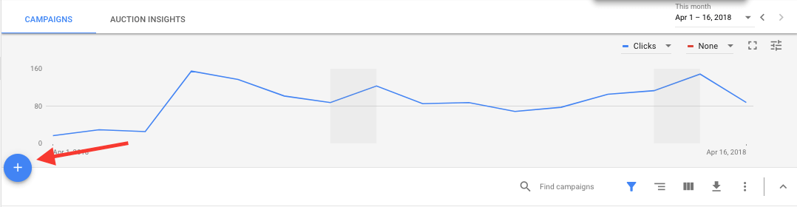
Fig 6.1
1. Select your campaign type and name: First, choose the campaign type—for now, we highly recommend the “Search Network only” option, then give your campaign a name. Also remove the tick next to “Include search partners” for now (you can always change this later).

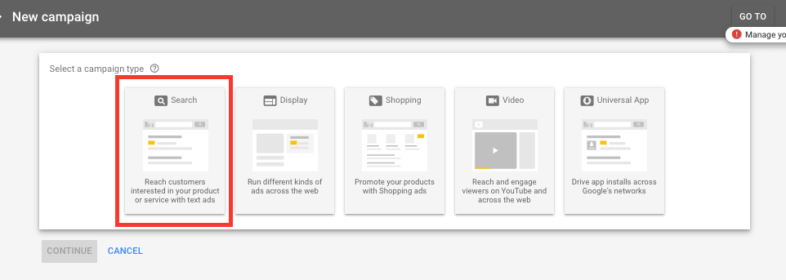
Fig 6.2

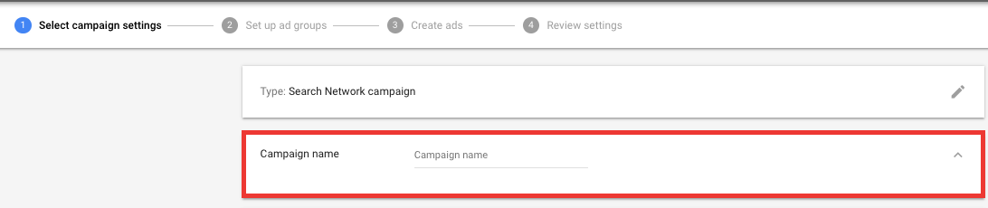
Fig 6.3

2. Choose the geographic location where you’d like ads to show:
Next, decide how large or small a geographic area you want to target. You can choose whole countries, regions of countries, states or provinces, cities. You can also choose custom-designated geographic areas, such as latitude-longitude coordinates or the radius of a set number of miles or kilometers around a specific address. Click “Let me choose ...” and then search for the most appropriate area for you.
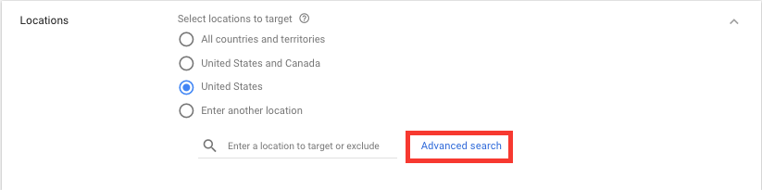

3. Choose your “bid strategy,” and set your daily budget:
Change the default “Bid strategy” to “I’ll manually set my bids for clicks.” This gives you more control and will help you learn AdWords at a greater level of understanding. You can always change to one of the many automatic options later.
Your daily budget is the maximum that Google is authorized to charge you per day. Chances are, you'll hit that maximum most days.
Set your daily budget so that if you screw up big-time, your checking account won’t get emptied out. You can always come back and bump it up, but it’s important to have a safety net.
Standard delivery (recommended) spends your budget evenly over a given day
Accelerated delivery spends your budget as quickly as possible, meaning your budget can be depleted by the end of the day.
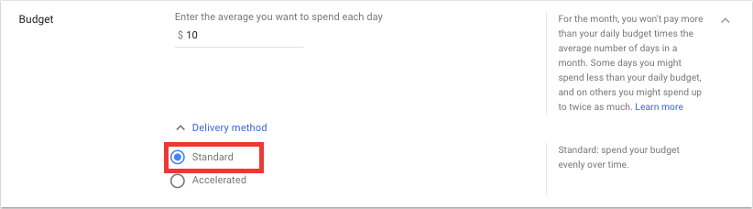
Fig 6.4
Next, set up your bidding. Choose your campaign’s main optimization focus:

Conversions: The action that is being measured by interacting with your ad. For example, a signup, or a purchase.
Conversion value: The financial worth of each conversion
Clicks: Someone clicks on your page.

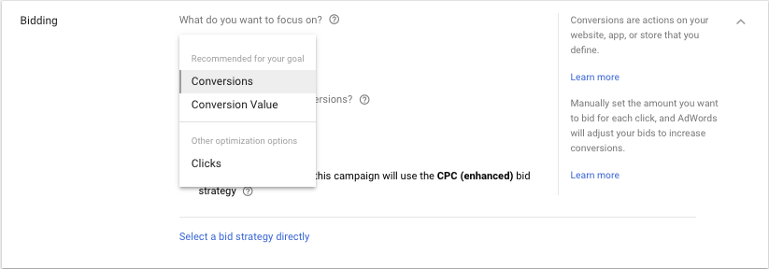
Fig 6.5
Select your bidding strategy. You can either choose to manually set your bids for clicks on your ads or let AdWords do it for you. Your bid strategy controls how you pay for users to interact with your ads.Your bid limit is the most you’ll pay per click for ads in an ad group.The ‘automatically maximize conversion’ options is an automated bid strategy while the manual option provides you the most control over your campaigns.

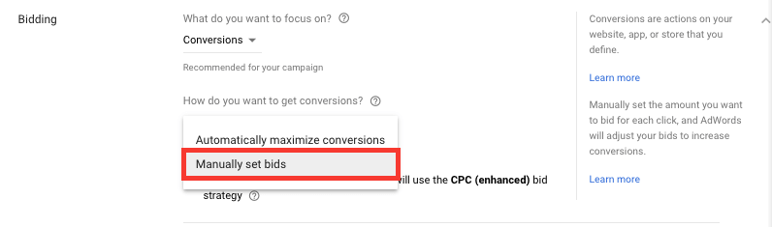
Fig 6.6

4. “Ad Extensions”:
This is an important part of any campaign,
Next, set up ad extensions to improve your quality score and ad performance. Extensions include even more information with your ads, such as location information, links to pages on your website, and your phone number.
- Sitelink Extensions
- Callout Extensions
- Call Extensions

5. Create your first ad group, and write your first ad:

More people click on ads when the headline includes the keyword they’re searching on. So use your keywords in your headline when you can. You’re limited to 25 characters here, so for some search terms, you’ll need to use abbreviations or shorter synonyms.
The last line is your actual destination URL, or your specific chosen landing page. You can also use a tracking link here.
Here’s the short version of your ad template:
Headline: up to 30 characters of text
2nd line: up to 30 characters
3rd line: up to 30 characters
4th line: your Display URL

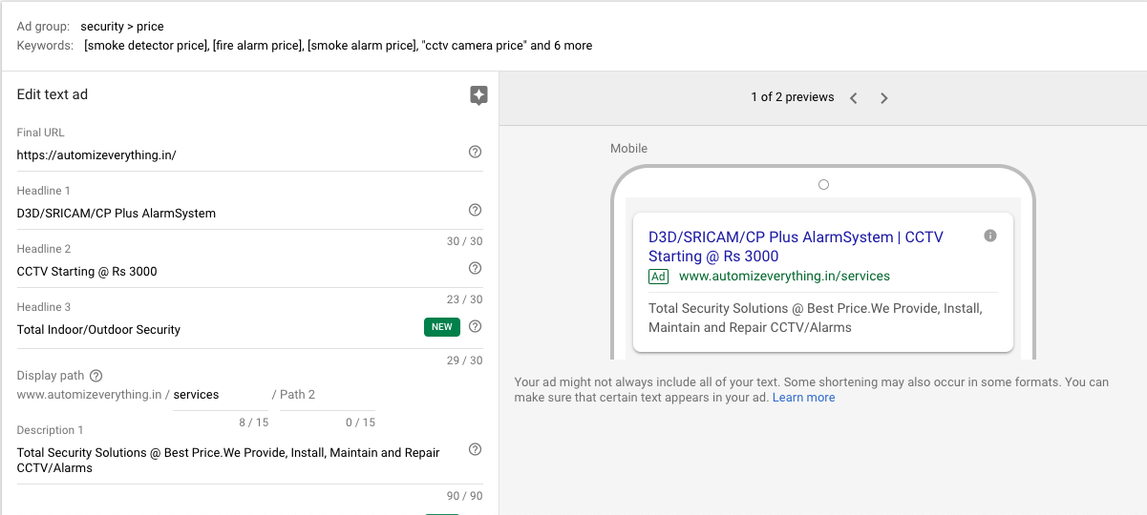
Fig 6.7

6. Insert your keywords into the keyword field in your account:
Paste in your keywords. Start with just one set, and add plus signs (+), brackets ([ ]), and quotes (“ “) to see precisely how many searches of each type you’ll get. When you’re getting started, it’s not a good idea to dump hundreds or thousands of keywords in. Start with a tiny handful of important ones, and work from there.

7. Set your maximum cost-per-click. Set your maximum price-per-click now (called your “default bid”), but realize this: Every keyword is theoretically a different market, which means that each of your major keywords will need a bid price of its own. Google will let you set individual bids for each keyword later.

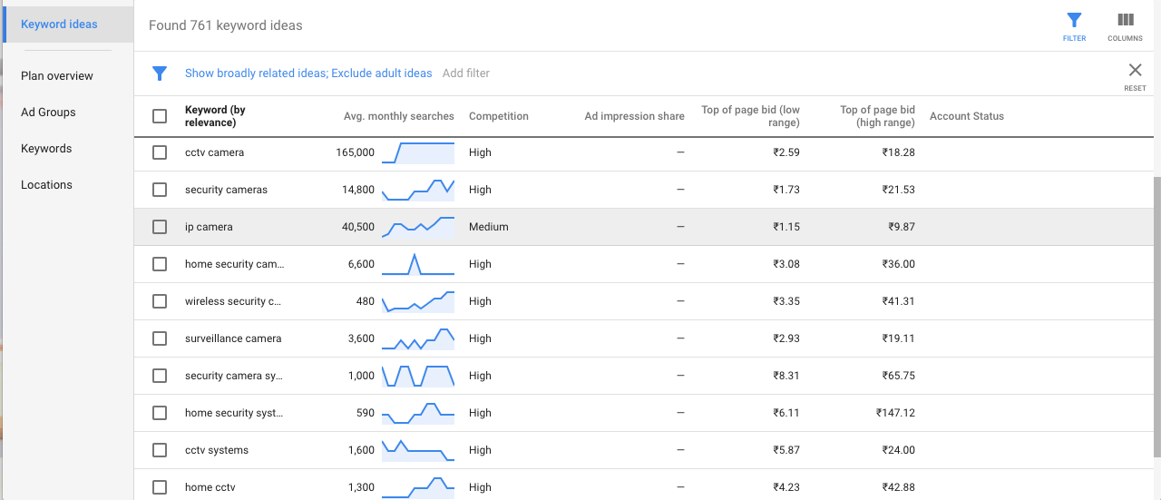
Fig 6.8

8. Review everything:
Double-check your ad and keywords to be sure they’re the best possible match. Check your cost-per-click to be sure you get the positions on the page you want. Double check your daily budget to be sure you don’t unwittingly drain your bank account right out of the gate.

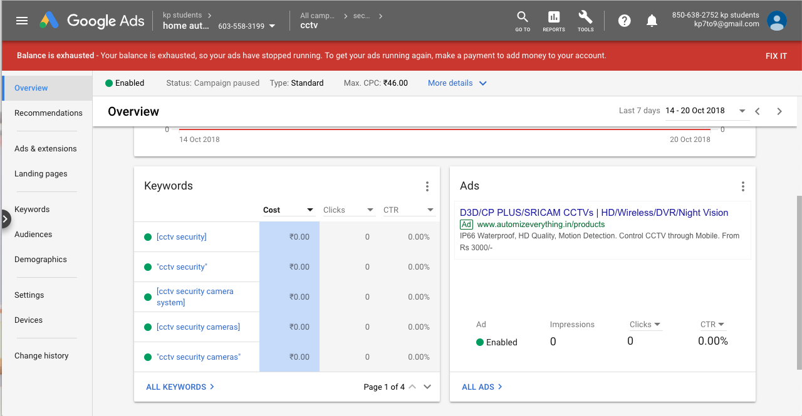
Fig 6.9

9. Enter your billing information:
Your ads will start showing as soon as you confirm your payment information. Now you’re set.

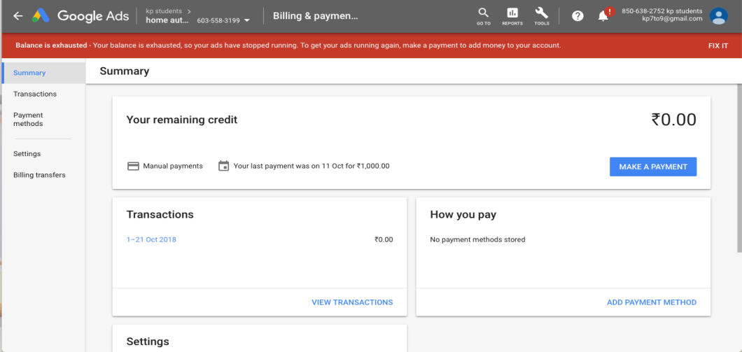
Fig 6.10

Things that should be take care of during creating campaign:

1. Have a clear goal.
2. Keep target customer in mind while writing ads.
3.Don’t mislead customers
4. Use negative key words.
5. Do Some Math to Compare Your Costs with Your Budget.
6. Create compelling Landing page.
7. Track your conversion
8.Optimize campaigns.

Limitations:

1. Competitive industries have higher cost per clicks.
2. If you have no budget, your ads will stop.
3.Adverts have limitations.
4. Regular tracking is very necessary.
5. Keep keywords upto date as at starting campaign you don’t get a exact clear picture of all relevant keywords, that results in unnecessary clicks and expenditure.

7. Research Methodology

Research Design : One Shot Case Study .

The basic objective of the project is to learn and understand so campaigns were implemented and outcome was observed.

Research methodology : Definition:

One-shot case studies is the design where, One group is exposed to the treatment, and only a posttest is given to observe or measure the effect of the treatment on the dependent variable within the experimental group. In this arrangement, subjects are presented with some type of treatment, such as a semester of college work experience, and then the outcome measure is applied, such as college grades. Like all experimental designs, the goal is to determine if the treatment had any effect on the outcome.

One Shot Case Study To attempt to explain a consequence by an antecedent.
X O
As cited above, the chosen group is exposed to the treatment, and then it is tested only once fo r the purpose of measuring the degree of change on the dependent variable after the treatment. For the present study the design is applicable as follows:

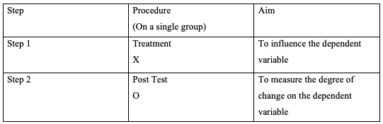

Campaign where made for:
Automizeverything - home automation company.

Duration of the campaign:
The campaign was run for 5 days.

Limitations :

1. If proper bidding is not set then campaign might end up with unnecessary spending of money.
2. Keywords selection should be very narrow so as to avoid unnecessary clicks and spending of money.
3. A campaing need to run at first in order to get analytics data, which will further help to make necessary changes in campaign.

8. Data Analysis and Interpretation:

STARTING OF CAMPAIGN
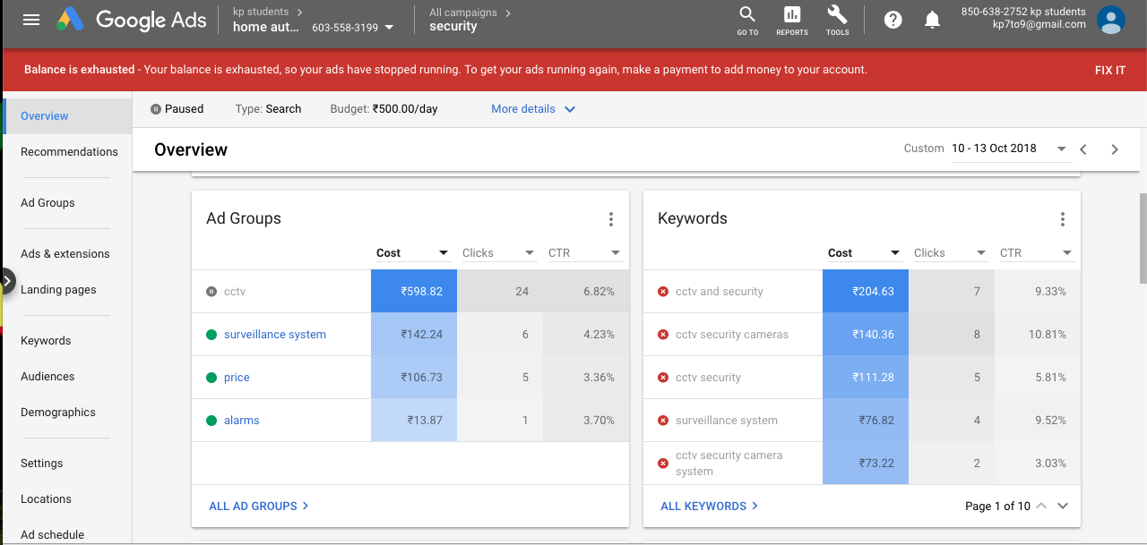
Fig 8.1 Overview of Campaign
Iterpretation:
4 ad groups were made for home automation service, i.e cctv, surveillance system, price, alarm. The amount spend for each ad group is Rs598, Rs 142, Rs106, Rs 13 respectively. With CTR of 6.82%, 4.23%, 3.36%, 3.70% respectively.

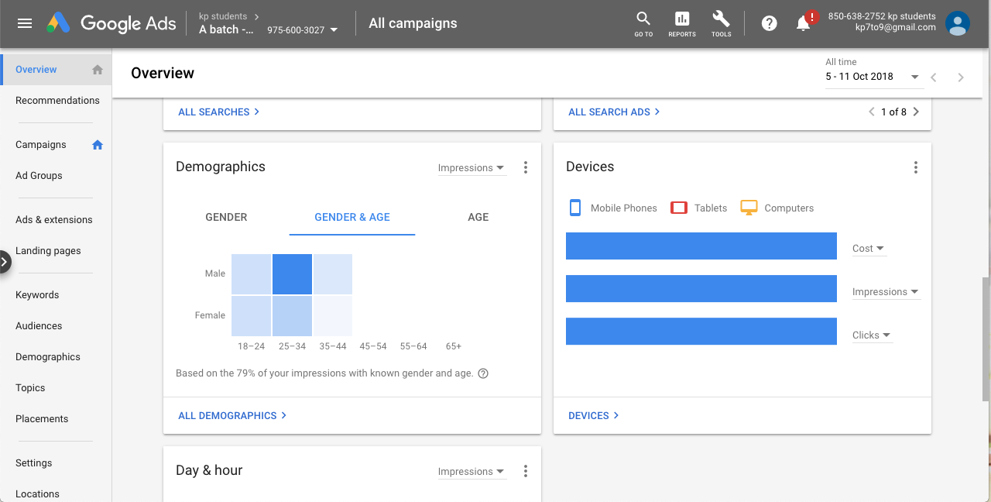
Fig 8.2 Demographic & Device

Interpretation:
Its is found that high no of people from age group between 25-34 are usually searching for home automation service.

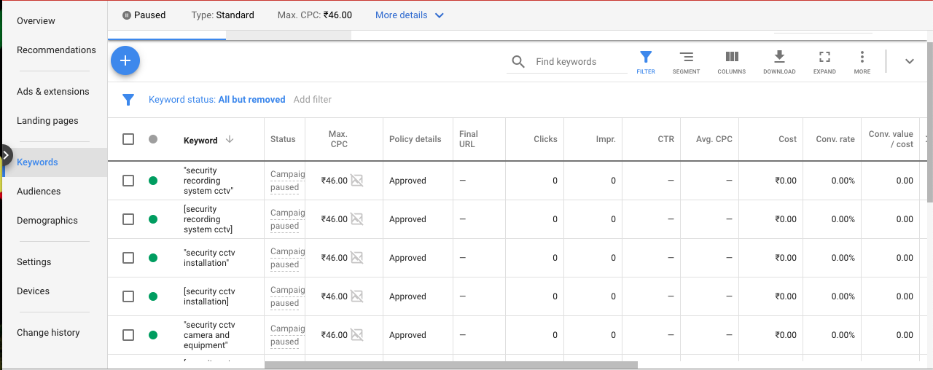
Fig 8.3 Keywords
Interpretation:
This are the keywords used for cctv ad group with max CPC of Rs46.

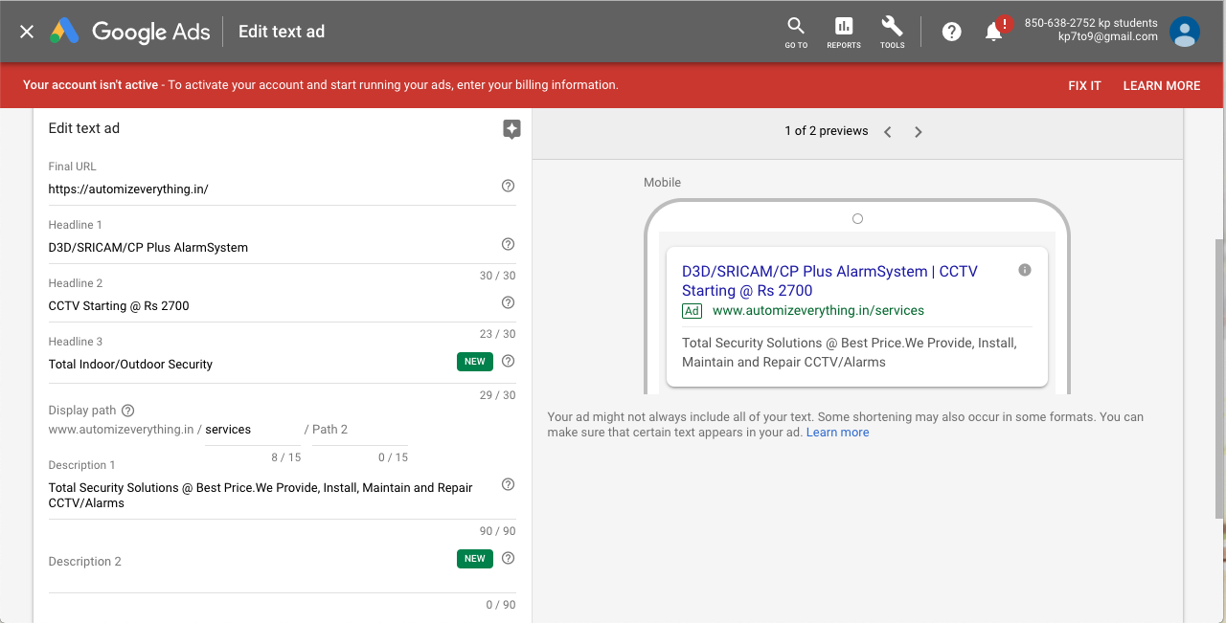
Fig 8.5 Making a Adcopy
Interpretation:
The following details were put for making a ad copy for cctv ad group.

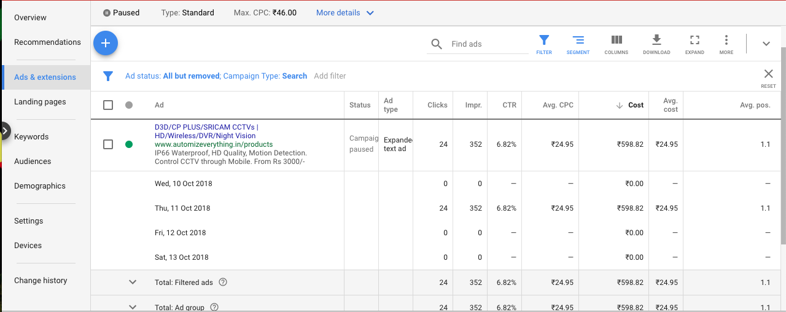

Fig 8.4 Adcopy
Interpretation:
The results for cctv ad copy with good CTR of 6.82% which is far better. With 24 clicks, 352 impression, with avg position 1.1.

End Results(after campaign going live)

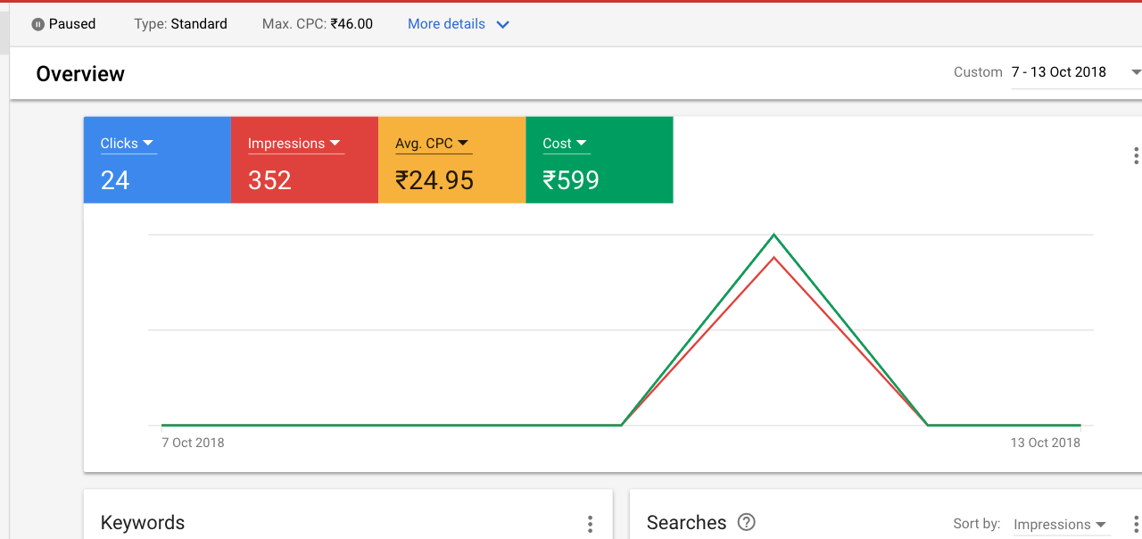
Fig 8.6 Results

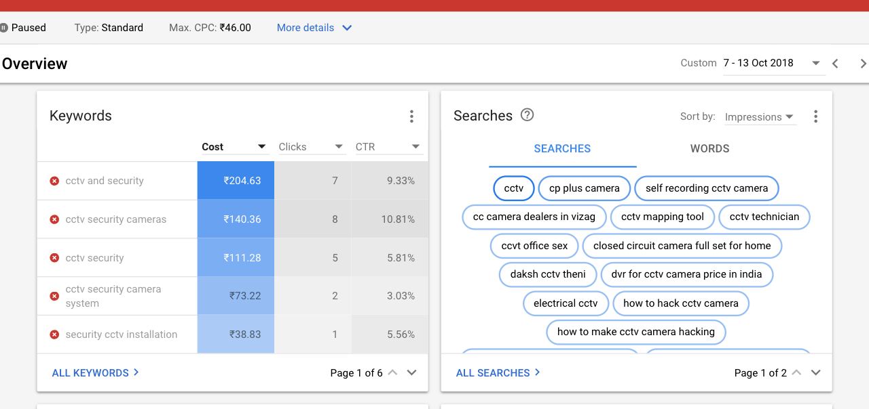
Fig 8.7 Searched keywords.
Interpretation:
This are the keywords that were searched by the people for there inquiry and landed on the webpage with this campaign.

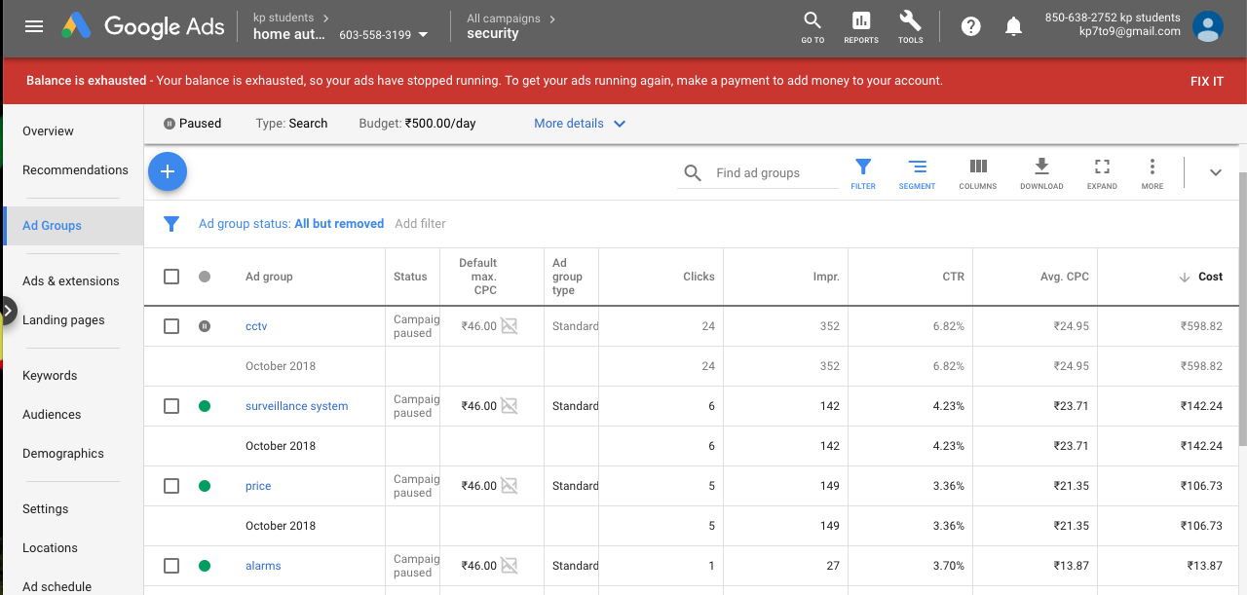

Fig 8.8 Analytics

Analytics for other campaigns:

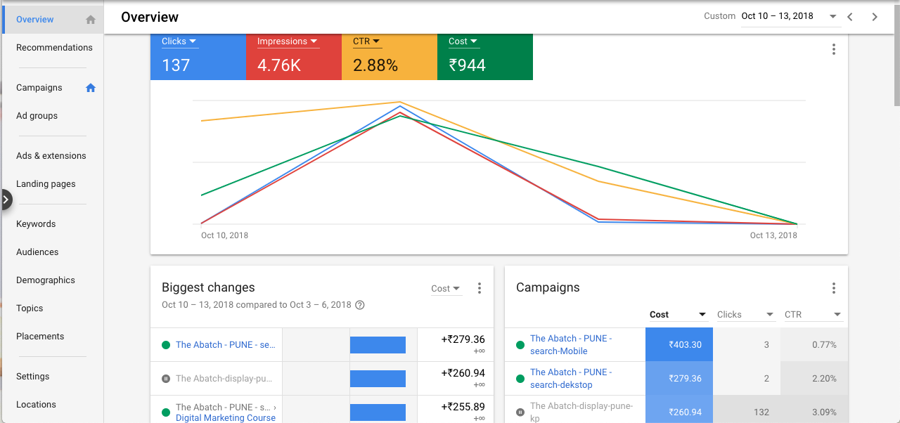
Fig 8.9 Result for “A Batch campaign”
Interpretation:
The Abatch have a impression of 4.76K with CTR of 2.88% and total cost for campaign for 5days was Rs944.

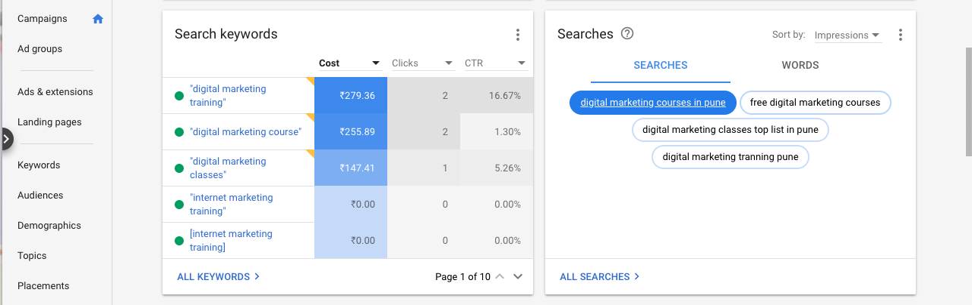
Fig 8.10 keywords for A-batch
Interpretation:
These are the keywords used for this campaign and in search box are the keywords that were searched. Here “digital marketing traning” keywords have a highest CTR of 16.67%.

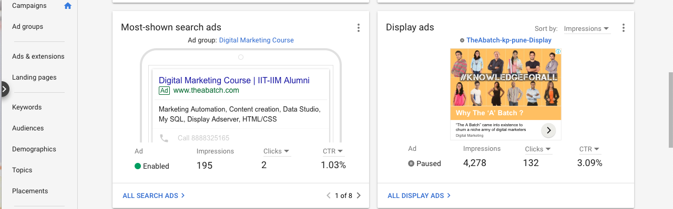

Fig 8.11 Adcopy and display ads.

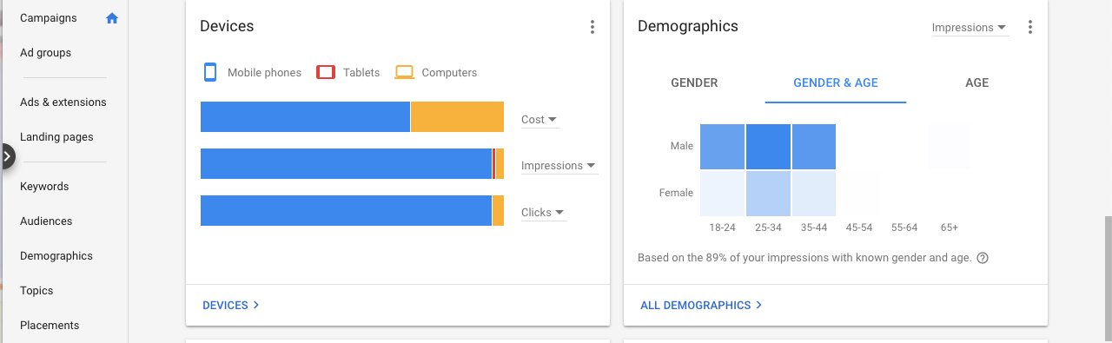

Fig 8.12 Device and Demographic

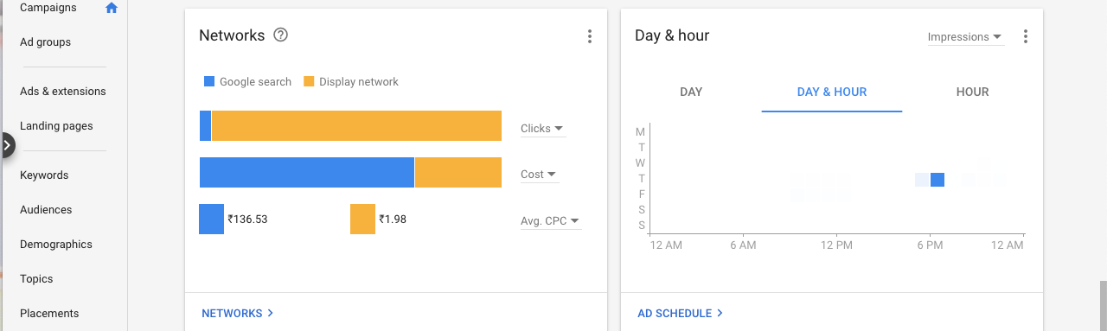

Fig 8.13 Network and hour.

9. LEARNINGS:p

- Get to know about challenges and opportunities for digital marketing in India.
Gain basic understanding of SEO, SEM, SMM, etc
- Always keep tracking the ad copy and keywords as negative ad copy and keywords results in unnecessary expense and false result.
- The common mistake that using wrong keyword match type that leads to wrong search and unnecessary clicks.
- Having a good ad copy and keywords attract more potential customers..
- Calculating the daily and monthly budget is very important.
- Targeting the right customer is high priority.

Mistake made during the campaign:

1. Failed to use proper match type while selecting keywords, the results in unnecessary clicks and spending of money.

10. CONCLUSION

The successful completion of this internship indicates that the future of marketing is in the hands of digital. Digital marketing is not only concerned with placing ads in portals, it consists of integrated services and integrated channels. Marketers want to use these components in an effective way to reach target groups and to build a brand. In this digital era marketer is not the custodian for a brand, people who are connected across the digital platforms are the custodians.
Brands want to build their presence over digital platform, because customers have high affinity towards digital media than other media’s. More than that customers are highly information seekers and digital media is the only platform for two way communication between brands and customers.
Google AdWords is an effective program that helps marketers and business owners to reach theircustomers through websites. It is effective and shows results within just a few hours of launching. Google AdWords is affordable and may be used by any business, regardless of their budget. The perception that Google AdWords is difficult to use is not always true. On the contrary, Google Ad Words is easy to use for all types of businesses. Any marketer or business owner looking to increase their Internet presence should adopt the use of Google AdWords.

On campaign I have worked on have a good CTR that is 6.83% (min 1% is also considered as good CTR) with average CPC of Rs 24.95 with average position of ad is 1.1 which clearly indicate that the add was on top ranking ie the 1st page of google. This is achieved by the ad copy and keywords have a good quality score that leads to good campaign but I do failed in conversion the client due to lack of budget and less time.

I conclude my research by quoting again that “BRAND CAN SUSTAIN MORE IN DIGITAL PRESENCEAND GOOGLE ADWORDS HELP THEM TO REACH THERE TARGET CUSTOMER EASILY”.

11. BIBLIOGRAPHY:

www.crystalwebtechs.com

- RICHARD,F.T.,1996.A Definition of Advertising.[online] Available from:http://public.wsu.edu/~taflinge/addefine.html[Accessed 9 April2014]

- MSG,2003. Advertising Agencies Meaning, its Role and Types of Agencies. [online] Available from:http://managementstudyguide.com/advertising-agencies.htm[Accessed 9 April2014]

- WIKIPEIDA,2017.Digital Marketing.[online] Available from:http://en.wikipedia.org/wiki/Digital_marketing[Accessed 9 April2014]

- FICCI-KPMG industry report, 2014. The stage is set. [online] Available from:http://www.ficci.com/spdocument/20372/FICCI-Frames-2014-KPMG-Report-Summary.pdf[Accessed 10 April2014]

- MEDIANAMA NEWS & ANALSIS OF DIGITAL MEDIA IN INDIA, 2014. GroupM Says Digital Advertising In India Up 30% In 2013; Rs 3402 Cr Expected In 2014. [online] Available From:http://www.medianama.com/2014/02/223-groupm-says-digital-advertising-in-india-30-in-2013-rs- 3402-cr-expected-in-2014/[Accessed 10 April2014]

