SEA WATER PURIFICATION USING SOLAR ENERGY

A PROJECT REPORT

Submitted by

Sr. No. | Name | Enrolment Number
1. | MEMARIYA SANDIP J. | 140430119064
2. | MORI MAULIK K. | 140430119068
3. | PATEL JAYDEEP B. | 140430119082
4. | SOLANKI MAHENDRA B. | 140430119108

In fulfillment for the award of the degree
of

BACHELOR OF ENGINEERING
In

MECHANICAL ENGINEERING

SHANTILAL SHAH ENGINEERING COLLEGE, BHAVNAGAR

Gujarat Technological University, Ahmedabad
2017-18
SHANTILAL SHAH ENGINEERING COLLEGE, BHAVNAGAR

MECHANICAL DEPARTMENT
CERTIFICATE

Date: / /2017

This is to certify that the dissertation and entitled “Sea Water Purification Using Solar Energy” has been carried out by MEMARIYA SANDIP J. (140430119064) under my guidance in partial fulfillment for the degree of Bachelor of Engineering in Mechanical engineering 7th semester of Gujarat Technological University, Ahmedabad during the academic year 2017-2018.

Guided by: - HEAD OF THE DEPARTMENT
PROF. H.S.PATEL PROF. A.V.GOHIL

SHANTILAL SHAH ENGINEERING COLLEGE, BHAVNAGAR

MECHANICAL DEPARTMENT
CERTIFICATE

Date: / /2017
This is to certify that the dissertation and entitled “Sea Water Purification Using Solar Energy” has been carried out by MORI MAULIK K. (140430119068) under my guidance in partial fulfillment for the degree of Bachelor of Engineering in Mechanical engineering 7th semester of Gujarat Technological University, Ahmedabad during the academic year 2017-2018.

Guided by: - HEAD OF THE DEPARTMENT
PROF. H.S.PATEL PROF. A.V.GOHIL
SHANTILAL SHAH ENGINEERING COLLEGE, BHAVNAGAR

MECHANICAL DEPARTMENT
CERTIFICATE

Date: / /2017
This is to certify that the dissertation and entitled “Sea Water Purification Using Solar Energy” has been carried out by PATEL JAYDEEP B. (140430119082) under my guidance in partial fulfillment for the degree of Bachelor of Engineering in Mechanical engineering 7th semester of Gujarat Technological University, Ahmedabad during the academic year 2017-2018.

Guided by: - HEAD OF THE DEPARTMENT
PROF. H.S.PATEL PROF. A.V.GOHIL

SHANTILAL SHAH ENGINEERING COLLEGE, BHAVNAGAR

MECHANICAL DEPARTMENT
CERTIFICATE

Date: / /2017
This is to certify that the dissertation and entitled “Sea Water Purification Using Solar Energy” has been carried out by SOLANKI MAHENDRA B. (140430119108) under my guidance in partial fulfillment for the degree of Bachelor of Engineering in Mechanical engineering 7th semester of Gujarat Technological University, Ahmedabad during the academic year 2017-2018.

Guided by: - HEAD OF THE DEPARTMENT
PROF. H.S.PATEL PROF. A.V.GOHIL

ACKNOWLEDEGMENT
It is to honor and pleasure to express our heartfelt gratitude to those who helped us and also contributed towards the preparation on this project. We express our deep sense of gratitude to our respected guide Prof. Harshit S. Patel for his valuable help and guidance. We are thankful to them for the encouragement they have given us in completing this project. We are also grateful to our respected HOD Prof. A.V. Gohil for permitting us to utilize all the necessary facilities of the institute. We are also thankful to all other faculties and staff members of our department for their kind co-operation and help.
We also express our thanks to the Library of Shantilal Shah engineering college Campus, which is a source of such invaluable information and of course the computer laboratory facility of the same.

THANK YOU,
MEMARIYA SANDIP
MORI MAUKIK
PATEL JAYDEEP
SOLANKI MAHENDRA

ABSTRACT

The lack of clean drinking water is a problem that plagues many areas of the world today. Most of the current technologies available to combat this problem are expensive and consume too much power to be effective in rural areas of the planet. With the idea of low cost and sustainability in mind, we plan to develop a water filtration system that take advantage of natural energy in order to power a water purification system. In India we all know very well the problem of drinking shortage of water. This is the worldwide question. after some research we knew that this problem can be solved by using several arrangements and modification. In our project we are going to introduce automatic steam generation using solar energy only, although tidal energy of sea and environment is also playing major role.

LIST OF FIGURES

Fig 1.4.1 | Plan of work
Fig 1.4.2 | Storage tank
Fig 1.4.3 | Condenser
Fig 2.2.1 | AEIOU Canvas Sheet
Fig 2.2.2 | Ideation Canvas Sheet
Fig 2.2.3 | Empathy Canvas Sheet
Fig 2.2.4 | Product Development Sheet
Fig 3.1.1 | Free Body Diagram of Project
Fig 3.3.1 | Worldwide Fresh Water Demand
Fig 3.3.2 | Water Available or Used by Source in World Bank 2007
Fig 3.3.3 | Counties using Solar Energy

Index
 | Page Number
Title | 1
Certificate | 2
Acknowledgement | 6
List of Figures | 7
Abstract | 8
CHAPTER – 1 INTRODUCTION | 10
1.1 Problem Summary | 10
1.2 Purpose | 10
1.3 Literature Review | 11
1.4 Plan of the Work | 11
1.5 Materials / Tools Required | 13
CHAPTER – 2 DESIGN | 14
2.1 Design Methodology | 14
2.2 Design Engineering Canvas Activities | 14
2.2.1 AEIOU Summary Canvas Sheet | 14
2.2.2 Ideation Canvas Sheet | 16
2.2.3 Empathy Mapping Canvas Sheet | 17
2.2.4 Product Development Canvas Sheet | 19
2.3 Implementation Strategy | 21
CHAPTER – 3 IMPLEMETATIONS | 22
3.1 Actual Implementations | 22
3.2 Results | 23
3.3 Diagrams / Screenshots | 23
CHAPTER – 4 SUMMARY | 26
4.1 Advantages | 26
4.2 Scope of Future Work | 26
4.3 Limitations | 26
4.4 Unique Features | 27
4.5 Conclusions | 27
CHAPTER – 5 REFERANCES | 28

CHAPTER 1: INTRODUCTION

  - PROBLEM SUMMARY

- Our project is based on producing pure water but it is quite time consuming and slow steam generation.
- The environment is also factor which effect productivity of steam in cloudy environment.
- The efficiency is low.
- Here external power source is not used and it is totally working on sea wave energy so the effect of tide effects a lot.

- PROJECT DETAIL

- The project can be installed at nearer to flowing water or at sea shore.
- Project is totally conventional energy based so electricity is not required.

  - PURPOSE

- Was we know that the earth contains 70% water but we can use only 20% water in drinking in many countries like south Africa, south America etc. have shortage of water although they have maximum number of sea . So ,in our project we are trying to provide maximum amount of fresh water to every place.
- The project can be also used for generating steam and generating power by using boiler.
- For SMSAA industry or governmental institute can build number of project and use it for electricity generation.

  - LITERATURE REVIEW

- For our project we have studied various books and research papers .
- We also studied patents related to our project.
- Various web search helped to find specific queries related to our project.
- We used websites like
www.quora.com
www.youtube.comoogle
www.google.com
www.google.com/googlepatent

1.4 PLAN OF WORK

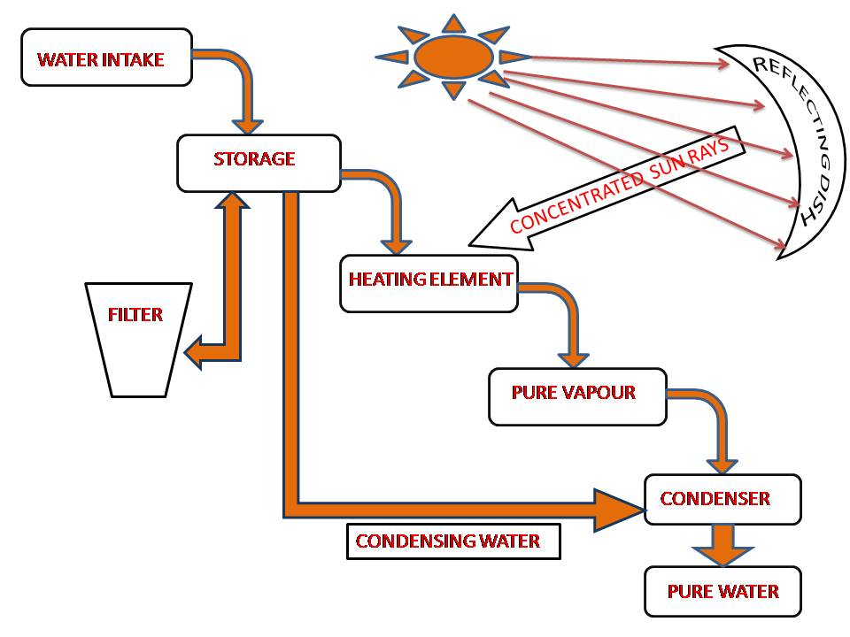

Fig 1.4.1 Plan of Work
As you can see in flow diagram the water is simply circulated through out system. various components are use in design of the project are described below

1. Storage tank :-
Storage tank is use for collect the seawater from the sea. This storage tank is flow the sea water into the heating element (evaporator) where the sea water is heated. Also sea water into the storage tank is use for condensing process. So that the storage tank is used for the both type like evaporating and condensing process.

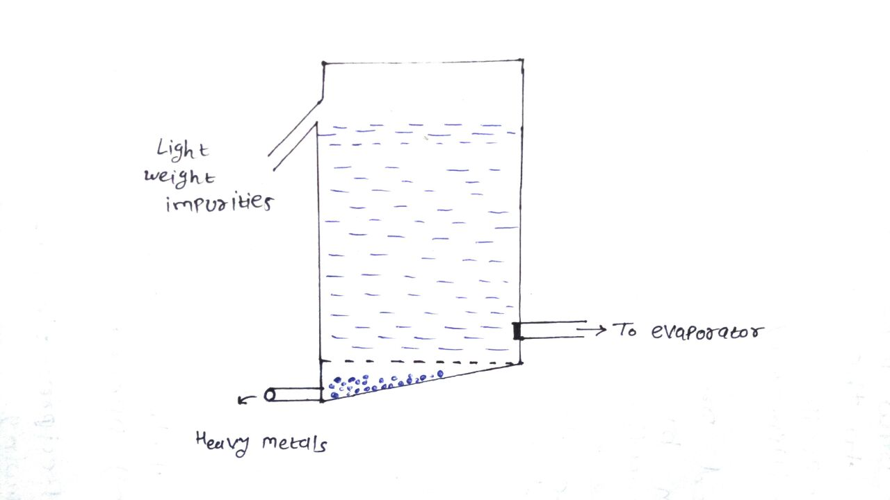
Fig 1.4.2 Storage Tank

2. Flow control valve :-
Flow control valve is use for controlling the flow seawater from storage tank. It is necessary to controlling the flow due to either over heating or during low heating.
3. Magnifier lens or mirror :-
The magnifier lens is use for focusing the Sun beam to the heating element where we heat the sea water. Main aim of the magnifier lens is to only use for heating.
4. Heating element ( Evaporator ) :-
The heating element ( Evaporator ) is used for evaporating process. The sea water from the storage tank is enter into the evaporator and after this sea water is heated by the Sun beam and the pure steam is produce. After this steam is entre into the condenser .
5. Condenser :-
A condenser is a device which is used for condensing vapor. In the condenser steam is enter from evaporator. Here the steam is condensed by the sea water which is also taken from storage tank, after this condensing process pure water is collect.
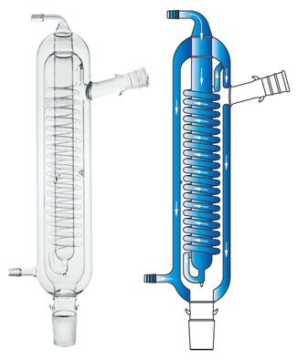
Fig 1.4.3 Condenser
6. Pipeline :-
Pipeline is main part of this system the whole system is run by the sea water.

1.5 MATERIALS TOOLS REQUIRED

- The various metallic components and non metallic component shown below.
Evaporator:-iron+ tungsten | Condenser:- thermo plastic
Storage tank:-stainless steel | Water Intake:- simple pipe

CHAPTER 2: DESIGN

2.1: DESIGN METHODOLOGY

- Form our project the first difficult question of selecting right tool and material as per its boiling point.
- For working model the continuous flow of water is basic requirement for proper working of project.
- After this removal of impurities is important because it direct effects nozzle supplying water to heating element.
- In our project dimensioning of reflecting disc was a big issue. the dimension of placement and arranging according to sun was difficult..
- After receiving filtered water the evaporator installment was important because it needs to be in centre of focus point.
- The condensation was not so difficult .although it consist several dimensioning for better condensing. Thus a battery bank is selected accordingly to store the energy generated.

2.2 DESIGN ENGINEERING CANVAS ACTIVITY

2.2.1 AEIOU Summary
- Environment :-

- Pollution free
- Cloudy environment
- No energy consumes
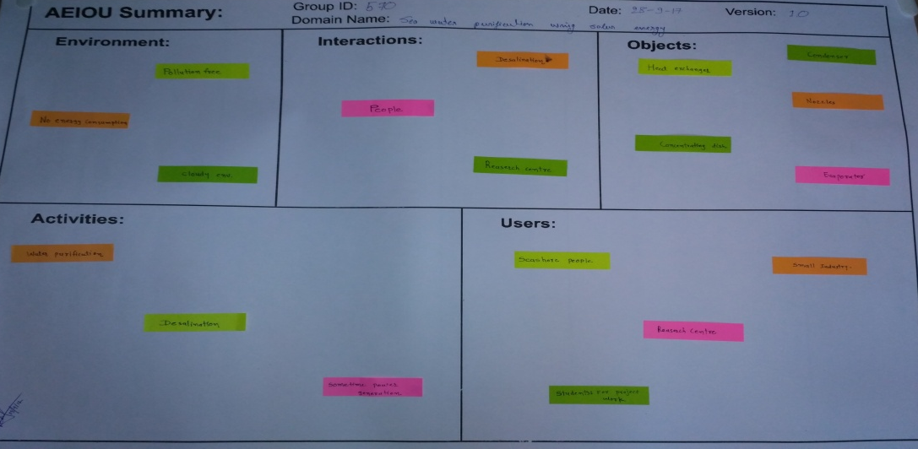
Fig 2.2.1 AEIOU Canvas Sheet
- Interactions :-
- People
- Research centre
- Small business

- Objects :-

- Heat exchanger
- Heating element
- Condenser
- Storage tank
- Nozzle

- Activities :-

- Desalination
- Water purification
- Steam generation
- Power generation

- Users :-
- Public
- Government authority
- Research centre

2.2.2 Ideation canvas
- People :-
- Researchers
- Students
- Small company
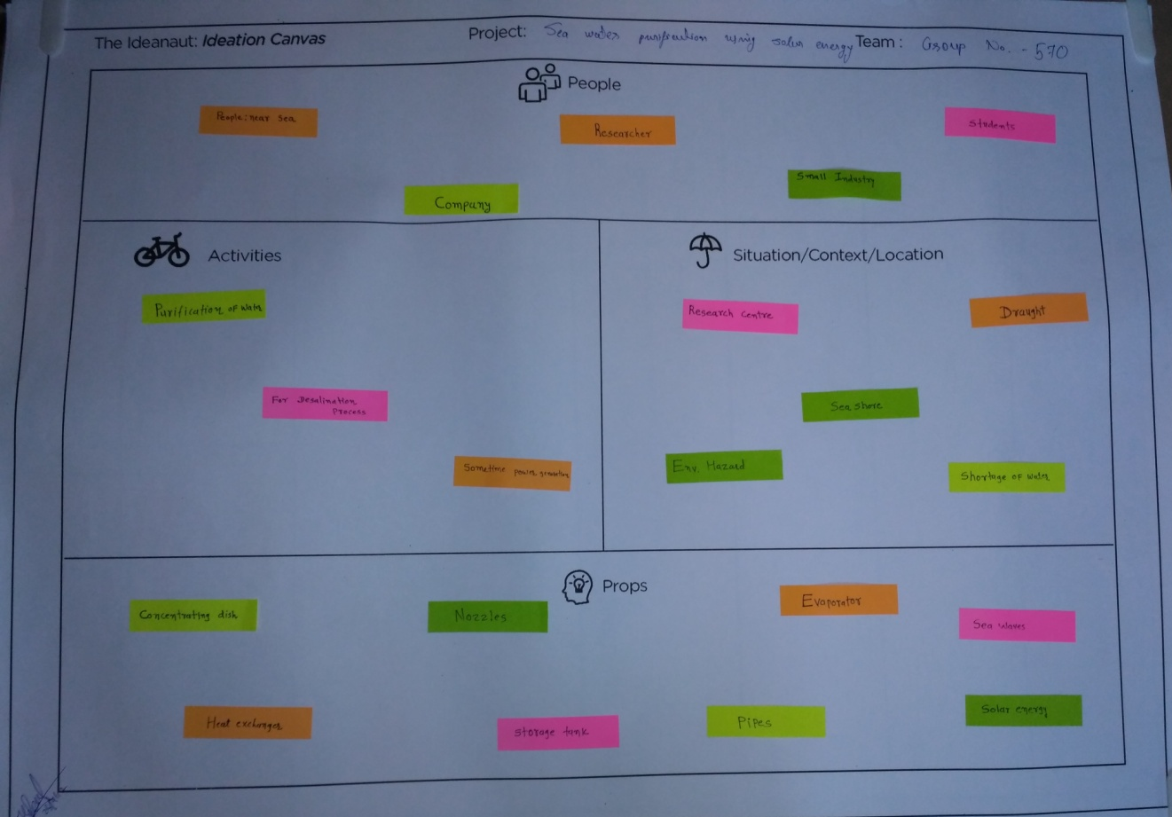

Fig 2.2.2 Ideation Canvas Sheet

- Activities :-

- Water purification
- Steam generation
- Power generation

- Situations / Context / Location :-

- Draught
- Research centre
- Sea shore area
- Shortage of water

- Props / Possible solution :-

- Evaporator
- Condenser
- Storage tank
- Nozzles
- Reflecting mirror

2.2.3 Empathy mapping canvas
- User :-
- Sea shore people
- Small industries
- Government

- Stakeholders :-
- People near to sea
- Research institutes

- Activities :-

- Water purification
- Desalination process
- Steam generation

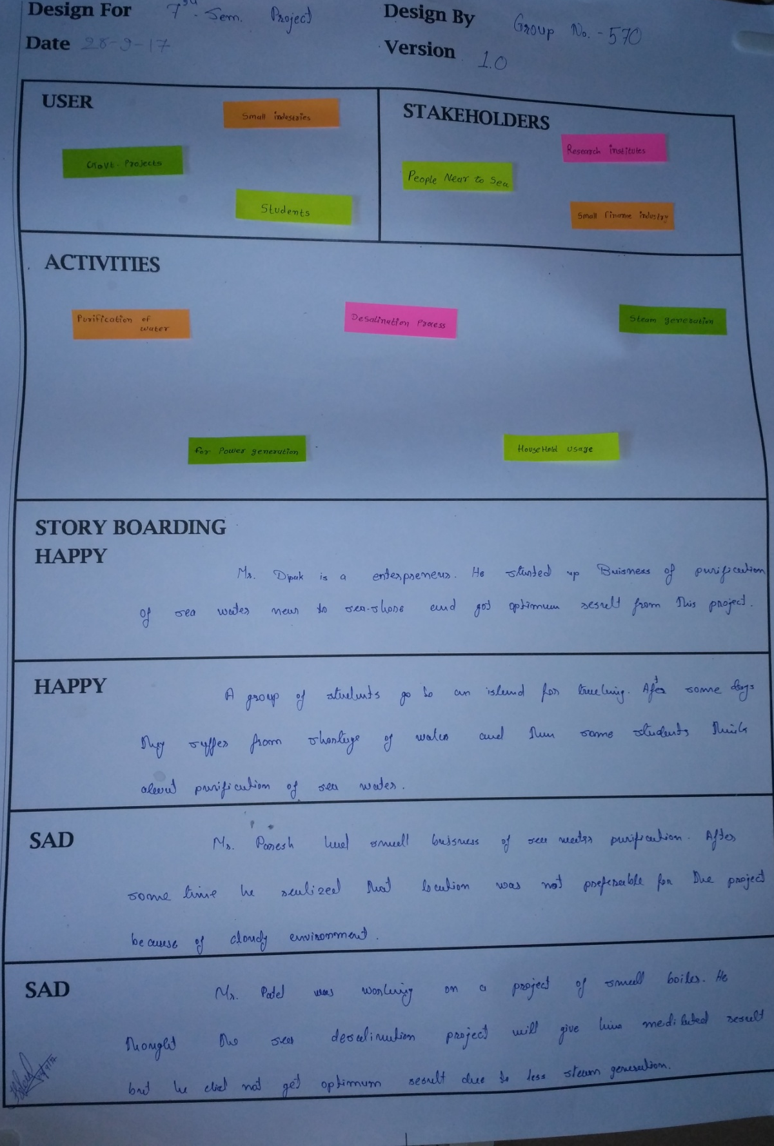
Fig 2.2.3 Empathy Mapping Canvas Sheet

2.2.4 Product development canvas

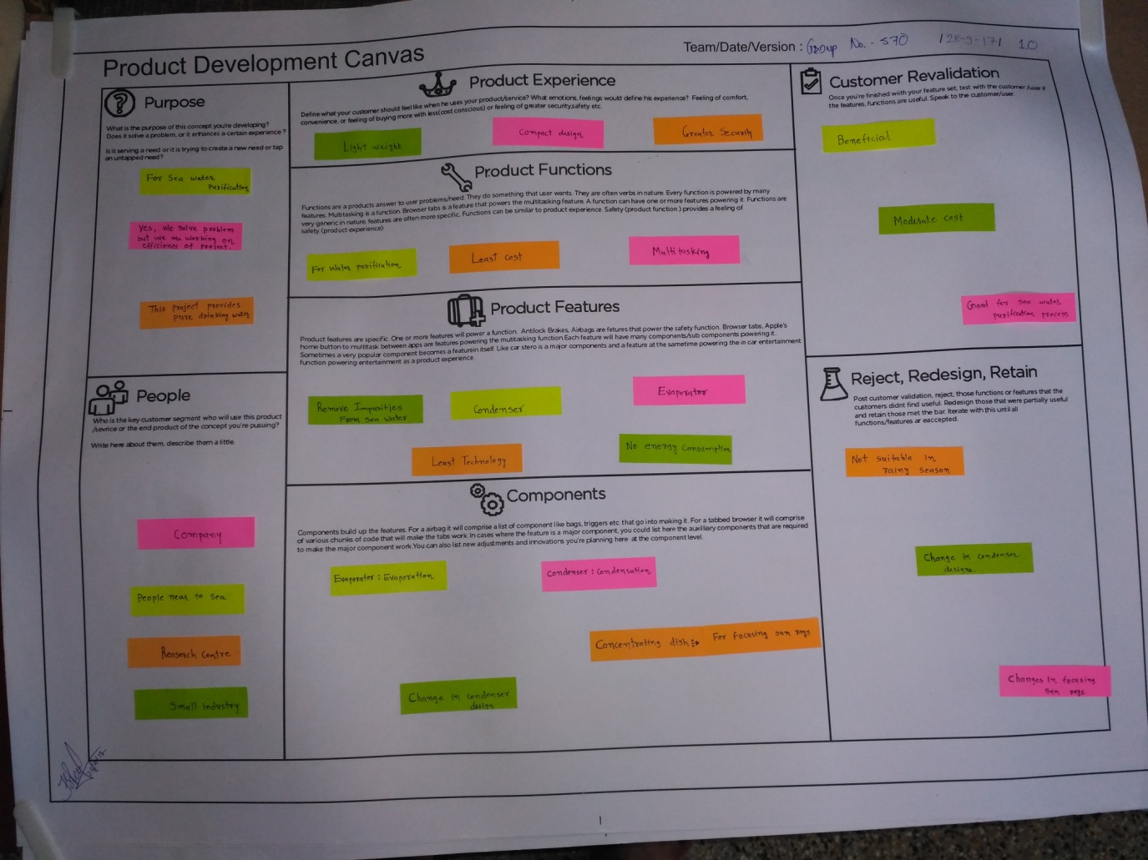
Fig 2.2.4 Product Development Canvas Sheet

- Purpose :-
- For sea water purification
- This project provides pure drinking water

- Product Experience :-
- Light weight
- Compact design

- Product Functions :-
- Least cost
- Multi tasking

- Product Features :-
- Remove impurities from sea water
- Condenser
- No energy consumption
- Evaporator

- Components :-
- Concentrating dish for focusing sun rays
- Evaporator
- Condenser

- People :-
- Company
- People near to sea
- Small industry
- Customer Revalidation :-
- Beneficial
- Moderate cost
- Good for sea water purification process

- Reject, Redesign, Retain :-
- Not suitable in rainy season
- Change in condenser design
- Changes in focusing rays

2.3 IMPLEMENTATION STRATEGY

- For implementation we tried various designs of water intake element. We tried many supplying techniques of water .i.e. nozzles, pipes tabular nozzle etc.
- We have designed storage tank for better filtration and removal of heavy and light weight impurities.
- For heating element we discussed to our guide and know that the stainless steel is best for this ,because of its heat resistance capacity and non corrosion property.
- We were confused in deciding using mirror and lens, at least after researching we know that reflecting mirror is better because of its cheaper cost and it has good tool life.

CHAPTER 3: IMPLEMENTATIONS
3.1 Actual Implementation :-
For this project we have redesign several components and arrangement of particular element as follows.
We are design the condenser, which can be used in condensation and used as heat exchanger. as shown in fig 1.4.1. As we can see that the spiral inside nozzle used for condensate the steam and outer space is used for heat ex changing. cold water is going to flow in outer nozzle by tidal effect.
We have designed storage tank as shown in fig 1.4.2. This design helps in removing heavy an light weight impurities .the bottom part is made tapper for sliding of stones and other impurities .the nozzle upside regulates amount of water in storage tank.
We can arrange whole piping system as shown in fig.3.1.1

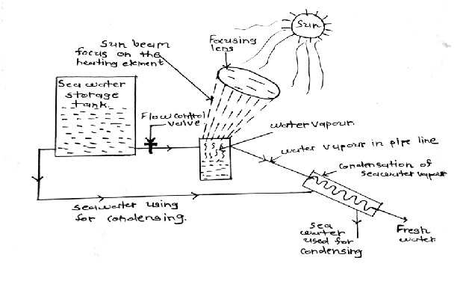
Fig 3.1.1 Free Body Diagram of Project

3.2 Results
- The project will produce steam, after condensing it can be used for drinking.the produced steam I can be used in power generation and electricity generation as per requirement.
- The water intake is made from hard thermoplastic and connected to transmitting nozzle which is simple flexible material.
- The storage tank is made from stainless steel, because we have to deal with corrosion and heat. for both conditions stainless steel is useful and it is easily available in market.
- The evaporator or heating element is made from stainless steel with Tungsten .tungsten is for high resistance against heat.
- Then condenser, it is made from high accurate glass which used in laboratories for experiments. the arrangement is made which can help in condensing and it will help as heat exchanger.
- The whole system is dependent in environment. Hazards like storm, tornado, rain, cloudy sky effects can effect on project.

3.3 DIAGRAMS/SCREENSHOTS
- First of all we have researched about water shortage in all over word . we collected some data regarding to the situation is shown below :

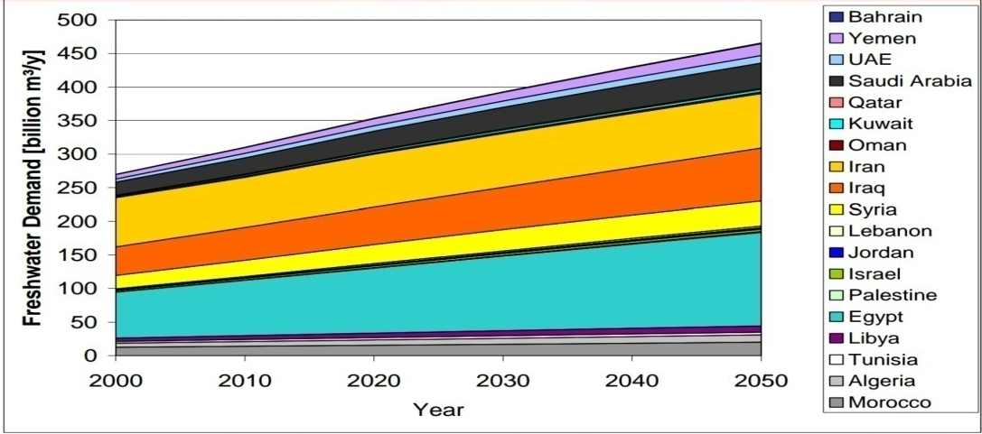
Fig. 3.3.1 worldwide fresh water demand
- As we can see in graph countries consume more and more demand of fresh water as per year passes.
- This graph shows just several countries situation as an assumption, researcher believes that this will increase in future.
- Now, we have another on table which shows demand of different water demand according to countries in fig 3.3.2.
- Here the graph is showing internal renewable water, external renewable water resources, virtual water etc.

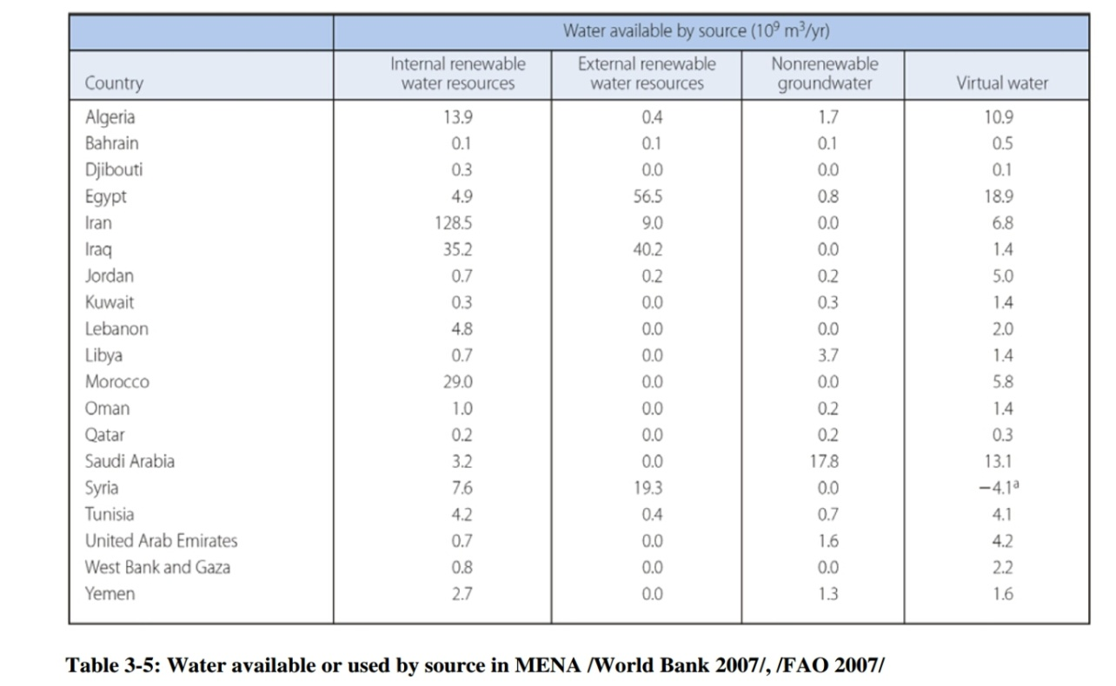

Fig 3.3.2 water available or used by source in world bank 2007

- After this we move to solar energy availability and usage by various countries.
- All over world people understood that solar energy is best that’s why solar equipments are developing and growing next renewable resources.
- Numbers of research centers are available scientists are searching for next renewable resources.
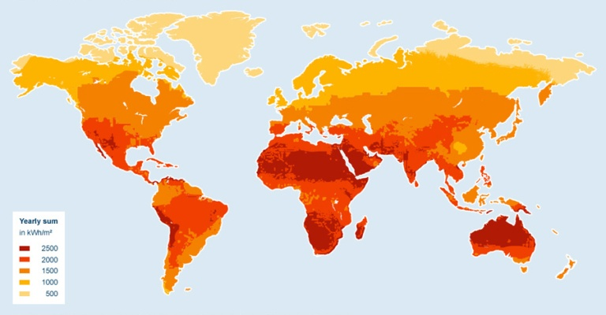

Fig 3.3.3 countries using solar energy

CHAPTER 4: SUMMARY
4.1: ADVANTAGES
- Easy to use :-
The project is very simple as it is based on automatic system so there is no operator needed anyone can use it no special skills need to study.
- Low cost :-
The project is quite cheap in cost so, anyone can have this kind of project at home easily. The installation cost is less also maintenance is very less.
- Security :-
The project is not consuming any harmful chemicals, explosives, radioactive material etc. Just we have to remember that the heating element is hottest part in project so keep distance from this.
- Power generation :-
We can get good quality steam from the project without using human energy or electric energy solar energy transmitted into heat energy and generates steam.

4.2: SCOPE OF FUTURE WORK
This project can be used widely after modification and redesign of several components. As we can see whole world is researching on solar energy based machinery and techniques. This kind of project can easily available in future power generation. And electricity generation as we know that future is mostly dependent on electric appliance and luxurious lifestyle. All these kind of facilities you can get without energy consumption is only possible by solar and wind energy .so we can say that the sea water purification project is one of the most useful project.

4.3 LIMITATIONS
- Time consumption :-
This project is quite time taking for generating good amount of steam. First of all the heating in starting an then it will work continuously.
- Efficient / outcome :-
- This project have Low production of steam generation however it can be modified the rate of boiling increase at some specific point an then it is constant. so limited steam can be produced per hour rate.

- Maintenance :-
Salted water from sea is boiled so heavy particles of NACL are at the bottom they make storage tank and heating element corrosive. So, we have to clean it by several time period.
Nozzles are very narrow so we have to clean it and check it time to time.
- Environment :-
Environment is very important phenomenon for this project. Project is based on solar energy so the sun rays needs to be directly in contact with reflecting dish otherwise we can't reach right temperature of boiling water.
In cloudy weather this project doesn't work properly. A sea shore place where wing effects a lot this project can't be used because of steadiness of mirror and heating element.

4.4 UNIQUE FEATURES :-
In this project some function shows the uniqueness like automatic working, no power for circulation no energy consumption, continuous working from this project we can reduce cost of inspection and labour cost as we think about government projects. we can build huge employment at a single place according to industry level we can make maximum steam by less investment solar energy and tidal energy both are main components and both are free of cost so any industry can make huge profit too.
4.5 CONCLUSIONS
The project of sea water purification is basically steam generating project from the steam We can obtain various things like pure water, power by using boiler, electricity etc. This kind of project can be used as household to global level. Even some countries are running governmental steam generation plants with help of the project at huge level. This project can be also used to generate electricity, so some countries like middle Asia and Europe developed power plants and use for electricity generation with help of solar energy. We are trying to provide at least pure and safe water to people.

CHAPTER 5: REFERENCES
- Solar Still Basics by Solaqua
- Solar Disinfection System Manual by EAWAG and SANEC,Page 15
- Waterborne pathogens, WHO
- World Health Organization
- Volatile Organic Compounds in Consumer and Commercial Products, definition of VOCs
- Solar Disinfection System Manual by EAWAG and SANEC, Page 11
- Solar Disinfection System Manual by EAWAG and SANEC, Page I
- Solar distillation by Practicalaction.org
- Water vapor
- Still operation by Solaqua
- Satellite observations of total solar irradiance
- Solar constant by Physikalisch – Meteorologisches Observatorium Davos World Radiation Center Consolair Solar Inc.
- RA 240 SOLAR MAX model specification by Consolair Solar Inc.
- Solar Disinfection System Manual by EAWAG and SANEC,Page 16
- Sommer B. et al. (1997): SODIS – An Emerging Water Treatment Process, J. Water SRT – Aqua 46, pp. 127-137.

