ORGANIZATION STUDY AT ANGEL STARCH, ERODE
By
DHARANIPATHYRAJKUMAR.S 15MBA107
Under the Guidance of
Mrs.P.Mohanamani
(Assistant professor)

P15BAP305 - CORPORATE INTERNSHIP REPORT
Submitted
In Partial fulfillment of the requirements
For the award of the degree
Of
MASTER OF BUSINESS ADMINISTRATION
Kumaraguru College of Technology
(An Autonomous institution affiliated to Anna University, Chennai)
Coimbatore – 641049
June - July 2016

BONAFIDE CERTIFICATE

This is to certify that this, “Organization Study at Angel starch” is the bonafide work of Dharanipathyrajkumar.s who carried out the project under my supervision. Certified further, that to the best of my knowledge the work reported herein does not form part of any other project report or dissertation on the basis of which a degree or award was conferred on an earlier occasion on this or any other candidate.

Faculty Guide Director
Mrs.P.Mohanamani Dr. Vijila Kennedy
Assistant Professor KCTBS
KCTBS

Submitted for the Project Viva-Voce examination held on ________________

Internal Examiner External Examiner
(Signature with date) (Signature with date)
DECLARATION

I, hereby declare that this Corporate Internship project report entitled as, “Organization Study at Angel Starch, Erode” has been undertaken for academic purpose submitted to Anna University in partial fulfillment of requirement for the award of degree of Master of Business Administration. The project report is the record of the original work done by me under the guidance of Mrs.P.Mohanamani, Assistant Professor, KCT - BS during the academic year 2016-2017.

I, also declare hereby, that the information given in this report is correct to the best of our knowledge and behalf.

Place: Coimbatore Name and Signature
Date: S.Dharanipathyrajkumar

ACKNOWLEDGEMENT

I express my thanks to Dr. Vijila Kennedy, Director, KCT BS for implementing this project and providing under the supervision in its execution. I am indebted to my Institution and my faculty members without whom this project would have been a distant reality.
I also would like to give my sincere thanks to Mrs.P.Mohanamani, Assistant Professor, KCTBS my Project guide for giving me support and guidance for this project from inception to closure.
I also would like to give my sincere thanks to Mr.ShivarajaDhanavel, Project Consultant, Angel Starch my Company guide for giving me support and guidance for this project from inception to closure.

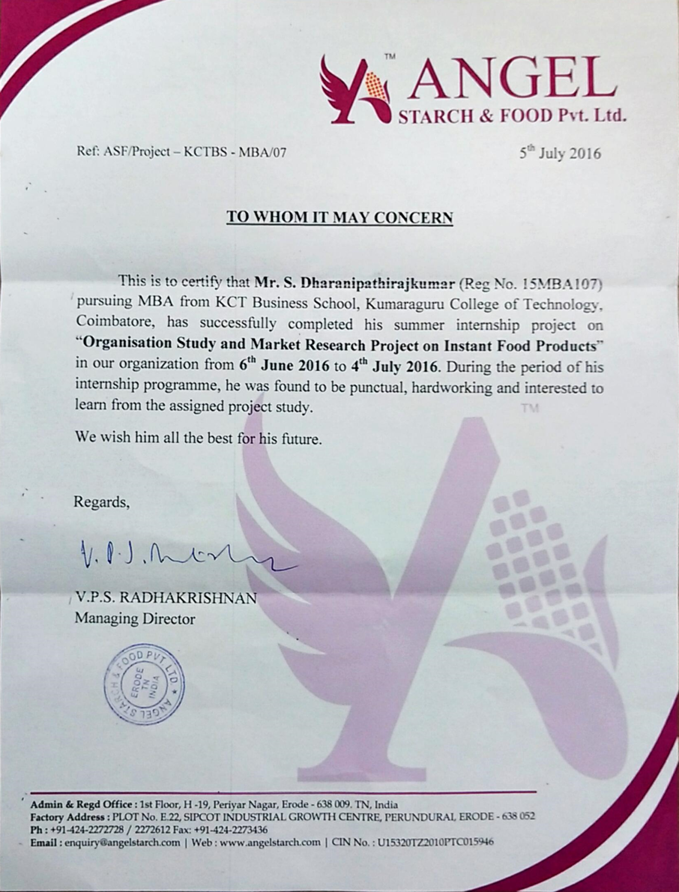
TABLE OF CONTENTS
S. No | Contents | Page No.
1 | Introduction | 1
2 | Industry Profile | 2
3 | Company Profile | 7
4 | Organization Structure | 10
5 | Overview of functions | 11
6 | Human Resources | 12
7 | Marketing | 13
8 | Finance | 15
9 | Production | 15
10 | Operation | 16
11 | Problem Identified | 19
12 | Analysis | 20
14 | Findings | 29
15 | Suggestion | 30
16 | Conclusion | 31

LIST OF TABLES

S. No | Topic | Page No.
1 | Correlation | 20
2 | Consumer buying pattern | 21
3 | Buying pattern of the consumers for the present instant products in outlet | 20
4 | Consumer opinion about the product | 25
5 | Segment of people buying instant products | 26
6 | Size of the pack sold in market | 27
7 | Price range of instant products sold | 28

LIST OF FIGURES

S. No | Topic | Page No.
1 | Organization Structure | 9
2 | Marketing Flow Chart | 16
3 | Consumer buying pattern | 21
4 | Buying pattern of the consumers for the present instant products in outlets | 22
5 | Source to know about the product | 24
6 | Consumer opinion about the product | 25

CHAPTER 1
INTRODUCTION
Angel starch and food Private Limited was established in the year 2010 as one of the distinguished manufacturers, suppliers, traders, distributor, wholesaler and exporter of massive assemblage of industrial starch. They are private limited company under the capable leadership of Mr.V.P.S. Radhakrishnan. His vast industry experience of 20 years in marketing & technical support, consistent efforts and magnificent guidance has inspired them to achieve their organizational goals. Initially V.P.S. Radhakrishnan, Managing director started Shree Mangalmoorthi starch industries in the year 1990, then later entered into trading by establishing SreeBoomeshwar traders in 1993.
SreeMangalmoorthi Starch Industries was started in the year 1990 for Native Starches and in 2010 Angel Starch & Food Private Limited was established in Erode, Tamil Nadu. Under the guidance of Mr. V. P. S. Radhakrishnan and his vast industry experience of 25 years, the company supplies about 2500 tons of native starches per month to the domestic and international market. It manufactures maize starch, tapioca starch, potato starch and modified starches for food, textile sizing, paper, packaging and bio polymers for various industries.

CHAPTER 2
INDUSTRY PROFILE
a) BACKGROUND OF THE INDUSTRY
Starch production in India is highly fragmented, with a variety of manufacturers with small to large capacities offering different sources, grades and derivatives of starch. It is estimated that around 1.56 million tone starch and derivatives were manufactured by about 30 producers.
While maize is the main raw material, to a much smaller extent, potato, tapioca and rice are also utilized for the manufacture of starch. Key products from these raw materials include native starch, modified starches and sweeteners including syrups and polio’s. As earlier mentioned, the usage of starches within India is largely by the non-food sectors.
Within the food sector, soups and snacks, noodles, meat and fish products, confectionery, ready meals and instant gravies and Indian/traditional food products use a large volume of starches and derivatives. Some unique features of the Indian market include the lop-sided proportions of different end-use sectors within total demand.
Unique sectors such as fireworks have significant utilization of starches.
In the food sector, for example, unorganized confectionary and bakery operators contribute to a large proportion of liquid glucose usage.

b) MARKET SIZE
A large part of the demand for starches arises from the paper, textile, construction and pharmaceutical industries. Their use in foods is growing at a low rate, but the potential in this sector is largely untapped, mostly due to the legal restriction regarding the use of modified starches in food.

MAJOR END-USER OF STARCH AND STARCH BASED PRODUCTS IN INDIA
The following are the end users of starch and starch based product :
Hindustan Lever Ltd, Colgate Palmolive Ltd, Lotte India Ltd, PerfettiVanmelle India Ltd, Nutriene Confectionary Ltd, ITC Limited, Wrigley India Ltd, Cadbury India Ltd, Aviat Chemicals Ltd, Hindustan Latex Ltd, GlaxoSmithkline Ltd, Merck India Ltd, Kamani Oil Mills, Wardex Laboratories Ltd, Griffon Labs Ltd, EmcurePharma Ltd, Britannia India Ltd, Godrej Agrovet Ltd, Modern Food Industries Ltd, Nestle India Ltd, Heinz India Ltd, Campco Ltd, Bombay Dyeing Ltd, Kissan Foods Ltd, Marico Oil Industries.
c) MAJOR PLAYERS
Gujarat
Anil Starch Products Ltd, Ahmedabad
Maize Products Ltd, Ahmedabad
Gujarat Ambuja Starch Products Ltd, Ahmedabad
GulshanPolyols Ltd, Jhagadia Industrial Estate, Bharuch
Karnataka
Riddhi Siddhi Glucobiols Ltd, Gokak, Belgaum District
Maharashtra
Sahyadri Starch & Industries Ltd, MIDC, Miraj
Universal Starch Products Ltd, Dhule
Yaswant Glucose Ltd, Sangli
Kissan Starch Ltd, Dhule
Haryana
Bharat Starch Products Ltd, Haryana
Madhya Pradesh
Rajaram Corn Products Ltd
Tirupathi Starch Products Ltd, Indore
Tamilnadu
Santhosh Maize & Industries Ltd, Salem
Varalaxmi Starch Ltd, Salem
Kamala Sugars Ltd, Coimbatore
Andhra Pradesh
Gayathri Starch Ltd, Hyderabad
VensaBiotek Ltd, Samalkot
Punjab
Sukhjit Starch Products Ltd, Phagwara

d) GOVERMENT POLICY AND REGULATIONS
The Food Safety and Standards Authority of India has been established under the Food Safety and Standards Act, 2006 as a statutory body for laying down science based standards for articles of food and regulating manufacturing, processing, distribution, sale and import of food so as to ensure safe and wholesome food for human consumption.
Starch industry has some similar regulation with the food products where the product should be edible and there are certain levels for the chemical contents. eg: glucose and lead.
The Indian Starch industry is still at a nascent stage and derives about 40 products from corn whereas more than 500 products of starch and starch derivatives are being derived in the international arena. The size of the industry is also negligible compared to international market. However, profit may tend to fluctuate from year to year due to erratic availability of basic raw material corn being an agri-product and depends on natural vagaries. Currently, the Indian starch industry produce starch at Rs1800 crore tones and about 65% of the total production comes from organized sector whereas remaining 35% by unorganized players. Organized sector comprises of 6 players namely Anil Products Ltd, Riddhi Siddhi GlucoBiols Ltd, Sukhjit Starch and Chemicals Ltd, Tirupati Starch & Chemicals, Universal Starch-Chem Allied Ltd, Gayatri BioOrganics Ltd.

e) RECENT TRENDS
The easy availability of corn and its wide application as corn starch and modified corn starch makes it as a major source for modified starch. The price is lower than modified tapioca or wheat starch, with a wider range of applications. In food application, corn starch is used in gluten-free products against wheat, as the latter contains gluten in it. Firms such as ADM are specialists in producing wide categories of corn starch and serve various application industries such as food manufacturing, paper manufacturing, and many more, across the globe. Tapioca is a major crop with its abundant availability and usage in Asia-Pacific region, and arising as a major competitor for corn starch. Still, corn starch is expected to maintain its market share for a longer period of time.
Asia-Pacific: Growing Market Whereas North America Leads the Way
North America leads the global modified starch market with wide availability of corn, which has broad array of food, non-food, and feed applications. The consumption pattern and developed economy in North America played a special role in triggering the modified starch market as well. There is a considerable inflow of money in the region and all the industries be it food, pharmaceutical, drilling, paper, cosmetics etc., are monetarily strong. The growing application industry also forms a major driver for the growth of ingredient industry. Hence, the case is same with modified starch. The application industries in the region focuses on quality, therefore uses modified starch in all possible applications.
Asia-Pacific is estimated to experience a high growth rate due to its aim of commercializing and widening the application of cassava across the globe.
Food Dominates the Modified Starch Application Market
Modified starch found its major application in the food sector as its functions are most required in food processing. It is used in sub-segments of food such as bakery, confectionery, processed food, beverages, etc. Modified starch performs function like emulsification, stabilization, thickening, etc. For instance, modified tapioca starch is used in convenience or processed food such as noodles, soups, etc., in order to maintain the paste viscosity. Various starches have different characteristics and are used in food applications based on the requirements of different food products. The other applications of modified starch include the paper industry, medicine & pharmaceuticals, drilling industry, cosmetics, glues and adhesives, and many more in the non-food sector.
f) CHALLANGES
- Managing the profit Margin.
- Educating the new employees in marketing.
- Maintaining customer not to switch to other brands.

- Basic knowledge in handling advance Technology

- Price fluctuations in the raw materials.

CHAPTER 3
COMPANY PROFILE
a) HISTORY
SreeMangalmoorthi Starch Industries was started in the year 1990 for Native Starches and in 2010 Angel Starch & Food Private Limited was established in Erode, Tamil Nadu. Under the guidance of Mr. V. P. S. Radhakrishnan and his vast industry experience of 25 years, the company supplies about 2500 tons of native starches per month to the domestic and international market. It manufactures maize starch, tapioca starch, potato starch and modified starches for food, textile sizing, paper, packaging and bio polymers for various industries.
- Started off with 50 customers in one industry and today the company has over 600 customers spread across 8 industries and 9 countries.
- Started with a sale of 3 million and today they do sales over 500 million.
- Started manufacturing 30 tons per month and today it manufacture 1000 tons.
The core value is ‘Customer Focused Innovation’ has made them emerge as one of the largest manufacturers, suppliers and exporters of wide varieties of starch in India. The company has a registration and membership under the Certificate of Agricultural and Processed Food Products Export Development Authority.
Quality of the products has always been the prime concern. They take stringent measures to check the products on various parameters like composition, viscosity, pH value, purity and effectiveness. The history, milestones and achievements attached to the organisation success.

b) VISION
We foresee Angel Starch & Food Private Limited to be a leading Indian company to place itself on the global starch map as a one stop solution for quality starch products for Food, Textile, Paper and Packaging industries, Nutraceuticals and Biopolymers. .

MISSION
- To spread our business network across global markets while making a firm step in the Indian industries for quality starch and chemical products.
- To supply outstanding customized products according to the customers requirement and satisfaction
- To enhance customers’ production efficiency and reduce their production cost

c) PRODUCTS AND SERVICE
Company manufactures maize starch, tapioca starch, potato starch and modified starches for food, textile sizing, paper, packaging and bio polymers for various industries. They act as Manufacturer, Supplier, Distributor, Wholesaler and Trader.

d) MARKET
They manufacture starch for food, textile sizing, paper, packaging and bio polymers for various industries in India and also in some foreign countries. Their market is totally industry based but now they are getting into food processing market which is booming in India. Our main focus on jam, sauce, soup, ketchup and corn flour products.

e) FINANCIAL STATUS
Annual turnover per year is between Rs. 50-100 crore.

f) CHALLANGES FOR THE COMPANY
One of the major challenges is unpredictable change in the price of raw materials. Frequent change in the price of the product may cause the customers to switch. Since the company concentrates only on industries as for now, it is hard to find new potential customers.

FIGURE: 1
ORGANIZATION STRUCTURE
MANAGING DIRECTOR

GENERAL MANAGER

MARKETING TEAM OF ALL BRANCHES
PRODUCTION MANAGER
MARKETING MANAGER
GLOBAL MARKETING EXECUTIVES
ACCOUNTS MANAGER
QC/PRODUCT DEVELOPMENT
OFFICE MANAGER

PURCHASE EXECUTIVE
DATA EXECUTIVES
LOGISTIC INCHARGE
BRANCH INCHARGE
SALE BILING EXECUTIVES
WHAREHOUSE INCHARGE
ADMIN
EXECUTIVE

CUSTOMER RELATIONSHIP EXECUTIVE

CHAPTER 4
OVERVIEW OF FUNCTIONS
NAME OF THE DEPARTMENT:
- Human Resource
- Marketing
- Finance
- Production
- Operation
- Quality control
DEPARTMENT HEAD:
Human Resource : VPS Radhakrishnan
Marketing : VM Balasubramaniyan
Finance : R Chandraseaker
Production : A Sakthivel
Operation : O Meenakshi
Quality control : S Gobinath

FUNCTIONAL ACTIVITIES OF THE DEPARTMENT:
HUMAN RESOURCE:

DEPARTMENT HEAD : VPS Radhakrishnan
The main functions of the human resource department in Angel Starch are,
- Recruitment
- Placement
- Orientation
- Training

Employee benefits and rewards:
Rewards were given to the employees who do not take leave, and employee welfare programs are organized by this company. The programs are like,
- Yearly once the employees are arranged for tour.
- Each and every employee's birthday is celebrated in the office.
- KAIZEN AWARD: The employee who put forth the work stress in the monthly meeting will be awarded.

MARKETING:

DEPARTMENT HEAD : VM Balasubramaniyan
In Angel starch marketing department have 3 major officers,
- Senior Executive
- Technical Marketing Manager
- CRM Executive
Mani functions of marketing department is,
- Training
- Entering the field
- Networking

Training:
Executives are trained for seven days in head office with audio-video presentation on history, growth and values of the company, product, system, process and procedure of customer approach, application and accounting etc are taught in personal training.

Entering the field:
Executive will move on assigned territory with a senior for few days. Once he is familiar and confident, is allowed to work under the guidance of manager.

Networking:
Making network with "People in place” by creating a good relation between company and customer. It is B2B process so marketing people should create a network between companies.

Technology advancement :
Marketing executives are provided individual mobile phone with gps tracker to identify the place of action they visit. Employees are in different places like Chennai, Coimbatore and Bangalore and its very difficult to manage their action from erode so this gps tracker helps to identify they are stick to their job or not.

FINANCE :
DEPARTMENT HEAD : R Chandraseaker
- Finance department deals with funds which are required for all process from production to marketing. Accounts manager of Angel Starch will allocate fund to each department.
- Budgeting for the company's need.
- Raising funds.
- Finding out the average sales of batch in a month and end year.

PRODUCTION:
DEPARTMENT HEAD: A Sakthivel
The company has separate production unit in Perundurai, Erode. The production process, technology and production units are,
Production Process : Batch processing
Level of Technology : Capital Intensive
Utilization rate : Produce 500 tons per month
BATCH PROCESS :
The performing of an industrial process on material in batches of a limited quantity or number.Based of the pre order done in a month is used to forecast the next month order.

CAPITAL INTENSIVE:
Business process or an industry that requires large amount of money and other financial resources to produce a good or services. Upfront investment is made and balanced in the profit but the initial hurdle to enter into the market is really high and barrier in entry.

5S IS IMPLEMENTATION IN THE COMPANY:
- Sort
- Set in order
- Shine
- Standardize
- Sustain

OPERATION:
DEPARTMENT HEAD: O Meenakshi
The operation department people will purchase the raw material and send to production unit. The logistics is maintained by operation team.
QUALITY CONTROL:
DEPARTMENT HEAD : S Gobinath
In quality control, they are doing more than 10 tests to maintain the quality of the product. Some of the tests done by the company's quality control team is,
- pH value (5-7)
- Viscosity
- Moisture (Maximum 13%)
- Ash content (Maximum 0.5%)
- Sieve test (Maximum 0.5%)
- Solid test
- acidity
- Bulk density
- Water hardness
- Sizing test
- single yarn strength
DEPARTMENT PROCESS FLOW CHART:
My major area is in marketing department, marketing department's process flow chart is given below.

FIGURE : 2
MARKETING PROCESS FLOW CHART:
Marketing strategy
Campaign
(Email, ad, etc)

Assigning Lead to manager

Lead Generation
(Getting information of company who are need in starch)

Follow up

Fit/Unfit

Convert lead to Prospect

Opportunity
Contact

Follow up Lead
No order
Order ?

Got Order
CHAPTER 5
PROBLEM IDENTIFIED
As the company was going to launch a new product they had problem in finding the target market. They wanted to find the need of the consumers as they are new to the product category they are going to launch (Instant food products like Jam, Sauce, Ketchup and Soup). They need to find the potential of the market and they needed to know how the sales and distribution network works for them.
Action taken:
We prepared a questionnaire for consumers, retailers, wholesalers, distributor and stockiest. Survey was conducted in all the parts of Coimbatore to know about the market potential of Coimbatore for that particular product. We conducted a market research in Coimbatore.
Methodology:
TYPE OF STUDY | Descriptive research
RESEARCH METHOD | Primary Data
RESEARCH INSTRUMENT | Structured questionnaire
SAMPLE SIZE | 145
SAMPLE AREA | Coimbatore
SAMPLING METHOD | Convenience sampling
STATISTICAL PACKAGE | SPSS
ANALYTICAL TOOLS | Percentage analysis, Descriptive statistics.

ANALYSIS:

CORRELATION

Step 1: Formulate the hypothesis

H0: There is no association between annual income and quantity of instant food products bought.
Ha: There is association between annual income and quantity of instant food products bought.

Step 2: Choose the alpha level

The alpha level is chosen as 5% or 0.05

Step 3: Select the test

The data is metric, not normally distributed. We need to find the association between two variables. Hence the non- parametric test Spearman's Correlation is used.

Step 4: Execute with SPSS
Analyse -> Correlate -> Bivariate.

Step 5: Analyze

TABLE: 1

Correlation
 |  | Annual income | Quantity of Instant Food Products Brought
Annual income | Pearson Correlation | 1 | .258**
 | Sig. (2-tailed) |  | .007
 | N | 109 | 109
Quantity of Instant Food Products Brought | Pearson Correlation | .258** | 1
 | Sig. (2-tailed) | .007
 | N | 109 | 110
**. Correlation is significant at the 0.01 level (2-tailed).

TABLE: 2 Consumer Buying pattern

 | SAUCE |  | SOUP |  |  | KETCHUP |  | JAM |  | CORN FLOUR
Particulars | Freq | % | Freq | % |  | Freq | % | Freq | % | Freq | %
Yes | 33 | 30 | 44 |  | 40 | 52 | 47 | 54 | 49 | 26 | 24
NO | 77 | 70 | 66 |  | 60 | 58 | 53 | 56 | 51 | 84 | 76
Total | 110 | 100 | 110 |  | 100 | 110 | 100 | 110 | 100 | 110 | 100

FIGURE: 3

INTERPRETATION:

- From the above product such as soup, sauce, jam, ketchup, corn flour and other instant products. People mostly prefer to buy ketchup, soup and jam for their household.
- Based on the ranking Jam, ketchup, soup, sauce, corn flour and others are ranked top to bottom.
- Jam and ketchup are used highly by the ‘B’ class people who are middle class peoples who is earning between Rs.2 to 9 Lakhs.
- Employees, kids and It professionals are more favorable in buying instant food products for their breakfast and lunch.
- There is no other instant product in the market used by the customer but very few have their own products like noodles.

BUYING PATTERN OF CONSUMERS FOR INSTANT PRODUCTS IN OUTLETS

TABLE : 3

 | Numbers | Minimum | Maximum
Small Retail Store | 23 | 1.00 | 2.00
Department Store | 59 | 1.00 | 3.00
Exclusive Food Store | 15 | 1.00 | 1.00
Super Market | 22 | 1.00 | 1.00
Malls | 9 | 1.00 | 1.00
Online | 2 | 1.00 | 1.00

FIGURE: 4

INTERPRETATION :

- Customers are buying the instant products very highly in the departmental store as compared to the other outlets.

- Small retail stores and super markets are the second top most outlets where end consumers buy the product.

- People who buy in malls are ‘A’ class people who earn high income.

- Consumer who buy the instant product in online are very less and it shows people are not ready to buy food products in online.

FIGURE: 5

SOURCE TO KNOW ABOUT THE PRODUCTS:

INTERPRETATION:

- Consumers are mostly following the tv source to know about the instant product.
- Consumers are well educated about the product through tv
- Newspaper and source display in the outlets are the next source to purchase the product
- Few customers are buying the instant products with the friends and relatives who experienced the product
- consumer who buy the product with the source of online are very less.

TABLE: 4
Consumer opinion about the product:

 | Particulars | Frequency | Percent
 | Satisfied | 102 | 92.7
 | Not Satisfied | 8 | 7.3
 | Total | 110 | 100

FIGURE: 6

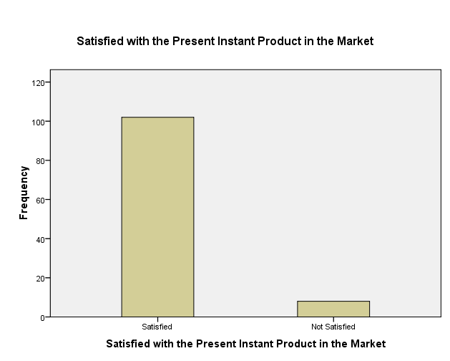

TABLE: 5
Segment of people buying instant products:

 | sauce | soup | jam | ketchup | Corn flour
Low income | 7 | 11 | 12 | 10 | 1
Middle income | 4 | 2 | 1 | 2 | 5
Value buying | 3 | 1 | 1 | 2 | 8
total | 14 | 14 | 14 | 14 | 14

Interpretation:

- Low income people are buying the soup, sauce, jam and ketchup highly and it is clearly spotted that they are not using corn flour products.

- Sauce and corn flour are regularly purchased in retail shop by middle income people.

- Corn flour products are purchased very highly by the value buying people ie high class people.

- Soup and sauce are not mostly preferred by middle income and value buying people.

Table: 6
Size of the pack sold in market:

Particulars |  | Frequency | Percent
 | <50grms | 3 | 23.4
 | 100grms | 8 | 57.1
 | 200grms | 3 | 23.4
Total |  | 14 | 100.0

Interpretation:

- 100 grams packets are sold highly in retailor shop in the market where 57percentages of the packs are sold in 100 grams packets.

- 200 grams and less than 50 grams packs are sold in equal level in the market where 23 percentages of 200 grams and less than 50 grams packs are sold 23 percentages equally in the market.

Table: 7

Price range of instant products sold

particulars |  | Frequency | Percent
 | <100 | 10 | 71.0
 | 100-200 | 2 | 14.5
 | 200-300 | 2 | 14.5
 | Total | 14 | 100.0

Interpretation:

- 71 percentages of Consumers are buying are buying the instant products which are less than Rs100.

- Between Rs100-200, 14 percentages of consumers are buying the instant product equally.

- Finally Between Rs 200-300 , 14 percentages are brought by the consumers.

FINDINGS:

- Purchasing and consumption of the instant products are totally dependent on the income level of the consumers.
- Jam is the most fast moving product in the market. Following jam there is sauce and ketchup and the sales of soup is not as expected.
- Most of the people prefer to buy products from the departmental store, super market and exclusive food store on a monthly basis.
- 200gm box or pouch is the fast moving product in which sales quantity is high followed by 100gm and 500 gm.
- Most of the people tend to prefer the products which are below the price of 100 rupee.
- Some people who prefer more quantity of the product looks for the price range of 100 to 200 rupee.
- People tend to buy these instant products base on the quality, Packet size, Availability on the store and taste.
- Majority of the People come to know about our product either because of Television advertisement or by Store display.
- Majority of the people look for the ISO and FSSAI standard mark on the product.
- Majority of the People are satisfied with current level of instant products.

SUGGESTIONS:

- Mainly concentrate on the low income people.
- Most efficient way to create awareness about this product is by television advertisement.
- Trial launch in the areas like Race course, R.S.Puram, and Sai baba colony which are quite developed areas in Coimbatore.
- Price the product below the price of 50 rupees for 100 gram.

CHAPTER 6

CONCLUSION

There is a lot of competition in the market. Kissan and Maggi are the brands major players in the market. There are also lots of local players in the market. As far as I have known only the middle class and the low income people go for the instant products. The people who are health conscious try to avoid the instant products. Middle level income people mostly look out for the price, discounts and size. Most of the people are not aware of the corn flour mix products. There is a lack of awareness on the instant products. Consumers buy whatever is there on the store display or what the retailer says. Most of the people are becoming aware of the product only though television or store display. The people who buy online refer the online pamphlets and the reviews given for the product. Based on the survey with the retailers they say that "OMA" is one of the major local players for sauce in the local market. Mostly families prefer to go with the branded product. Quality comes first then followed by taste and price. The retailers say that they need at least 10% of margin in all the products. The wholesalers ask for the margin of at least 3%. In consumers point of view they buy the product for its convenience mostly. Taste and price are secondary.

