Mini Project Synopsis
Home Automations

Submitted by:

Siddhartha mudgal
(1506820037)

(Department of Electrical Engineering)
Submitted to:
Asst.Prof Snighda Sharma


Meerut Institute of Engineering &Technology
Dr. A. P. J. Abdul Kalam Technical University, Lucknow
Uttar Pradesh (India)

Mini Project
HOME AUTOMATION

SUBMITTED IN PARTIAL FULFILLMENT OF THE REQUIREMENT FOR THE
COMPLETION OF FIFTH SEMESTER

of
BACHELOR OF TECHNOLOGY

SUBMITTED BY
Siddhartha mudgal
(1506820037)

Under the Supervision of
Asst. Prof. Snighda Sharma
Department of Electrical Engineering



MEERUT INSTITUTE OFENGINEERING & TECHNOLOGY
DR.A.P.J ABDUL KALAM TECHNICAL UNIVERSITY
LUCKNOW, UTTAR PRADESH, INDIA-250005

DECLARATION

This is to certify that Report entitled ”Home Automation” which is submitted in partial fulfillment of the requirements for the Bachelor of Technology(Third Year) in Electrical Engineering of the Dr.A.P.J.Technical University, Lucknow, during the academic year 2017-18, comprises only our own work and due acknowledgement has been made in the text to all other material used.

Department of Electrical Engineering
Meerut Institute of Engineering & Technology

ABSTRACT

Today we are living in 21st century where automation is playing important role in human life. Home automation allows us to control household appliances like light, door, fan, AC etc. It also provides home security and emergency system to be activated. Home automation not only refers to reduce human efforts but also energy saving and time efficiency. The main objective of home automation and security is to help handicapped and old aged people who will enable them to control home appliances and alert them in critical situations.

This paper put forwards the design of home automation system using ARDUINO UNO board. Home appliances are connected to the ARDUINO and communication is established between the ARDUINO with Bluetooth device. The home appliances are connected to the input / output ports of the Relay board and their status is passed to the ARDUINO and can be controlled using android/ios based application. We would develop an authentication to the system for authorized person to access home appliances. The device with low cost and scalable to less modification to the core is much important. It presents the design and implementation of automation system that can monitor and control home appliances via ARDUINO UNO Board.

INTRODUCTION

The “Home Automation” concept has existed for many years. The terms “Smart Home”, “Intelligent Home” followed and has been used to introduce the concept of networking appliances and devices in the house. Home automation Systems (HASs) represents a great research opportunity in creating new fields in engineering, architecture and computing (Huidobro and Millan, 2004). HASs becoming popular nowadays and enter quickly in this emerging market. However, end users, especially the disabled and old aged due to their complexity and cost, do not always accept these systems. Due to the advancement of wireless technology, there are several different of connections are introduced such as GSM, WIFI, ZIGBEE, and Bluetooth. Each of the connection has their own unique specifications and applications. Among the four popular wireless connections that often implemented in HAS project, Bluetooth is being chosen with its suitable capability. Bluetooth with globally available frequencies of 2400Hz is able to provide connectivity up to 100 meters at speed of up to 3Mbps depending on the Bluetooth device class [1]. In addition, a Bluetooth master device is able to connect up to 7 devices in a “Piconet”.This paper will describe the approach which we are implementing to control various home appliances with ARDUINO UNO.

From the overall papers reviews, HAS according to the papers, never mentioned about the existing physical electrical switches in their system. Without the switches on the wall, the designed system limited the control only at the GUI. This issue brings inconvenient to the people in the house. This designed system remains the physical switches with the modified low voltage activating method, in order to provide safer physical control to the user compared to the conventional high voltage switches. The Bluetooth connection in this system is established by Bluetooth module that directly receives/ transmits commands from/to ARDUINO UNO Board.

As discussed earlier we are using graphical user interface(GUI) application by modifying the panel parameters. The application consists of main function like light controlling, Getting Temprature, Humidity etc. When the application starts user is first need to connect to the bluetooth device by entering an authentication code, if user is authorized he will be navigated to main screen. The main screen has a list of all functions among which user can select any one function which he want to control. After selecting a function he would be able to see a current status of a particular device. If user wishes, he can enable or disable intended device. The system is programmed to auto on/off lights when any person enter/leaves the room. If user wants to control the devices manually, He/She can manually adjust fan/AC or lights as per user requirement.

Used Component
- Ardunio uno
- Bluetooth module HC-05
- Ir proximity sensor
- DHT 11 Temprature and Humidity sensor
- Led display
- Relay board

Ardunio Uno

The Arduino UNO is a widely used open-source microcontroller board based on the ATmega328P microcontroller and developed by Arduino.cc. The board is equipped with sets of digital and analog input/output (I/O) pins that may be interfaced to various expansion boards (shields) and other circuits. The board features 14 Digital pins and 6 Analog pins. It is programmable with the Arduino IDE(Integrated Development Environment) via a type B USB cable. It can be powered by a USB cable or by an external 9 volt battery, though it accepts voltages between 7 and 20 volts. It is also similar to the Arduino Nano and Leonardo. The hardware reference design is distributed under a Creative Commons Attribution Share-Alike 2.5 license and is available on the Arduino website. Layout and production files for some versions of the hardware are also available. "Uno" means one in Italian and was chosen to mark the release of Arduino Software (IDE) 1.0. The Uno board and version 1.0 of Arduino Software (IDE) were the reference versions of Arduino, now evolved to newer releases. The Uno board is the first in a series of USB Arduino boards, and the reference model for the Arduino platform. The ATmega328 on the Arduino Uno comes preprogrammed with a bootloader that allows to upload new code to it without the use of an external hardware programmer. It communicates using the original STK500 protocol. The Uno also differs from all preceding boards in that it does not use the FTDI USB-to-serial driver chip. Instead, it features the Atmega16U2 (Atmega8U2 up to version R2) programmed as a USB-to-serial converter. The Arduino UNO is generally considered the most user-friendly and popular board, with boards being sold worldwide for less than 5$.
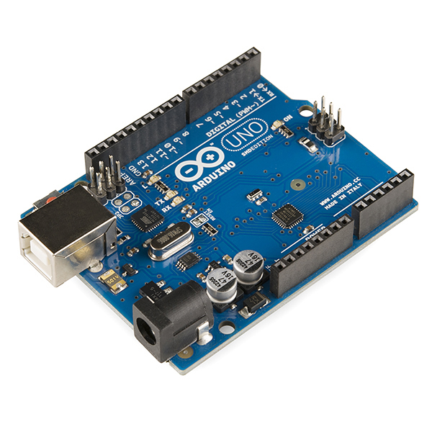

Technical specifications
- Microcontroller: ATmega328P
- Operating Voltage: 5v
- Input Voltage: 7-20v
- Digital I/O Pins: 14 (of which 6 provide PWM output)
- Analog Input Pins: 6
- DC Current per I/O Pin: 20 mA
- DC Current for 3.3V Pin: 50 mA
- Flash Memory: 32 KB of which 0.5 KB used by bootloader
- SRAM: 2 KB
- EEPROM: 1 KB
- Clock Speed: 16 MHz
- Length: 68.6 mm
- Width: 53.4 mm
- Weight: 25 g

Pins
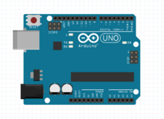
Arduino UNO

General Pin functions
- LED: There is a built-in LED driven by digital pin 13. When the pin is HIGH value, the LED is on, when the pin is LOW, it's off.
- VIN: The input voltage to the Arduino/Genuino board when it's using an external power source (as opposed to 5 volts from the USB connection or other regulated power source). You can supply voltage through this pin, or, if supplying voltage via the power jack, access it through this pin.
- 5V: This pin outputs a regulated 5V from the regulator on the board. The board can be supplied with power either from the DC power jack (7 - 20V), the USB connector (5V), or the VIN pin of the board (7-20V). Supplying voltage via the 5V or 3.3V pins bypasses the regulator, and can damage the board.
- 3V3: A 3.3 volt supply generated by the on-board regulator. Maximum current draw is 50 mA.
- GND: Ground pins.
- IOREF: This pin on the Arduino/Genuino board provides the voltage reference with which the microcontroller operates. A properly configured shield can read the IOREF pin voltage and select the appropriate power source or enable voltage translators on the outputs to work with the 5V or 3.3V.
- Reset: Typically used to add a reset button to shields which block the one on the board.

Special Pin Functions
Each of the 14 digital pins and 6 Analog pins on the Uno can be used as an input or output, using pinMode(),digitalWrite(), and digitalRead() functions. They operate at 5 volts. Each pin can provide or receive 20 mA as recommended operating condition and has an internal pull-up resistor (disconnected by default) of 20-50k ohm. A maximum of 40mA is the value that must not be exceeded on any I/O pin to avoid permanent damage to the microcontroller.The Uno has 6 analog inputs, labeled A0 through A5, each of which provide 10 bits of resolution (i.e. 1024 different values). By default they measure from ground to 5 volts, though is it possible to change the upper end of their range using the AREF pin and the analogReference() function.^{[7]}
In addition, some pins have specialized functions:
- Serial: pins 0 (RX) and 1 (TX). Used to receive (RX) and transmit (TX) TTL serial data. These pins are connected to the corresponding pins of the ATmega8U2 USB-to-TTL Serial chip.
- External Interrupts: pins 2 and 3. These pins can be configured to trigger an interrupt on a low value, a rising or falling edge, or a change in value.
- PWM(Pulse Width Modulation) 3, 5, 6, 9, 10, and 11 Can provide 8-bit PWM output with the analogWrite() function.
- SPI(Serial Peripheral Interface): 10 (SS), 11 (MOSI), 12 (MISO), 13 (SCK). These pins support SPI communication using the SPI library.
- TWI(Two Wire Interface): A4 or SDA pin and A5 or SCL pin. Support TWI communication using the Wire library.
- AREF(Analog REFerence: Reference voltage for the analog inputs.

Bluetooth Module HC-05

HC‐05 module is an easy to use Bluetooth SPP (Serial Port Protocol) module, designed for transparent wireless serial connection setup.The HC-05 Bluetooth Module can be used in a Master or Slave configuration, making it a great solution for wireless communication. This serial port bluetooth module is fully qualified Bluetooth V2.0+EDR (Enhanced Data Rate)3Mbps Modulation with complete 2.4GHz radio transceiver and baseband. It uses CSR Bluecore 04‐External single chip Rluetooth system with CMOS technology and with AFH (Adaptive Frequency Hopping Feature).

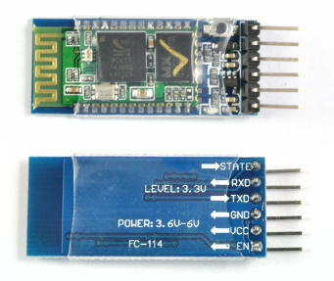
Hardware Features
- Typical ‐80dBm sensitivity.
- Up to +4dBm RF transmit power.
- 3.3 to 5 V I/O.
- PIO(Programmable Input/Output) control.
- UART interface with programmable baud rate.
- With integrated antenna.
- With edge connector.

Software Features
- Slave default Baud rate: 9600, Data bits:8, Stop bit:1,Parity:No parity.
- Auto‐connect to the last device on power as default.
- Permit pairing device to connect as default.
- Auto‐pairing PINCODE:”1234” as default
Pin Description
The HC-05 Bluetooth Module has 6pins. They are as follows:
ENABLE:
When enable is pulled LOW, the module is disabled which means the module will not turn on and it fails to communicate.When enable is left open or connected to 3.3V, the module is enabled i.e the module remains onand communication also takes place.
Vcc:
Supply Voltage 3.3V to 5V
GND:
Ground pin
TXD & RXD:
These two pins acts as an UART interface for communication
STATE:
It acts as a status indicator.When the module is not connected to / paired with any other bluetooth device,signal goes Low.At this low state,the led flashes continuously which denotes that the module is not paired with other device.When this module is connected to/paired with any other bluetooth device,the signal goes High.At this high state,the led blinks with a constant delay say for example 2s delay which indicates that the module is paired.

BUTTON SWITCH:
This is used to switch the module into AT command mode.To enable AT command mode,press the button switch for a second.With the help of AT commands,the user can change the parameters of this module but only when the module is not paired with any other BT device.If the module is connected to any other bluetooth device, it starts to communicate with that device and fails to work in AT command mode.

How to connect HC05 bluetooth module with Arduino Uno?

Hardware and Software Required
- HC-05 Bluetooth Module
- Arduino Uno
- Arduino IDE(1.0.6V)

Hardware Connections
As we know that Vcc and Gnd of the module goes to Vcc and Gnd of Arduino.The TXD pin goes to RXD pin of Arduino and RXD pin goes to TXD pin of Arduino i.e(digital pin 0 and 1).The user can use the on board Led.But here,Led is connected to digital pin 12 externally for betterment of the process.
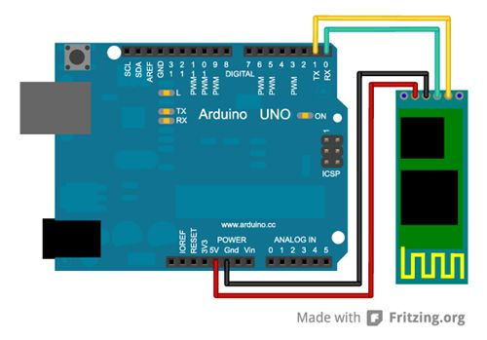
IR proximity sensor
This is the ubiquitous IR proximity sensor connected to most obstacle avoidance robots. Our infrared transceiver modules contains an infrared transmitter and a receiver fit in a compact form on a tiny board. Transmitter emits infrared light and another receiver (photo-transistor) receives that IR light after reflection. The module has both analog and digital output. Analog output can be used to calculate the distance to the nearest object while digital sensor can be used to trigger an action when the module detects an obstacle.
Analog pin read the distance to the nearest obstacle and outputs analog values. The digital output can be connected to trigger an activity when the distance falls below a threshold value (set by the pot)

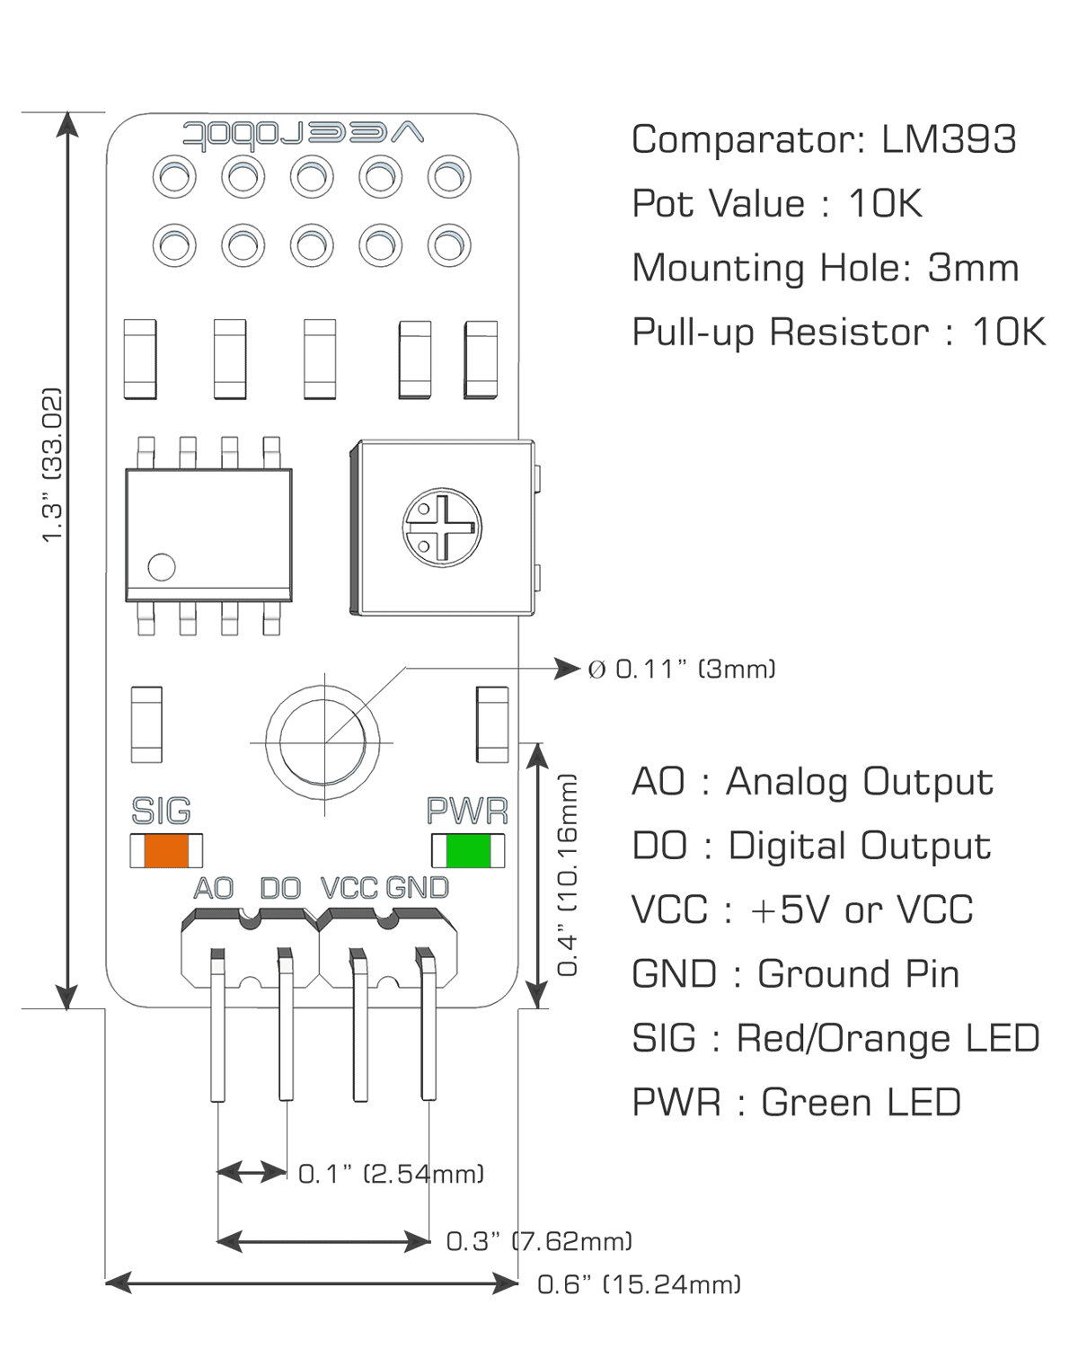

Pin Definition
- AO : This is the analog output pin from the sensor and should be connected to Analog input pin of microcontroller. If you are using an Arduino, this can be connected to any of the analog pins A0 through A5 (on UNO for example). On a Draco board, this can be connected to any of the pins PC0 through PC5. If you are using LCD, then the module can be connected to PC4 or PC5 and sensor values can be displayed on LCD. Analog output from IR proximity sensor can be used to identify distance to the nearest obstacle (though it varies with change in color of different materials)
- DO : This is the digital output pin from the sensor. The pin is connected to a pull-up resistor and will read high. You can adjust the pot to set a threshold value. A comparator continuously checks if the analog pin has hit the threshold value. When it crosses the threshold, the pin goes low and signal LED turns on. This setup is very useful when you need to trigger an action when certain threshold is reached. For example, when the distance to nearest obstacle is less than 3cm, you can signal your robot to reverse and change direction. If it is more than 5cm, and there is no indicator, you can drive straight.
- VCC : Positive power pin and this should be connected to VCC (or +5V) of your microcontroller.
- GND: Ground pin and this should be connected to GND(or 0V) of your microcontroller.

DHT Temprature & Humidity 11 Sensor
This DFRobot DHT11 Temperature & Humidity Sensor features a temperature & humidity sensor complex with a calibrated digital signal output. By using the exclusive digital-signal-acquisition technique and temperature & humidity sensing technology, it ensures high reliability and excellent long-term stability. This sensor includes a resistive-type humidity measurement component and an NTC temperature measurement component, and connects to a high-performance 8-bit microcontroller, offering excellent quality, fast response, anti-interference ability and cost-effectiveness.
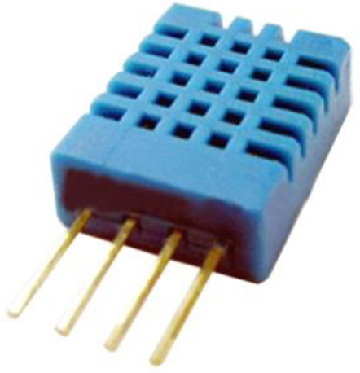

Each DHT11 element is strictly calibrated in the laboratory that is extremely accurate on humidity calibration. The calibration coefficients are stored as programmes in the OTP memory, which are used by the sensor’s internal signal detecting process. The single-wire serial interface makes system integration quick and easy. Its small size, low power consumption and up-to-20 meter signal transmission making it the best choice for various applications, including those most demanding ones. The component is 4-pin single row pin package. It is convenient to connect and special packages can be provided according to users’ request.
Item | Measurement  Range | Humidity  Accuracy | Temperature Accuracy | Resolution | Package
DHT 11 | 20-90% RH  0-50 C | ±5％RH | ±2℃ | 1 | 4 Pin Single Row

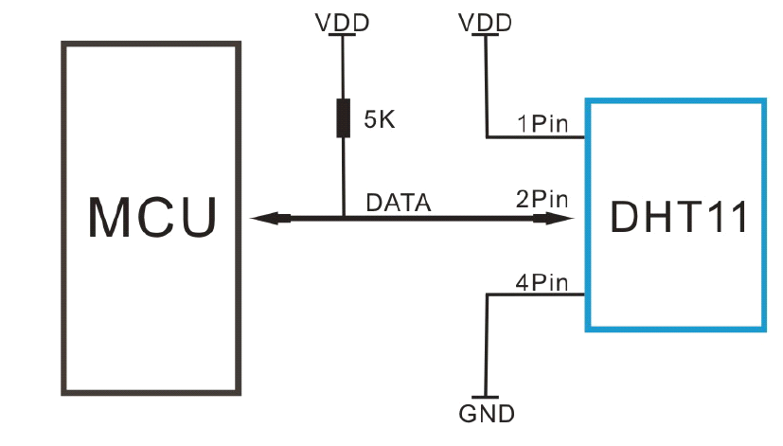
Note: 3Pin – Null; MCU = Micro-computer Unite or single chip Computer
When the connecting cable is shorter than 20 metres, a 5K pull-up resistor is recommended; when the connecting cable is longer than 20 metres, choose a appropriate pull-up resistor as needed.
Power and Pin
DHT11’s power supply is 3-5.5V DC. When power is supplied to the sensor, do not send any instruction to the sensor in within one second in order to pass the unstable status. One capacitor valued 100nF can be added between VDD and GND for power filtering.

LCD Display
The liquid crystal display uses the property of light monitoring of liquid crystal and they do not emit the light directly. The Liquid crystal display is a flat panel display or the electronic visual display. With low information, content the LCD’ s are obtained in the fixed image or the arbitrary image which are displayed or hidden like present words, digits, or 7 segment display. The arbitrary images are made up of large no of small pixels and the element has larger elements.
The 16×2 liquid crystal display contains two horizontal lines and they are used for compressing the space of 16 display characters. In inbuilt, the LCD has two registers which are described below.
- Command Register
- Data Register
Command Register: This register is used to insert a special command in the LCD. The command is a special set of data and it is used to give the internal command to the liquid crystal display like clear screen, move to line 1 character 1, setting the curser and etc.
Data Register: The data registers are used to enter the line in the LCD

LCD Interfacing with the Arduino Module
The following circuit diagram shows the liquid crystal display with the Arduino module. From the circuit diagram, we can observe that the RS pin of the LCD is connected to the pin 12 of the Arduino. The LCD of R/W pin is connected to the ground. The pin 11 of the Arduino is connected to the enable signal pin of LCD module. The LCD module & Arduino module are interfaced with the 4-bit mode in this project. Hence there are four input lines which are DB4 to DB7 of the LCD. This process very simple, it requires fewer connection cables and also we can utilize the most potential of the LCD module.
The digital input lines (DB4-DB7) are interfaced with the Arduino pins from 5-2. To adjust the contrast of the display here we are using a 10K potentiometer. The current through the back LED light is from the 560-ohm resistor. The external power jack is provided by the board to the Arduino. Using the PC through the USB port the Arduino can power. Some parts of the circuit can require the +5V power supply it is taken from the 5V source on the Arduino board.

The following schematic diagram shows the LCD module interfacing with the Arduino.
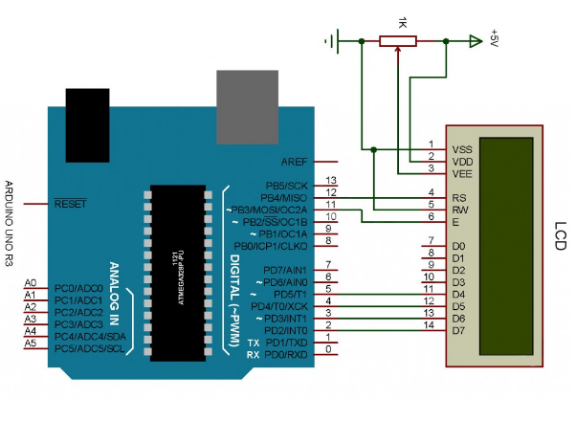
This article gives the information about how the LCD module interfacing with the Arduino. I hope by reading this article you have got basics knowledge about how to LCD module with the Arduino. If you have any queries regarding this article or about the microcontroller projects,please don’t hesitate to feel free to comment in the below section. Here is the question for you, what is the function of LCD module by interfacing with the Arduino

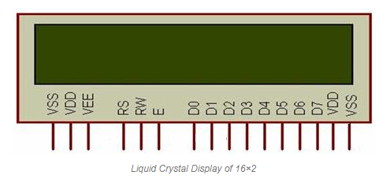
Pin diagram and description of each pin have explained in the following table.
Pin no. Pin name Pin Description
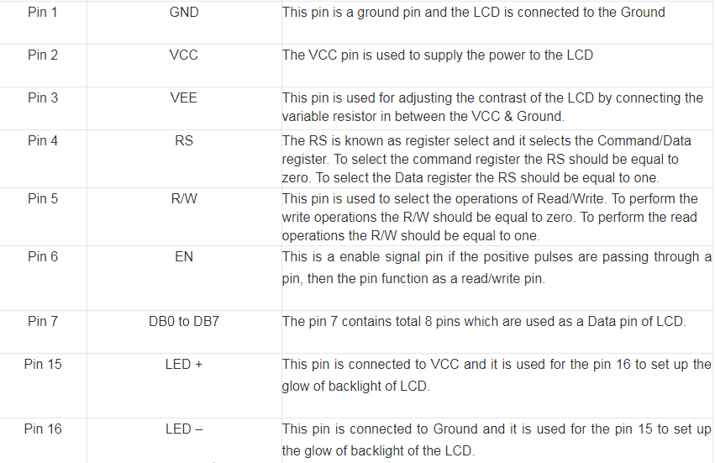

Relay Board
Quad Channel Relay Board is a simple and convenient way to interface 4 relays for switching application in your project. 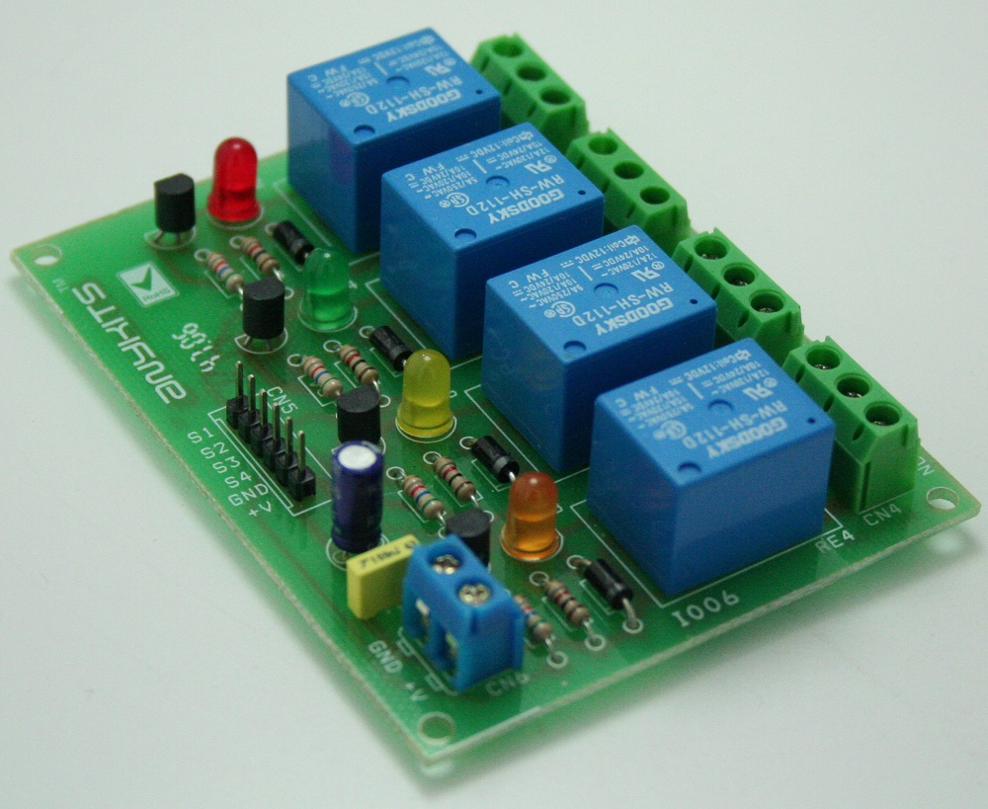

Features

- Input supply 12 VDC @ 170 mA
- Output four SPDT relay
- Relay specification 5 A @ 230 VAC
- Trigger level 2 ~ 5 VDC
- Berg pins for connecting power and trigger voltage
- LED on each channel indicates relay status
- Power Battery Terminal (PBT) for easy relay output and aux power connection
- Four mounting holes of 3.2 mm each
- PCB dimensions 88 mm x 68 mm
Applications: Robotics, Electronics projects, Industrial controls, Microwaves Oven, Fans, DC Motor, AC Lamp, Solenoids Remote Controls etc.

Relay Load (Contact Capacity of Relay)

- 7 A @ 230-250 VAC
- 10 A @ 120 VAC
- 10 A @ 24 VDC
- CN1 – CN4 Connector : Relay 1 to 4 (S1 to S4) Output (Normally Open/Normally Close)
- CN5 Connector : Control Signal Input, Trigger 2 to 5 VDC and Supply Input 12 VDC
- D2,D4,D6,D8 : Relay On/Off LED Indication
- CN6 Connector : Axillary Supply 12 VDC

Code
#include <LiquidCrystal.h>
#include <SimpleDHT.h>
#include <Streaming.h>
int pinDHT11 = 6;

SimpleDHT11 dht11;
const int rs = 10, en = 9, d4 = 5, d5 = 4, d6 = 3, d7 = 7;
LiquidCrystal lcd(rs, en, d4, d5, d6, d7);
#define in 14
#define out 19
#define relay1 2
int LED1 = 13; // the on-board LED
int LED2 = 12;
int LED3 = 11;
String Data; // the data received
int count = 0;

void IN()
{
count++;
Serial.println("Person In ROOM\n");
delay(1000);
}

void OUT()
{
count--;
Serial.println("Person Leaves ROOM\n");
if (count < 0)
{
count = 0;
}

delay(1000);
}

void irsensor() {

if ((digitalRead(in) || digitalRead(out)))
{
if (digitalRead(in))
IN();
if (digitalRead(out))
OUT();

if (count > 0)
{
digitalWrite(relay1, LOW);
delay(200);
}
else
{
digitalWrite(relay1, HIGH);
digitalWrite(LED1, HIGH);
digitalWrite(LED2, HIGH);
digitalWrite(LED3, HIGH);
}
Serial.print(count); Serial <<"*P" << (count) << "*" <<endl;
Serial.println("\n");
}
}
void btcontrol() {
if (Serial.available())
{ //wait for data receiverj
Data = Serial.readString();
Serial.print(Data);
if (Data == "ON1"&&(digitalRead(LED1))) {
digitalWrite(LED1, LOW);
Serial.println("LED1\n");
Serial.println("LED1 On!\n");
}
else if (Data == "OFF1"&&(!digitalRead(LED1))) {
digitalWrite(LED1, HIGH);
Serial.println("LED1 Off!\n");
Serial.println("LED1 Off !\n");
}
if (Data == "ON2"&&(digitalRead(LED2))) {
digitalWrite(LED2, LOW);
Serial.println("LED2 On\n");
Serial.println("LED2 On!\n");
}
else if (Data == "OFF2"&&(!digitalRead(LED2))) {
digitalWrite(LED2, HIGH);
Serial.println("LED2 Off\n");
Serial.println("LED2 Off !\n");

}
if (Data == "ON3"&&(digitalRead(LED3))) {
digitalWrite(LED3, LOW);
Serial.println("LED3 On\n");
Serial.println("LED3 On!\n");

}
else if (Data == "OFF3"&&(!digitalRead(LED3))) {
digitalWrite(LED3, HIGH);
Serial.println("LED3 Off!\n");
Serial.println("LED3 Off !\n");

}
if (Data == "ON4"&&(digitalRead(relay1))) {
digitalWrite(relay1, LOW);
Serial.println("relay1 On\n");
Serial.println("relay1 On!\n");

}
else if (Data == "OFF4"&&(!digitalRead(relay1))) {
digitalWrite(relay1, HIGH);
Serial.println("relay1 Off!\n");
Serial.println("relay1 Off !\n");

}
if (Data == "ONALL") {
digitalWrite(LED1, LOW);
digitalWrite(LED2, LOW);
digitalWrite(LED3, LOW);
digitalWrite(relay1, LOW);
Serial.println("LEDs ON\n");
Serial.println("LEDs On!\n");
}
else if (Data == "OFFALL") {
digitalWrite(LED1, HIGH);
digitalWrite(LED2, HIGH);
digitalWrite(LED3, HIGH);
digitalWrite(relay1, HIGH);
Serial.println("LEDs Off!\n");
Serial.println("LEDs OFF !\n");
}

}
}

void temprature() {
irsensor();
if (Data=="TEMP"){

Serial.println("=================================");
Serial.println("DHT11 readings...");
delay(2000);
byte temperature = 0;
byte humidity = 0;
int err = SimpleDHTErrSuccess;

if ((err = dht11.read(pinDHT11, &temperature, &humidity, NULL)) != SimpleDHTErrSuccess) {
Serial.print("No reading , err="); Serial.println(err); delay(1000);
return;
}
Serial.print("temp: ");
Serial.print((int)temperature); Serial.print(" Celcius, ");
Serial.print("humidity:");
Serial.print((int)humidity); Serial.println(" %");
Serial <<"*T" <<(int)temperature << "*" <<endl;
Serial <<"*H" << ((int)humidity) << "*" <<endl;

lcd.clear();

lcd.setCursor(0, 0);

lcd.print("Temp: ");

lcd.print((int)temperature);

lcd.setCursor(0, 1);

lcd.print("Humidity(%): ");

lcd.print((int)humidity);
delay(750);

}
}

void setup()
{
Serial.begin(9600);

pinMode(in, INPUT);
pinMode(out, INPUT);
pinMode(relay1, OUTPUT);
pinMode(LED1, OUTPUT);
pinMode(LED2, OUTPUT);
pinMode(LED3, OUTPUT);
Serial.println("Waiting for command...");
Serial.println("Send ON'X' to turn on the LED. Send OFF'X' to turn Off");

digitalWrite(relay1, HIGH);
digitalWrite(LED1, HIGH);
digitalWrite(LED2, HIGH);
digitalWrite(LED3, HIGH);
digitalWrite(pinDHT11,HIGH);

lcd.begin(16, 2);

}

void loop()
{
if ((digitalRead(in) || digitalRead(out)))
{
irsensor();
}
if (Serial.available())
{
btcontrol();
}
temprature();
statuS();
}
void statuS(){

if(!digitalRead(LED1))
Serial.print("*A1=ON*");
if(digitalRead(LED1))
Serial.print("*A1=Off*");
if(!digitalRead(LED2))
Serial.print("*B2=ON*");
if(digitalRead(LED2))
Serial.print("*B2=Off*");
if(!digitalRead(LED3))
Serial.print("*C3=ON*");
if(digitalRead(LED3))
Serial.print("*C3=Off*");
if(!digitalRead(relay1))
Serial.print("*D4=ON*");
if(digitalRead(relay1))
Serial.print("*D4=Off*");
if(!digitalRead(LED1)&&!digitalRead(LED2)&& !digitalRead(LED3)&& !digitalRead(relay1))
Serial.print("*EALL=ON*");
if(digitalRead(LED1)&&digitalRead(LED2)&&digitalRead(LED3)&&digitalRead(relay1))
Serial.print("*EALL=Off*");

}

