INTELLIGENT PLANT AEROPONICS USING IOT
Mr.G.Premalatha¹, P.Ajeeth kumar²,G.Aravind³ , R.S.Diwakar⁴.

Associate Professor¹, ^{2,3,4} Students (ECE-final year, thiruvallur, Chennai, Tamil Nadu.)

ajeethkumar1111@gmail.com,
aravind24003@gmail.com,
diwakar.r.s97@gmail.com

ABSTRACT

Aeroponics is the recent advancement in the modern organic plant culture. In this process of culture nutrient rich air or mist is used as the growing medium. Plants are grown on a solid cloth or equivalent membrane like holding medium and which takes the nutrients from the spray or mist given to the roots. A minimum support of the plant to the holding medium is ensured in order to avoid pathogen and other cosmopolitan microbe growth. Aeroponics provide fast and efficient food production. In this
phase, design has been shown through a proteus software.
I. INTRODUCTION
Aeroponics is the process of growing plants in an air or mist environment without the use of soil or an aggregate medium (known as geoponics). Aeroponic culture differs from both conventional hydroponics, aquaponics, and in-vitro (plant tissue culture) growing. Unlike hydroponics, which uses a liquid nutrient solution as a growing medium and essential minerals to sustain plant growth; or aquaponics which uses water and fish waste, aeroponics is conducted without a growing medium. It is sometimes considered a type of hydroponics, since water is used in aeroponics to transmit nutrients.
II. EXISTING SYSTEM
An Intelligent Plant Care Hydroponic Box (IPCH-Box) that exercises environment driven control methods through an Internet-of-Things (IoT) management tool called IoTtalk. IoTtalk provides a scalable and configurable software for users to easily and quickly add/remove/exchange the sensors and actuators, and program their interactions. From the experimental measurement results of IPCH-Box, the developed environment driven control methods include LED lighting, water spray and water pump which can effectively lower the CO2 concentration, the temperature and increase water level, respectively. Specifically, the time of CO2 concentration reduction in IPCH-Box is 38.54% faster than that with the plant system without our mechanism.

III. PROPOSED SYSTEM
Aeroponics is a hydroponic system in which plant roots are suspended in air and misted with a nutrient water.
- Maximize oxygen available at the root zone, thus helping to maximize plant growth.

ADVANTAGES OF PROPOSED SYSTEM
Compared to hydroponics ,aeroponics offers even more control over the root system,because you don’t even need to immerse the roots in any liquid medium. Aeroponics can also be combine perfectly with hydroponics, to produce strong, healthy plants, as in hydro-aeoponics. The secret of aeroponics lies in theroots due to the lack of root zone media. It requires less space for cultivation. Mobility –plants, even whole nurseries, can be moved around without too much efforts, as all that required is moving the plants from one place to another.
METHODOLOGY
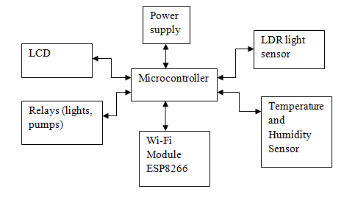
Block Diagram
Microcontroller plays master role in the aeroponics system to monitor plant in a container with help of sensors. Humidity sensor will monitor the humidity or mist in the container. Temperature sensor will monitor the temperature in the container to keep it in perfect condition. If any changes in the condition then it will send information to the microcontroller. It will switch on the motor to spray water and it will send information to lcd display and web link to monitor. The principles of Aeroponics are based on the possibility of cultivating vegetables whose roots are not inserted in a substratum (the case with hydroponics) or soil, but in containers filled with flowing plant nutrition. In these containers roots can find the best condition regarding oxygenation and moisture. These conditions allow for better plant nutrition assimilation in a more balanced way, with consequential faster development of the cultivated plants.
Plant containers can be mounted on top of one another and because they are light and handy, they can be easily moved according to agricultural needs. Numerous plants are mounted in vertical columns within a greenhouse or shade house space. Nutrients are allowed to trickle down through the growth columns.
Most agricultural plants need a direct exposure to the sun during the first vegetative development. Afterwards this direct exposure is no longer relevant. Based on this observation, plant containers are periodically displaced. Young plants are placed at the highest level of the growth column. Afterwards they are progressively lowered utilizing a rotational mechanical system. With the rotation periodically repeated, this permits constant production without any interruption. The Aeroponic system is agriculture with a non-stop production cycle.
We implemented in proteus
The Proteus Design Suite is wholly unique in offering the ability to co-simulate both high and low-level micro-controller code in the context of a mixed-mode SPICE circuit simulation. With this Virtual System Modelling facility, you can transform your product design cycle, reaping huge rewards in terms of reduced time to market and lower costs of development.
If one person designs both the hardware and the software then that person benefits as the hardware design may be changed just as easily as the software design. In larger organisations where the two roles are separated, the software designers can begin work as soon as the schematic is completed; there is no need for them to wait until a physical prototype exists.
In short, Proteus VSM improves efficiency, quality and flexibility throughout the design process. Proteus Virtual System Modelling (VSM) combines mixed mode SPICE circuit simulation, animated components and microprocessor models to facilitate co-simulation of complete microcontroller based designs. For the first time ever, it is possible to develop and test such designs before a physical prototype is constructed.

BASIC PROTEUS DESIGN
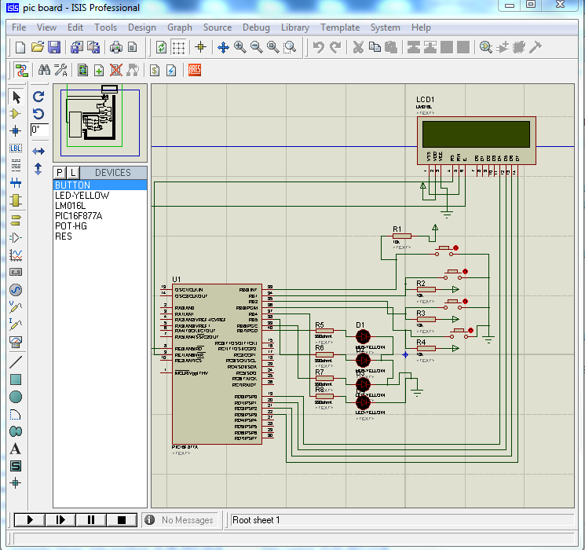
At the heart of Proteus VSM is ProSPICE. This is an established product that combines uses a SPICE3f5 analogue simulator kernel with a fast event-driven digital simulator to provide seamless mixed-mode simulation. The use of a SPICE kernel lets you utilise any of the numerous manufacturer-supplied SPICE models now available and around 6000 of these are included with the package.

Proteus VSM includes a number of virtual instruments including an Oscilloscope, Logic Analyser, Function Generator, Pattern Generator, Counter Timer and Virtual Terminal as well as simple voltmeters and ammeters. In addition, we provide dedicated Master/Slave/Monitor mode protocol analysers for SPI and I2C - simply wire them onto the serial lines and monitor or interact with the data live during simulation. A truly invaluable (and inexpensive!) way to get your communication software right prior to hardware prototyping.
Should you wish to take detailed measurements on graphs, or perform other analysis types such as frequency, distortion, noise or sweep analyses of analogue circuits, you can purchase the Advanced Simulation Option. This option also includes Conformance Analysis - a unique and powerful tool for Software Quality Assurance.

Result and discussion
The behaviour of the model under variations to the transition rules was
observed. The step increment amounts of the transition rules were found to have
a large impact on the resulting simulated leaf shape and rates of growth, as was
expected.

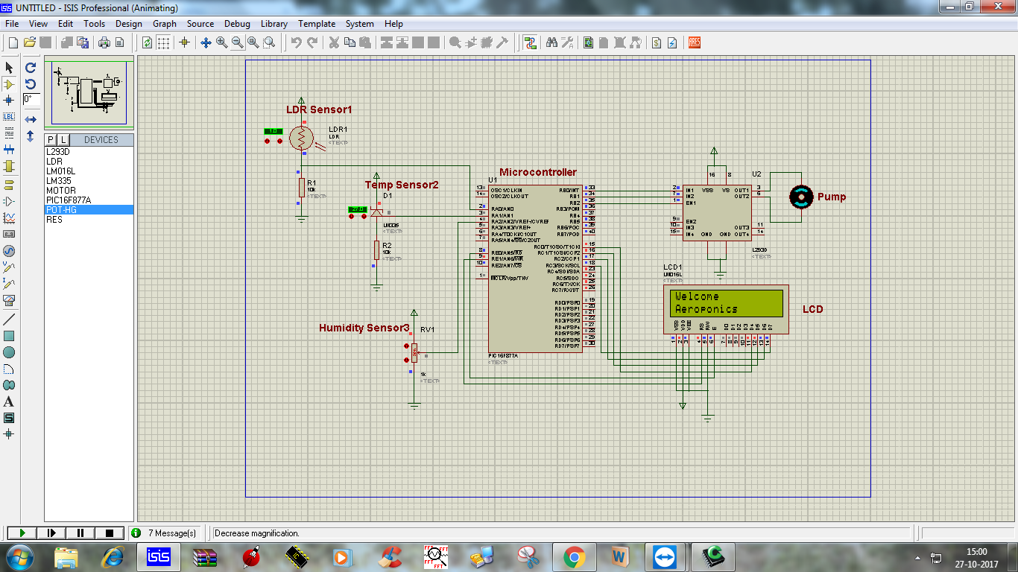
Proteus design at normal
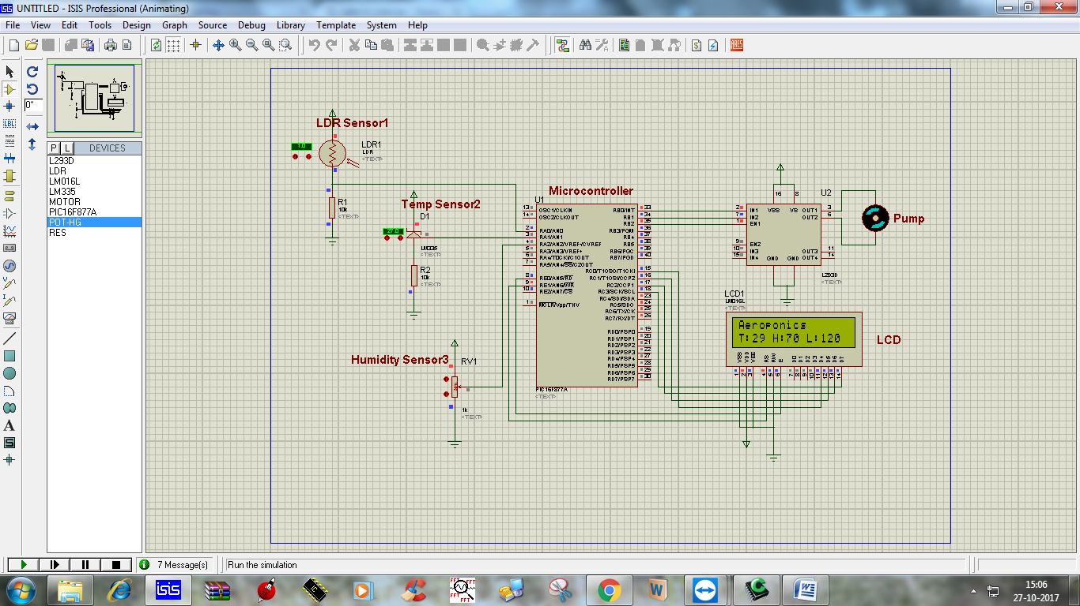
Proteus design for sensor taking reading
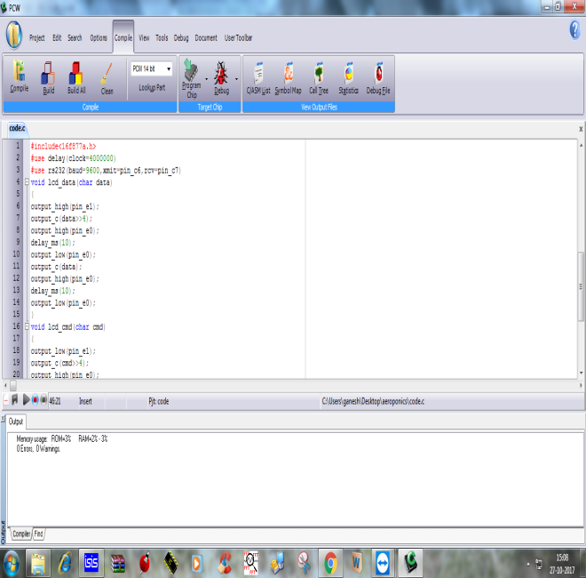
Program for Aeroponics
CONCLUSION
A major breakthrough is required in the organic farming practices. Pesticide and modern fertilizer usages are bringing various health hazards. Plant and food quality is being in a state of degradation day by day. Personal or home farming practices are to be rejuvenated and supported in various manners. Aeroponic systems are pointing to success of the technology adoption in the organic farming culture. Possibilities in assisted large farmlands also need to be confronted through agricultural technologies. The main advantages of this type of system Limited water consumption, independent of land and soil quality, and aeroponic can be used in places where the gardening is not possible. Thus not only is it a profitable undertaking, but one which has proved of great benefit to humanity. People living in crowded city streets, without gardens, can grow fresh vegetables and fruits in household gardens or in small discarded containers. By means of hydroponics, a regular and abundant supply of fresh greens vegetables, fruits can be produced in poor production areas and clean areas can be made productive at relatively low cost.

REFERENCES
[1] L. A. Velázquez, M. A. Hernández, M. León, First Advances on the Development of a Hydroponic System for Cherry Tomato Culture, in 2013 10th International Conference on Electrical Engineering, Computing Science and Automatic Control (CCE) Mexico City.
[2] M.F. Saaid, N. S. M. Fadhil, M.S.A. Megat Ali, M.Z.H. Noor , Automated Indoor Aquaponic Cultivation Technique, in 2013 IEEE 3rd International Conference on System Engineering and Technology.
[3] Experiments advance gardening at home and in space, NASA spinoff 2008 (https://spinoff.nasa.gov/Spinoff2008/ch_3.html).
[4] Monica Rozenfeld, Indoor farms could revolutionize agriculture, The institute – IEEE tech news resource online magazine, 23May2016 [5] Students boost food production with simple technologies, The institute - IEEE tech news resource online magazine, 23May2016.
[5] S. Lee, S. Park, “Energy savings of home growing plants by using daylight and LED,” IEEE Sensors Applications Symposium (SAS), pp. 202-204, Feb. 2013.
[6] A. N. Harun, R. Ahmad, N. Mohamed, “WSN application in LED plant factory using continuous lighting (CL) method,” IEEE Open Systems (ICOS), pp. 56-61, Aug. 2015.
[7] AeroGarden [Online]. Avaliable: https://www.aerogrow.com/
[8] Rododo Science [Online] Avaliable: http://www.rododo.farm/
[9] Y. B. Lin, Y. W. Lin, C. Y. Chih, T. Y. Li, C. C. Tai, Y. C. Wang, F. J. Lin, H. C. Kuo, C. C. Huang, and S. C. Hsu, “EasyConnect: A management system for IoT devices and its applications for interactive design and art,” IEEE Internet of Things Journal, vol. 2, no. 6, pp. 551-561, Dec. 2015.
[10] Representational state transfer (REST) 2016 [Online]. Available: https://en.wikipedia.org/wiki/Representational_state_transfer.

