Gujarat Technological University
Chandkheda, Ahmedabad, Affiliated
Vidhyadeep institute of engineering &technology
A report on :-
“PLANNING OF SOCIETY ”

Under subject of
DESIGN ENGINEERING-2B
B.E. III, Semester-VI
(Civil Branch)

Submitted by:-Group: 9

Sr. no | Name of student | Enrollment no
1 | PATEL MOXA R. | 140940106079
2 | PRAJAPATI ABHI V. | 140940106095
3 | VAKHARIA SIDDHI R. | 140940106124

Mrs. MITALI KATHIWALA
(Faculty Guide)

Mrs. VRUNDA SULE
(Head of the Department)

Academic year
(2016-2017)
GUJARAT TECHNOLOGICAL UNIVERSITY
Chandkheda, Ahmedabad.
Affiliated

VIDHYADEEP INSTITUTE OF ENGINEERING AND TECHNOLOGY.

Certificate

This is to certify that project work embodied in this project entitled “PLANNING OF SOCIETY” was carried out by PATEL MOXA R. (140940106079) PRAJAPATI ABHI V. (140940106095) VAKHARIA SIDHHI R. (140940106124 ) at Vidhyadeep Institute of Engineering and Technology, Anita kim, surat for Design Engineering 6th semester, work has been successfully submitted, this project work has been carried out under my supervision and is to the satisfaction of department.

Date:
Place: Anita, kim,
surat.

__________ ____________ _________________
(Internal Guide) (Head of Department) (External)

ACKNOWLEDGMENT

First and foremost I thank Almighty GOD – the exalted, the most high and merciful, for giving me the opportunity to complete my design Engineering (Civil Engineering) degree programme.

I would like to give big thank to my guide Mrs. MITALI KATHIWALA. she is Asst. Professor of Vidhyadeep Institute Of Engineering & Technology, Anita(Kim). She is always polite, thoughtful, very inspiring, kind and honest mentor. Her constructive ideas made the thesis to have more focus.mem, I thank you so much and God bless.

I would like to sincerely express my delight to Head of our department, Mrs. Vrunda S. sule and her immense
contribution, guidance and encouragement lifted my spirits in my endeavor’s most especially whenever I was in quandary.

I also extend my appreciation to all staff members of Civil. Dept. VIEAT, (KIM)

Lastly my sincere appreciation goes to my parents, for their indirect support to work with my project.

PATEL MOXA R. 140940106079
PRAJAPATI ABHI V. 140940106095
VAKHARIA SIDHHI R. 140940106124 (B.E. 6th sem Civil Department)

- INDEX:-

A.PROCESS REPORT COMPRISING:
- Introduction
- Preparation of canvases based on different phase of design thinking
- Feedback analysis with the user shall be clearly included in the report
- Detail design calculation/data
- CAD/Software modelling details
- Testing of final model if available
- Any other aspects you feel should be included
B. ITERATIVE VERSIONS OF THE PROTOTYPE MODELS WITH ALL NECESSARY DETAILS:
C. INDIVIDUAL LOG BOOK:

- Summary of finding of prior Art search on their purpose (summary papers)
- Summary of the learning from design thinking
- Summary of validation process & refinement in rough prototype
- Any other important aspects you feel should be included

- PROCESS REPORT COMPRISING:

- Introduction:-

TYPES OF RESIDENCY:-

- HUT
- CHAWL
- FALTS
- APPARTMENT
- ROW-HOUSE
- BUNGALOW
- PALACE/CASTLE

These are the main types of residency in which we choose planning of bungalow

DEFINATION OF BUNGALOW: - A bungalow is a type of building, originally from Bengal region in South Asia, but now found throughout the world. Across the world, the meaning of the word bungalow varies. Common features of many bungalows include verandas and being low-rise. In Australia, the California bungalow was popular after the First World War. In North America and the United Kingdom a bungalow today is a residential building, normally detached, may contain small loft, which is either single-story or has a second story built into a sloping roof, usually with dormer windows (one-and-a-half stories). Some portable classrooms are called bungalows

A bungalow is a single-story house, cottage or cabin.
This term, bungalow has different meanings across the world but common features of these definitions include being detached, low-rise and the use of verandah.
When considering buying a property you may know exactly what you want or you may be looking with an open mind.
Whatever your attitude, one type of property is often overlooked: the humble bungalow. These single story houses have a reputation for being practical, and very fairly so.

The bungalow is much maligned but does it doesn’t deserve its reputation as an inferior alternative to two story homes. The bungalows of today have evolved.
So, even if the idea of living in a bungalow has never crossed your mind you may still find that buying one is the key to owning the home of your dreams.

CONCEPT OF SOCIETY PLANNING:-

FACILITIES PROVIDED IN SOCIETY:

- ROADS
- INFRASTRUCTURE
- ATMOSPHERE
- VANTILATION OF THE HOUSES
- TRANSPORTATION
- PARKING MANAGEMENT
- HOSPITAL
- COMMON PLOT
- TEMPLE
- COMMERTIAL AREA
- CHILDREN PLAY GROUND

- Preparation of canvases based on different phase of design thinking

AEIOU Summary:-

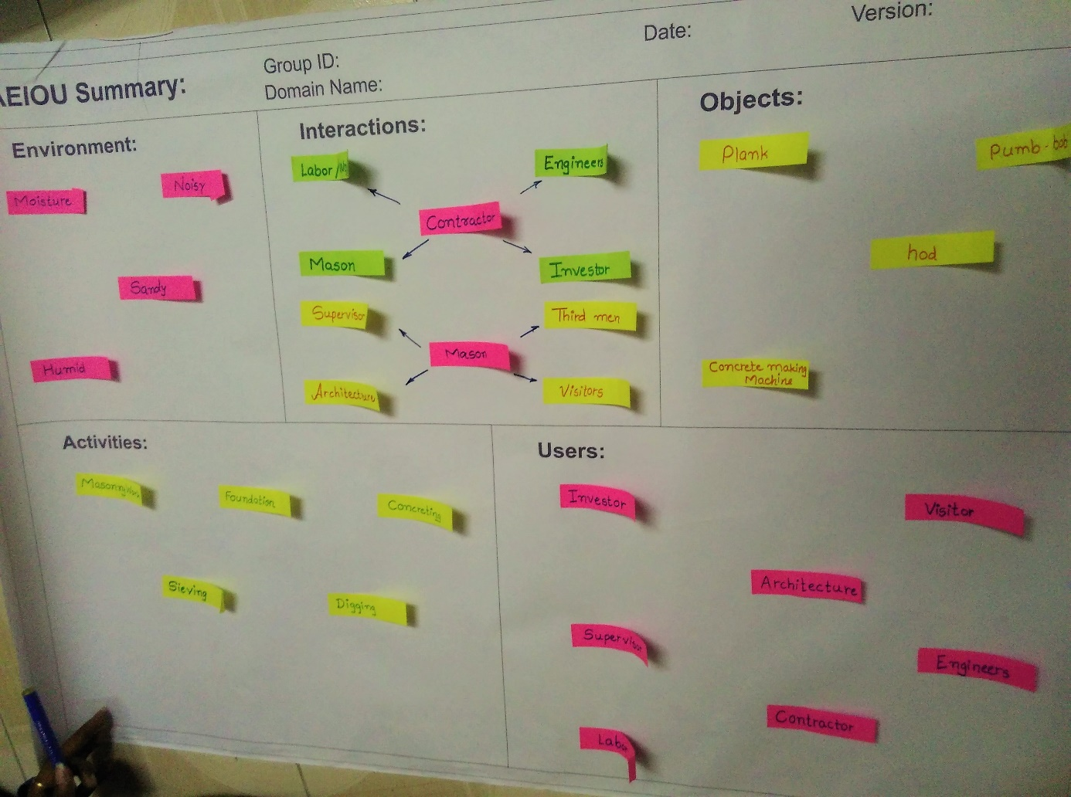

Observation Through AEIOU:-

ACTIVITIES CANVAS:

When we visit the construction site of society development, we saw that the labour was complete the footing and other was complete the foundation. Some labour making the concrete. Mason completes their masonry work.
- Footing
- Concreting
- Masonry Work
- Foundation
- Sieving
- Digging
- Watering
- Supervising

ENVIRONMENT CANVAS

When we visit to the construction site, We feel that the atmosphere is Humid and Noisy. There are many of person which is talk with each other and many noises are created by the machines. So, the atmosphere is very noisy.
- Humid
- Dusty
- Noisy
- Sandy

INTERECTIONS CANVAS
When we visit to the construction site, we saw that the interaction between investor to engineer for take information about the plot or houses. Mason talk with the labour about their work. Supervisor talk with the mason about the how much work is completed.
- Contractor – Supervisor
- Supervisor – Mason
- Architecture – Contractor

OBJECTS CANVAS
When visit society we saw that the some objects. For examples we saw the concrete making machine, plank, hod, plumb-bob, sieve, shovel, etc.
- Sieve
- Aggregate
- Water Tank
- Cement Bags
- Sand

USERS
When we visit the construction site, we saw some user as like Investor, Contractor, Labour, Engineers, visitors, etc.
- Contractor
- Visitors
- Investor
- Labour
- Architecture
- Supervisor

Empathy Mapping Canvas:-

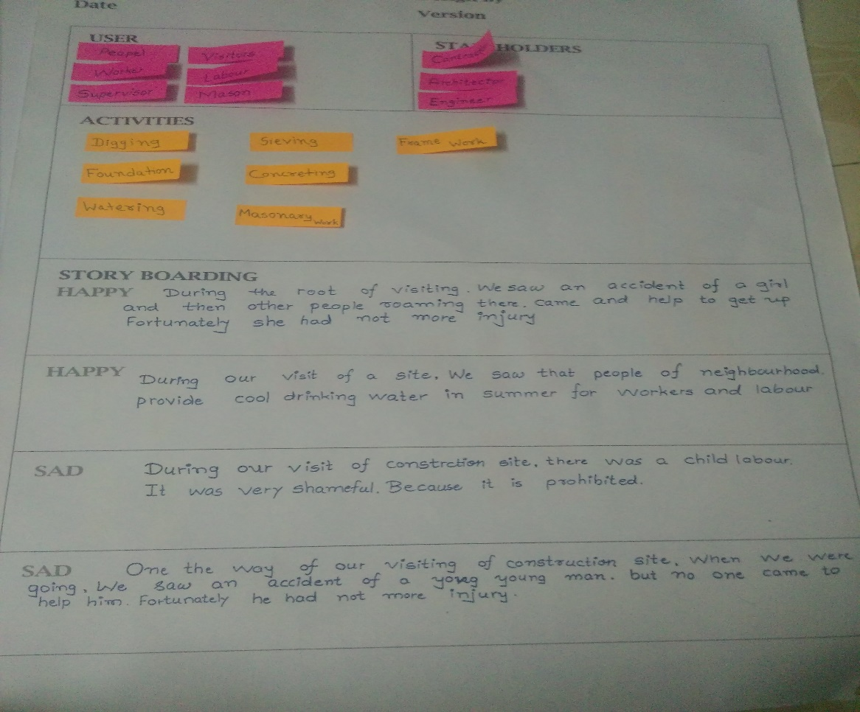

USERS
• CONCTRATOR
• VISITOR
• INVESTOR
• ARCHITECTURE

STAKEHOLDERS
- Contractor
- Supervisor
- Engineer

STORY BOARDING:-

HAPPY STORY

- During the root of visiting we saw accident of a girl and then other people roaming there came and help to get up. Fortunately she had not more inquiry.
- During our visit of a site we that people of neighbourhood provide cool drinking water in summer for worker and labour.

SAD STORY

- On the way of our construction site, when we were going we saw an accident of a young man, but no one came to help him. Fortunately he had no more injured.

- During visit a construction site, there was e children labour. It is very shameful. Because it is a prohibited.

Ideation Canvas
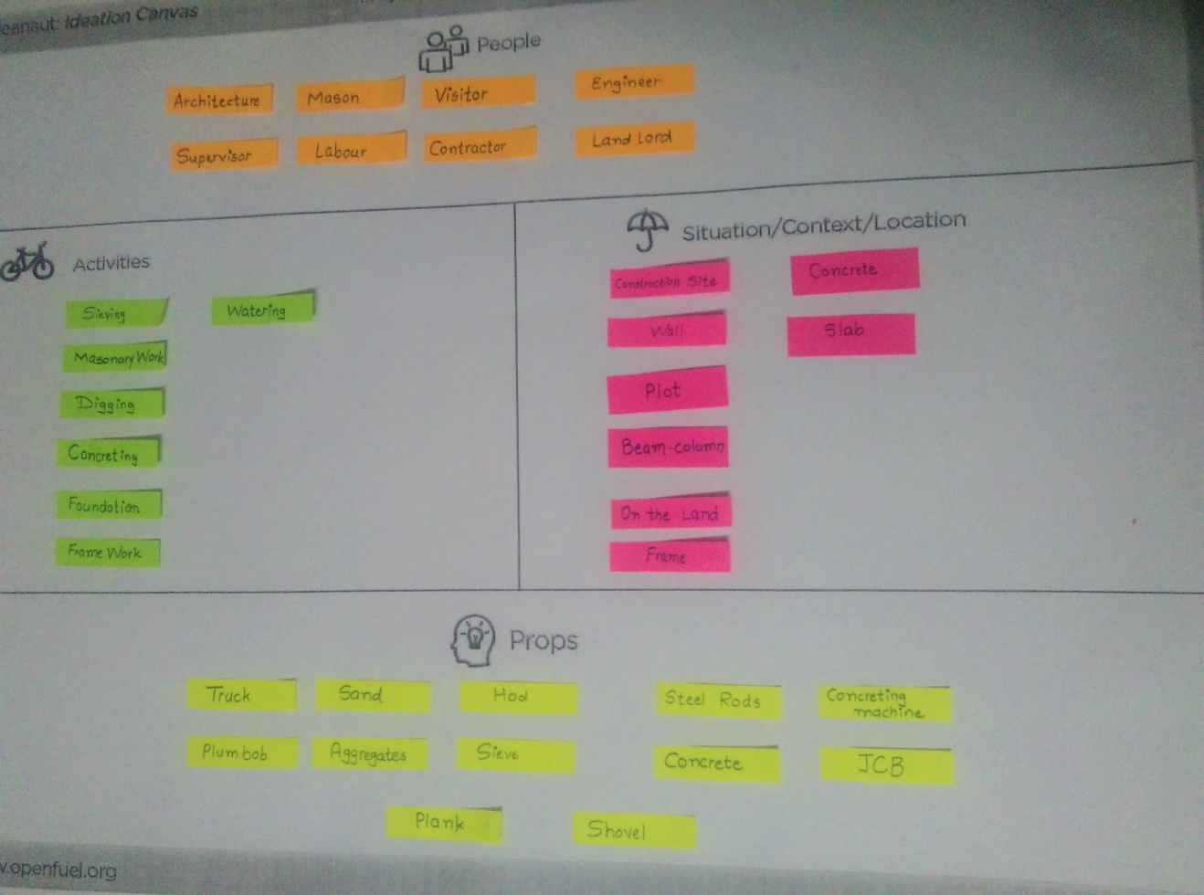

Product Development Canvas:
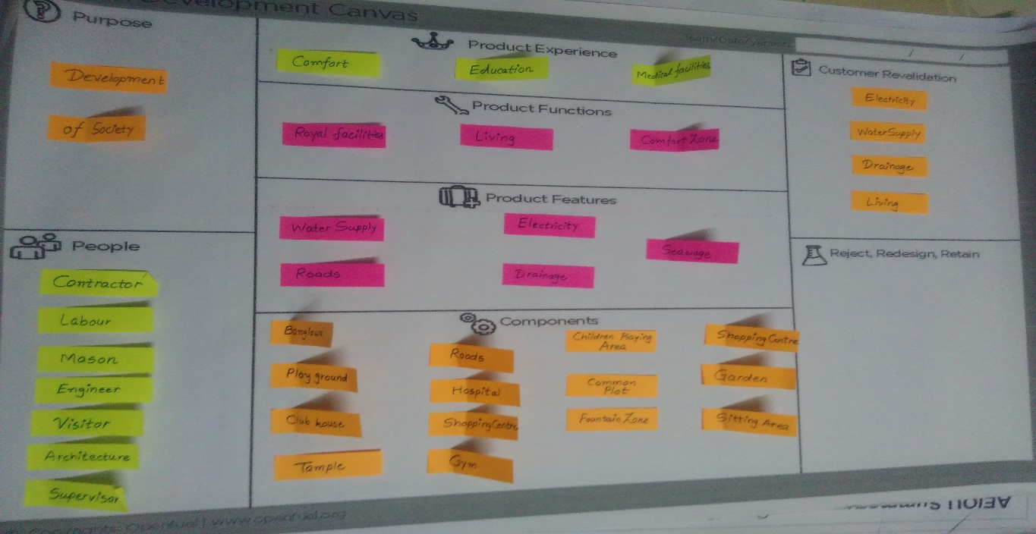

- Feedback analysis with the user shall be clearly included in the report:-

Feedback of engineering at construction side:-

Advantages:

– Flexibility: Bungalows are not restrictive as far as modifications are concerned. Space can easily be added by building an extension. There is anytime an option of converting a bungalow into a two-story property.
A bungalow offers a lot of room for renovation as space requirements changes. This level of flexibility does not exist in apartments and condominium units.
– Accessibility: Maybe the main attraction of a bungalow property is that with its single storey layout it is ideal for those with reduced mobility. Also because of the way in which these houses are constructed the interiors are highly customizable, meaning that doorways can easily be widened to more easily accommodate a wheelchair.
– Affordability: Maintaining a bungalow is affordable. Because of its moderate and open space, they have fairly modest heating and cooling requirements.
– Privacy: Because of their structure bungalows will either be detached or semi-detached, meaning that residents often have more privacy than in other types of property. Planting trees or shrubs around the edge of the property can create a very private atmosphere.
– Large plot size: Because of the nature of the foundations the overall size of the plot the property is built on will be larger than for a more conventional house. This means that you have excellent options for either extending your property or remodeling it.
– Good Investment: Buying a bungalow is a good investment. The property value of bungalow homes is not likely to decline. This architectural style has withstood the test of time. A well-maintained bungalow will have a higher resale value even during hard times. Indeed, in some areas the average bungalow has actually risen in value during the current property slump.

Disadvantages:
– Cost per square foot: It is the claim that bungalows are overpriced for the actual living space you get. As there is only one floor, the cost per square foot of internal space is almost always more than that of a two story house. However, buying a bungalow may be a valid option to get you the perfect location.
– Lack of storage: Because of the high cost to floor space ratio it is likely that a bungalow will have fewer rooms than a two-leZvels property of the same price.
– Reputation: Because of their practicality over the years bungalows have earned a reputation for being stylistically out-dated and rather stuffy.
– Layout Considerations: Because all rooms are on the ground floor some private areas, such as bedrooms or bathrooms may be more visible than usual.
– Security: A bungalow lacks some of the most basic deterrents possessed by other types of property: namely hard to reach windows. Because every room (including the sleeping areas of every member of the family) is accessible from the ground it is extra important to have good security on all your doors and windows.

FINAL MODEL & DETAIL:-

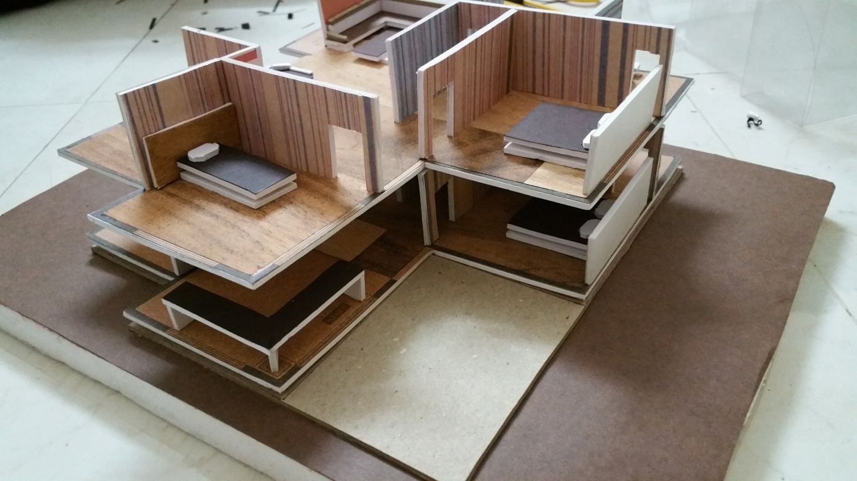

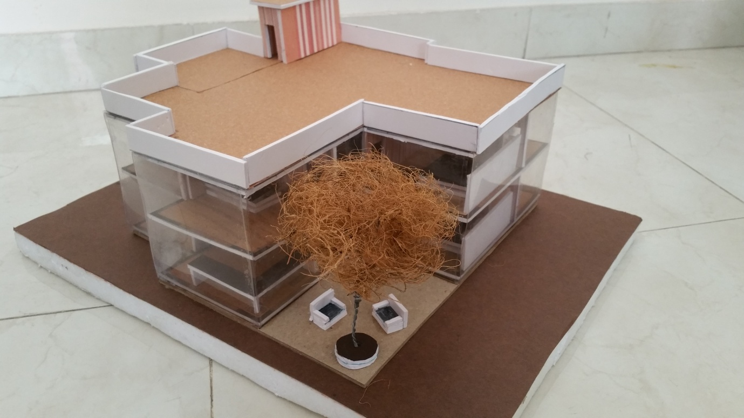

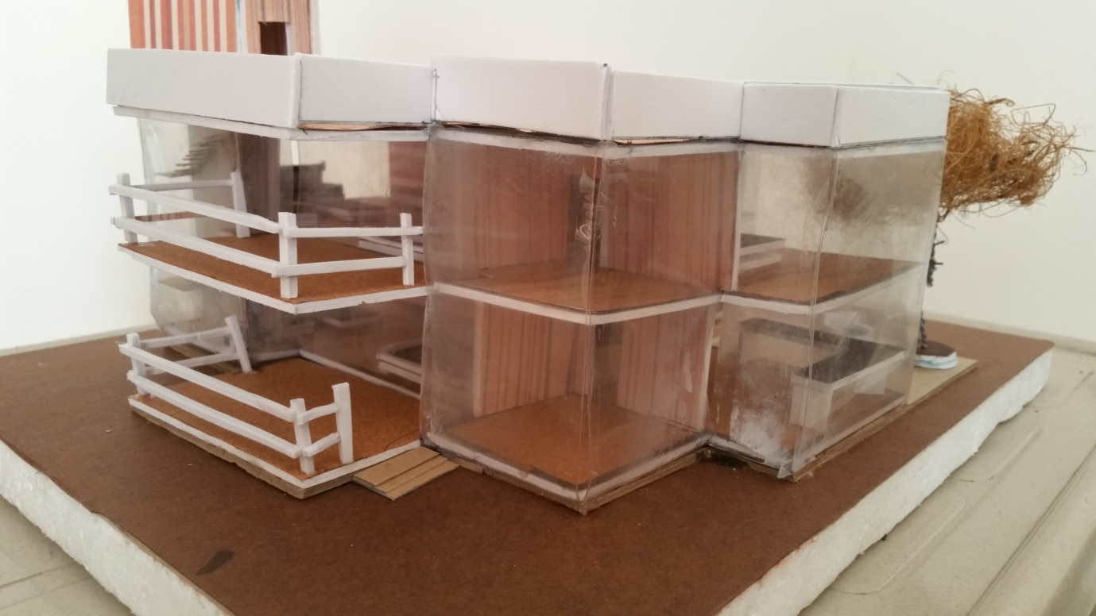

- Any other aspects you feel should be included

VALIDATION.

The cost of particular bungalow in our society is going to be affordable to middle class people and rich people obviously.
The cost of our bungalow is cheaper than the other society because.
The total payment of our bungalow is going to be taken in only and only white money.
Due to the change of the INDIAN CURRENCY by INDIAN GOVERNMENT

APPROXIMATE COST ESTIMATION:-
- Unit 1 :- BUNGLOW
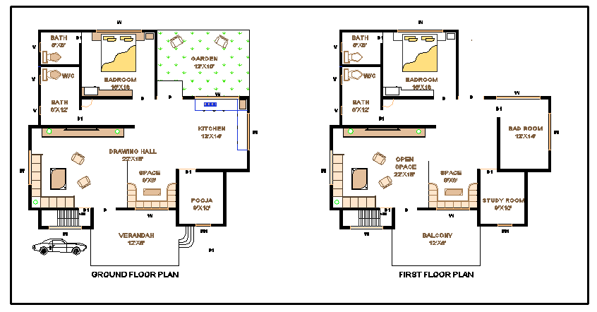
- Total plot area = 43 x 55
= 2365sq.feet
- Total built-up area = 37 x 48
= 1776sq.feet
CALCUCATION:- (land cost per square feet = 350)
- Land cost = 2365 x 350
= 827750 ₹/-
- Per 1 square feet construction cost = 950 ₹/-
- Contraction cost = 1776 x 950
= 1687200 ₹/-
- Total estimate = 1687200 + 827750
= 2514950 ₹/-
COST OF ONE BUNGLOW = 25,14,950 ₹/-
- Total number of bungalow = 48
- Cost of all bungalows = 48 x 2514950
= 12,07,17,600 ₹/-
GRAND TOTAL = 12,07,17,600₹/-

- Unit 2 :- HOSPITAL CONSTRUCTION
- Area = Hospital land + parking land
= (48 x 120) + (48 x 120)
=5760 + 5760
Total Area = 11520sq.feet
CONSTRUCTION COST PER SQURE FEET = 700 ₹/-(as per current construction rate)
- Construction cost = area x cost/ sq. Feet
= 5760 x 700
= 40,32000 ₹/-
+ 20,16,000 (land cost)
-------------------
60,48,000 ₹/-
- Parking land cost = 5760 x 350
= 20,16,000 ₹/-
- Total built-up with land = 60,48,000 ₹/-
Parking and gardening = 20,16,000 ₹/-
GRAND TOTAL = 80,64,000 ₹/-
- Unit 3:- APPROXIMATE SHOPPING CENTRE COST
GROUND FLOOR
- total number of shops = 6
- area of one shop = 14 X 20 = 280
- parking, wash room & other area = 160
- total = 6 shops = 280 X 6
= 1680
+ 160
----------
1840
- total construction area = 1840 X 850
= 15,64,000₹/-
+ 5,88,000 ( land cost = 1680 + 350)
-----------------
21,52,000₹/-
FIRST FLOOR COST = 15,64,000 ₹/-

GRAND TOTAL = (G.F + LAND) + (F.F COST)
= 21,52,000 + 15,64,000
= 37,16,000 ₹/-

- Unit 4 :- TEMPLE
- total area of temple = 50 X 50
= 2500
- construction cost = 2500 X 750
= 18,75,000 ₹/-
+ 08,75,000
-----------------
27,50,000 ₹/-

- Unit 5 :- APPROXIMATE ROAD COSTRUCTION COST
- width of road = 16 feet
- Length of rad = 43 X 68 = 2924 (length)
- Road = 2924 X 16
= 46,784 (square area)
- Road construction cost = 46,784 X 150 = 70,17,600 ₹/-
+ 1,63,74,400
-------------------
GRAND TOTAL = 2,33,92,000 ₹/-

- Unit 6 :- OTHER LAND AREA
- Area = 25,000 sq. Feet
- Land cost = 25,000 X 350 = 87,50,000 ₹/-

- TOTAL SOCIETY COST = 12,07,17,600 (Construction cost of bunglow@48 Nos)
+ 80,64,000 (construction cost of hospital)
+ 37,16,000 (construction cost of shoes@6 Nos)
+ 27,50,000 (construction cost of temple)
+ 2,33,92,000 (construction cost of road)
+ 87,50,000 (construction cost of other land area)
---------------------------------------------------------------------------------
= 15,94,39,600 ₹/- total approximate estimate of society

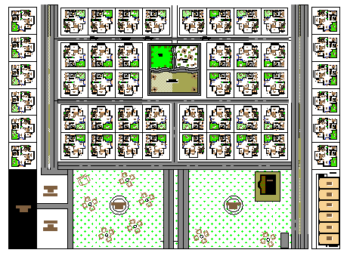

AREA CALCULATION
- Area of one bunglow: 43’X55’ = 2365 sq.feet
No.s of bunglow: 48
Total area of bunglow’s = 2365X48 = 1,13,520 sq.feet

- Hospital Area:
Construction area= 48X120
Parking area = 48X120
Total Hospital Area = (48X120)+(48X120)
= 11,520 sq.feet

- Commercial Area:1840 sq.feet

- Garden Area:
Garden:1 = 155x120 = 18,600 sq.feet
Garden:2 = 155X120 = 18,600 sq.feet
Total Garden area including Temple= 37,200 sq.feet

- Other Area:
Children Playing area = 3850 sq.feet
Party Plot area = 2475 sq.feet
Seating Zone = 2475 sq.feet
Total Area = 8880 sq.feet

- Road:
Total Road Area = 38,972 sq.feet

- Total Marginal Area = 48X40 = 1920 sq.feet

- Total construction Area = 2,13,852 sq.feet

- Total Society Area: 2,13,852 (total construction area)
+ 27,000 ( left side marginal area)
+ 27,000 (front side marginal area)
+ 27,000 (back side marginal area)
+ 13,750 (right side marginal area)
---------------------------------------------
= 3,10,102 sq.feet

B :-Summary of finding of prior Art search on their purpose (summary papers)

RESEARCH PAPER 1

N. VISWANADHAM
N. Viswanadham is Professor and Executive Director for The Center of Excellence Global logistics and manufacturing strategies in the Indian school Of Business, Hyderabad, India. He is also ISB in charge for the ISB-IBM Collaboratory on Service Sciences (COSS). He has held several prestigious positions before joining ISB: he was Deputy Executive Director of The Logistics Institute-Asia Pacific and also Professor in Department of Mechanical and Production Engineering at the National University of Singapore during 1998-2005, he was a GE Research Fellow during 1989-90, Tata Chemicals Chair Professor at the Indian Institute of Science, Bangalore, and the recipient of the 1996 IISc Alumni award for excellence in research. He was conferred the Distinguished Alumni Award for the year 2009 by the Council of the Indian Institute of Science.

Introduction
Of India’s 610 districts, the National Rural Employment Guarantee Act has a list of 200 backward districts. Similarly, out of India’s 600,000 society, around 125,000 are truly backward. There are 78 regions in the country, as per the NSS (National Sample Survey) classification. Based on these regions, the World Bank (2004) identifies 18 regions where human development is low. Currently, there is lot of public spending to improve the infrastructure, water and sanitation in these areas. The Socio- economic dualism in Indian economy is tackled by the Government by taking responsibility for uplifting the rural and the economically poorer sections. The Government does this by giving subsidies, loan waivers, and quota systems in educational institutions, jobs and offering several other schemes based on caste and profession. All these efforts are disparate, fragmented and piecemeal efforts and not much improvement has been achieved in most of the society. On the other hand, the society themselves are a powerhouse of large pool of man power. As we perceive there is a huge scope for the society to be self-sufficient and sustainable on their own. About 700 M people in India live in society and at least half of them are below 25 years of age. Availability of this rapidly expanding pool of young workers could and should be a major advantage for India’s economy if – a. the new generation of workers is healthy and educated b. the government succeeds in addressing social infrastructure (housing, health care, schools, colleges and universities) c. labor markets are generated for all categories of people primarily for those who are educated up to only the middle school.

Conclusions
There is no denying fact that we need smart society that provide welfare to the rural folks. This is the biggest challenge facing all developing countries today. There are technologies available and they are successful elsewhere. But the failure comes from lack of strategy, integrated planning and above all monitoring and execution of the activities. The STERM (Science, Technology, Engineering, Regulations and Management) framework can be used to design and build these society. We need to develop the ecosystem for each society depending on its location and investment climate. Our suggestion is to build smart society as contracts under PPP for group of companies with mandate to develop smart society.

RESEARCH PAPER 2

Professor Sir Brian Heap
Senior Adviser for Smart Society
Research Associate of the Centre of Development Studies

Introduction

Worldwide, 1.3 billion people remain without access to electricity and 2.7 billion are still cooking on harmful and inefficient stoves1 . Many live in remote rural society communities, and until they have access to energy services, little progress can be made to develop and improve their lives2 . As United Nations Secretary-General Ban Ki-moon has stated, “energy is the golden thread that connects economic growth, increased social equity, and an environment that allows the planet to thrive”3 . Improving the lives of rural communities by developing smart society is a concept analogous to the more familiar smart cities. The vision for smart society is that modern energy access can act as a catalyst for development – in education, health, food security, productive enterprise, clean water and sanitation, environmental sustainability and participatory democracy – which in turn supports further improvements in access to energy. Integrating energy access with other development initiatives, harnessing and developing local entre - preneurial capacities, and technological advances in the supply and use of sustainable energy are making such transformative change possible.

Conclusions

The conclusion is simple. Employment is the solution. For people who do not have the income to meet their basic needs, often in society that have no energy access, employment opportunities are the only sustainable means of reducing and eradicating poverty. The preceding essays argue that energy provision fosters employment opportunities. Moreover, employment creation and entrepreneurial activity mobilise the most abundant yet under - utilised resource in poor countries – the people for development. And the very people who constitute resources on the supply side also provide markets on the demand side. This interactive causation between supply and demand is a potential source of economic growth that highlights the importance of domestic markets in the process of development.

RESEARCH PAPER 3

PinakRanade
Spatial Sciences and Disaster Management Group, Centre for Development of Advanced Computing (C-DAC), Under Ministry of IT & Communications, Govt. of India, Pune, India – 411007
Introduction

When “India lives in its society" said Mahatma Gandhi, a great freedom fighter and visionary leader of India. A rural area is a geographic area that is located outside cities and towns, while rural areas are also known as 'society' in India. In these society, agriculture is the chief source of livelihood along with fishing, cottage industries, pottery, etc. According to the Erstwhile Planning Commission of India, a settlement with a maximum population of 15,000 is considered as “Society”. Much of India’s rural population lives in nucleated society, which most commonly have a settlement form described as shapeless agglomerate. India being a rural dominated country, the smartness concept is not even thought about the rural areas. All areas which are not categorized as urban area are considered as rural area. Number of rural units or society in India have increased from According to 2011 census, rural area has population of 68.84%, whereas urban area has population of 31.16% only. It is growing fact that the rural population is suffering more consequences for livelihood as compared to urban areas. The difficulties of livelihood may be forcing rural population to migrate to the urban areas. The government has already recognized this issue and has put serious efforts through various schemes for enhancing livelihood of rural masses. Presently, rural development mainly focuses on poverty alleviation, better livelihood opportunities, provision of basic amenities and infrastructure facilities through innovative programmes of self employment.
Keywords: Information Technology, Rural, Smart Society, Sustainable Development

RESEARCH PAPER 4
Asima Mishra
Spatial Sciences and Disaster Management Group, Centre for Development of Advanced Computing (C-DAC), Under Ministry of IT & Communications, Govt. of India, Pune, India – 411007
Introduction
Such changes are not very uncommon for human beings as human civilization has passed through various phases of development. Some of the milestones, which are witness to this development, are Prehistoric age, Stone Age etc.; the current era of human development is quit ahead and popularly known a
s “Smart age”. Human beings are using smart phones, smart TVs and live in smart homes. The concept of smartness is popular in respect of human development irrespective of rural or urban area, literate or illiterate in all the countries and India is not exception to it. Like many developing countries, India too is a rural dominated country. Though, the awareness of the smartness concept is well recognized by the planners and policy makers, but not effectively implemented for the rural areas. In recent times, there is an immense interest in the development of Smart Cities. Making a city "smart" is emerging as a strategy to mitigate the problems generated by the urban population growth and rapid urbanization. Globally, the concept of ‘Smart City’ is a significant initiative that seeks to improve the quality of life of urban citizens. Smart Cities across the country has the potential to be a game-changer in the country’s urban landscape and the lives of ordinary citizens. The smart city initiative is having good potential for urban development and India has also recognized this potential and is at the edge to start implementing this concept. This will facilitate better living for about 30% of the population, who live in urban area. But, more than half population will not be benefited from smart city development. Conditions in rural area are very different as compared to urban, so the same model of smart city cannot be implemented for the society. The efforts of rural development may not work on the same principle as of smart city.

Conclusions
Smart Society are the need of the hour as development is needed for both rural and urban areas for better livelihood and Information technology will offer effective solution. There are successful technologies available, which have been implemented in urban areas. There is tremendous pressure on urban landscapes due to migration of rural people for livelihood. Smart Society will not only reduce this migration but also irrigate the population flow from urban to rural area. ICT/ IT and GIS are the unbreakable pillars to support the whole process of society development.

RESEARCH PAPER 5

Introduction

The Smart Society Initiative is identifying how barriers to sustainable energy access in off-grid rural communities in developing countries can be overcome, and will make recommendations to policy makers, donors and stakeholders more generally regarding actions that need to be taken to address those barriers. The concept behind the ‘smart society’ is that modern energy access acts as a catalyst for development – in education, health, food security, productive enterprise, environment and participatory democracy – that in turn supports further improvements in energy access. The organising partners for the Arusha workshop were the Cambridge Malaysian Education and Development Trust (CMEDT), the European Academies Science Advisory Council, the International Science Programme (ISP) at the University of Uppsala, the Swedish Secretariat for Environmental Earth Systems Sciences (SSEESS) at the Royal Swedish Academy of Sciences, the Tanzanian Academy of Arts and Sciences and the Kenyan National Academy of Sciences. The workshop was funded by CMEDT, ISP and SSEESS.
Keywords: Information Technology, Rural, Smart Society, Sustainable Development

RESEARCH PAPER 6

Norizan Abdul Razak
UniversitiKebangsaan Malaysia, Malaysia
Abstract
The current study mainly aimed to investigate the Malaysian Smart Society project in a rural community which is labeled as Kg Besting in Malaysia. Specifically, the study intended to address the major issues faced by the community of farmers, identify the Smart Society indicators and put forward a strategic plan for the Smart Society implementation. It was carried out among Malaysian farmers in Kg Besting community in Malaysia. Data was collected through a survey, focus group interviews and documents. The quantitative and qualitative analyses of the data revealed that the major issues faced by the farmers in this community in agriculture are limited involvement of human capital in agricultural activities, the small size of land and limited knowledge of using technologies and innovative techniques to enhance the agricultural processing and production. Other issues are relevant to Micro Small Medium Entrepreneurs (SMMEs) in Kg Besting include lack of raw materials and crops, lack of machinery, limited knowledge and lack of advice and networking on how to ensure mass production and healthy marketing competition at the regional and global levels. Thus, the study emphasizes the importance of meeting the community‘s needs in Kg Besting and offers several useful recommendations. In conclusion, by incorporating the concept of ―Smart Society‖, the current study considers the potential Smart Society as an innovative means of improving rural people‘s life and it introduces a strategic implementation of the Smart Society project in Kg Besting in three phases; social empowerment, developing the Smart Society ecosystem and economic empowerment.

Keywords: Social empowerment, smart society ecosystem, SMMEs

RESEARCH PAPER 8

MuradSaeed
University Kebangsaan Malaysia, Malaysia
Introduction

Smart communities and smart society are being developed worldwide. Smart community is defined as a community with a vision of the future that involves the application of information and communication technologies in a new and innovative way to empower its residents, institutions and regions as a whole. A smart society is a concept which refers to a set, series or even a bundle of services being delivered to a group of residents inhabiting that particular rural area and businesses effectively and efficiently . Integration of ICTs in projects aiming to empower rural communities in different countries is evident of the positive impact on rural people‘s economic empowerment . The concept of smart community or society has become a global phenomenon that exists all over the world .
Conclusions
The findings of the current study revealed several issues encountered by the farmers in Kg Besting in Malaysia. The most prominent issues are their limited involvement in agricultural activities, the small size of land and limited knowledge of using technologies and innovative techniques to improve the quality of agricultural products. The study also highlighted other issues associated with the development of SMMEs and marketing in Kg Besting. Therefore, the study recommends that for successful implementation of the smart society initiative in Malaysia, there is a need for carrying out this implementation in three phases; social empowerment, developing the smart society ecosystem and economic empowerment.

RESEARCH PAPER 9

N. Viswanadham

Introduction

A Smart Society is a bundle of dozens of services delivered effectively to the residents and businesses in an efficient manner. These services could be location specific depending on the demography of the society and occupations of the residents. These services such as Power, Water, Buildings, Retail, Health care, etc. were built several decades ago. New designs, technologies and management models should be used to upgrade the existing ones and in building the new ones. This requires standardization, use of IT and sensor networks. Requires strategy, integrated planning and above all monitoring and execution of the activities using appropriate governance models.
Resources
Land and water are the natural resources. Education, Finance, Seed, Fertilizers, etc. are necessary resources. The Government support from various programs provides either cash or subsidies. Entrepreneurial environment would require Micro Financing organizations, Supporting industries and Orchestrators to connect the SMEs to the Global Value Chains

