Aug 01. 6 signs your furnace needs repairing
KEYWORD PHRASE: furnace repair signs
Furnaces are lifesavers when the weather gets cold. But, what about the time when you are not using it? Are you taking enough care of it during the time? If not, then you may face problems during winters due to a damaged furnace. If you’ve not taken a look at your furnace for long, then it’s time you do now. Chances are it may already need repair. Here are seven furnace repair signs:
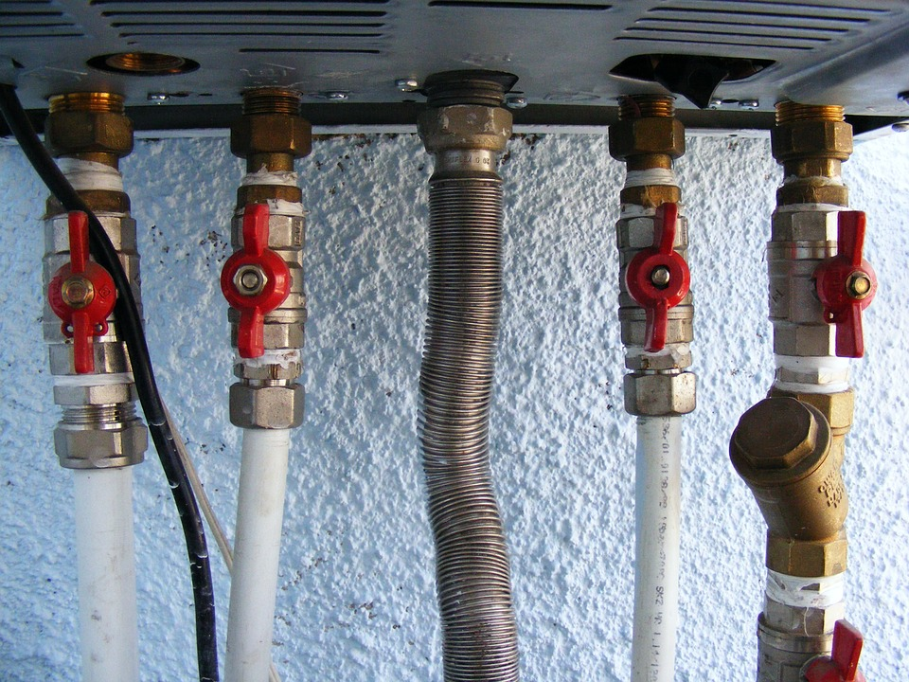
Image source: www.pixabay.com

Strange noises coming from your furnace
Yes, furnaces make sounds. But, if your furnace is making strange noises and also not working properly, it is a sign that something is wrong with it. In such a case, you should take immediate professional help to solve the problem.

A rise in the heating bills
Your furnace utilizes more energy starting up and shutting off than it uses while running. So, frequent turning on and off puts stress on the furnace that makes it work harder to heat the room. This prevents your furnace from heating your room properly. If you have observed such a issue with your furnace then this may be the reason for abnormal hike in your heating bills.

Water leakage around the furnace
The problem of leaking water from the furnace is not as dangerous as a gas leak. But, water leak might not help your furnace work efficiently. The leakage interferes with the heating effects of the furnace and prevents the furnace from keeping the house warm. If you have observed water leakage around your furnace, call a technician immediately to fix the issue.

Thermostat becomes ineffective
The primary function of the thermostat is to notify the HVAC system of how much heat it should produce. But, when you have to adjust the thermostat higher and higher to heat up the room a little bit, it is a sign that your furnace needs repair. Such an issue may stem because of tripped wire, blown fuse or loose wiring. As there is a risk of electric problems and short circuit, it is better to call a trained technician to solve this issue.

Carbon monoxide detector goes off
Furnaces are equipped with carbon monoxide detectors to detect the presence of toxic gases. If the carbon monoxide detector trips, the first thing you should do is to turn the furnace off and open the doors and windows to ventilate your home. The next step is to call a trained HVAC technician to look into the matter.

Dust coming from the heat registers
If you are experiencing a degraded quality of air in your home, then it may be because of poor furnace maintenance. This condition of the furnace may move dust, bacteria, and other foreign particles in the air that may give rise to cough, cold, and other respiratory ailments. Such a situation calls out for professional cleaning and probably repair of your furnace.
If you are worried about the degrading air quality, rise in the heating bills, and water leakage, a team of well experienced technicians will help you resolve issues regarding your furnace.

