ECOM4000
ECONOMICS

Table of contents
Part A- Microeconomics 3
Question 1 3
Question 2 3
Question 3 3
Question 4 4
Part B- Macroeconomics 4
Question 1 4
Question 2 4
Question 3 5
Indian economy 5
Question 1 5
Question 2 5
Question 3 5
Reference 7

Part A- Microeconomics

Question 1
The type of market structure where Coles and Woolworths operate is an oligopolistic market. In this market structure there exist only a few numbers of large players. In this case of Australia, the big players are Coles, Woolworths, Aldi and many more. There are also a few numbers of medium and small players of the market as well (Iossa and Martimort, 2015). Due to the presence of the small number of players in the market, each action of a single player affects the production and the prices of the other players in the market. This is also evident from the cases provided in the question. These characteristics ensure that the market structure where Coles and Woolworths operate is an oligopolistic market.
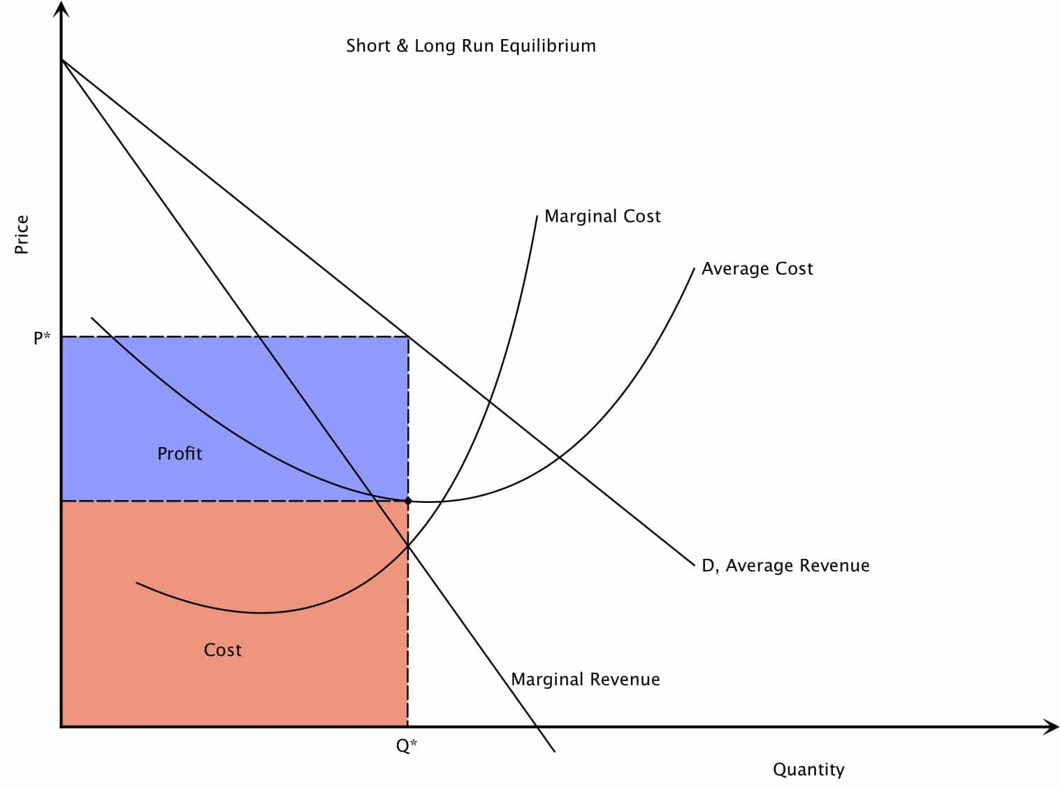
Figure 1: The oligopolistic market structure
(Source: Developed by the learner)

Question 2
The oligopolistic market structure assigns more power to the players at each of the products. The goods and the services sold in the oligopoly market structure are similar or slightly different to the products of the other players of the market. Therefore, each of the players has the ability to lower their prices in order to attract more customers. However, in this market structure the production of one player influences of the production of the other players in the market as well. Therefore, it is in the interest for Woolworths to go in a price war in order to increase the market share (Friedman, 2017). The customers, in that lower price, would find it convenient to buy from Woolworths and the demand for the products of the other sellers would go down pushing them to reduce their excessive production.

Question 3
The market for the farmers has the competitive market structure. This is due to the fact that, there are a huge number of farmers in the market that supplies goods and services to the big corporate firms. Apart from that they also sell their goods and the services on their own as well. One of the features of the perfectly competitive market is the lack of power over the prices of the market. Here in this case, as shown in the source two, the cost reduction is compelling the farmers to sell their products at a cheaper cost (Cowell, 2018). There are a number of farmers in the market the firms can choose to source their product if one seller refuses to lower his prices. Therefore, the market for the vegetables provided by the farmers is a perfectly competitive market.

Question 4
The price war between the big players of the market is putting a pressure on the cost which in turn is in part dependant on the cost at which the companies buys vegetables from the farmers. In the long term, the excessive pressure may push the equilibrium prices for the vegetables below the individual average cost curve of the farmers (Bauer, 2018). This may push the farmer to go out of the business in the long run.
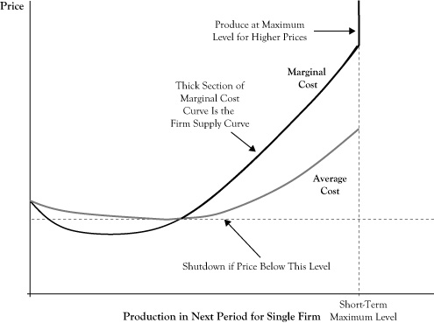
Figure 2: the cost curves of individual farmers
(Source: Developed by the learner)

Part B- Macroeconomics

Question 1
In the year 2013, the economy of Spain was in a recessionary phase. Agénor and Montiel (2015) stated that one of the important characteristics of the recessionary phase of the business cycle is the lack of aggregate demand for the goods and the service in the economy. According to the graphs provided, during the year 2013, the consumer spending of the economy was low. In addition to that, the unemployment rate was also very high as the economy was not operating at a full employment rate. Consequently, the actual GDP growth rate of the country fell far below the projected growth. In this phase the aggregate demand curve shifts to the left side leading to a decrease in the prices for the goods and the service in the economy (Johnson, 2017). The reduction in the demand also has resulted in a higher foreign demand for the domestic products which further increased the trade deficit of the economy.
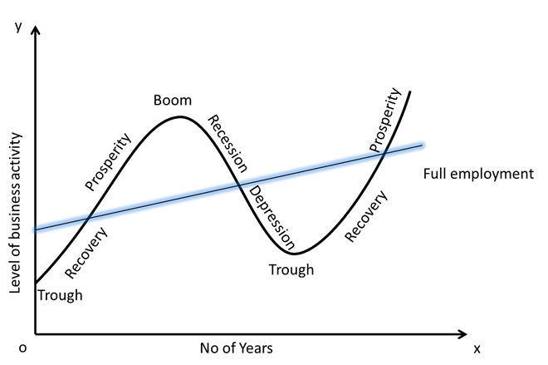
Figure 3: Different phases of the business cycle
(Source: Developed by the learner)

Question 2
In the year 2014, the economy of Spain entered the boom phase of the business cycle. One of the major characteristics of this phase is the operation of the economy beyond the level of full employment. The graphs show the evidence that, this boom period is the result of increased consumer spending. Consumer spending is one of the components of aggregate demand of the economy (Goodwin et al. 2015). This, in turn, influenced the other components of the economy such as the investment which in turn resulted in a lower and reduced unemployment rate in the economy. This can also be confirmed through the date provided in the question. The drastic reduction in the unemployment rate and the increase of consumer spending together allowed the GDP growth of the country to become positive from the negative figures which as shown in the year 2013 (Uribe and Schmitt-Grohé, 2017).

Question 3
As per the data provided in the question, the current unemployment rate is 24.47%. That means around 76% of the economy is employed in some form of a productive system of the country. Now, the number of unemployed labours in the economy of Spain is =
76% of the overall labour force is 17353000
Therefore, 100% of the labour force is (17353000*(100/76))= 22832895 (Approx)
Now the number of unemployed labours in the economy is= (22832895*(24.47/100))= 5587209

Indian economy

Question 1
In the year 2016, the economy of India is experiencing an expansionary phase of the business cycle. The real income of the customers of the market has increased over the years which eventually have boosted the aggregate demand in the economy. As a result, the aggregate demand curve has shifted to the right side. However, it needs to be noted, for the case of the Indian economy, the lower energy prices in the year 2016, has enabled the consumer to spend more on goods and the services (Sharma, 2016). Another characteristic of the Indian economy in the year 2016 also justifies the fact that the Indian economy is in the boom phase of the business cycle. This is the increase in the consumer inflation which is further expected to increase in the near future.

Question 2
The falling energy prices have an extensive impact on the other parts of the economy. Fuel is used in different activities of the economy including transportation, electric generation and many more (Agrawal, 2015). The lower fuel prices, thus, have reduced the prices of other goods and services of the economy. This is due to the fact that, transportation of the produced goods and raw materials have reduced sharply in the case of the Indian economy. This has eventually increased the disposable income of the consumers of the market leading to a higher aggregate demand.

Question 3
The macroeconomic indicator of consumer price index and consumer price inflation needs to be monitored closely by the government. The excessive consumer price index which is likely after the impressive economic growth of the economy can push the economy to a recessionary phase due to reduced aggregate demand (Yadav and Joseph, 2018). However, the Reserve Bank of India can use tight monetary policies and undertake supply-side steps to control the prices of goods and the services in the economy. The tight monetary policies in the form of reduced or stagnant money supply can absorb the volatility of the overall inflation of the economy (Varghese et al. 2016). Furthermore, supply sidesteps that can curb the cost-pull inflation in the economy may also be used by the reserve bank of India in order to keep a steady consumer price inflation. The rising inflation for goods and the services may become penalising for the consumer spending which is currently fuelling the impressive economic performance of India Amidst the marred global economic performances.

Reference
Agénor, P.R. and Montiel, P.J., 2015. Development macroeconomics. Princeton University Press.
Agrawal, A.N., 2015. Indian economy. New Age International Pvt.
Bauer, M.J.R., 2018. Principles of microeconomics.
Cowell, F., 2018. Microeconomics: principles and analysis. Oxford University Press.
Friedman, L.S., 2017. The microeconomics of public policy analysis. Princeton University Press.
Goodwin, N., Harris, J.M., Nelson, J.A., Roach, B., and Torres, M., 2015. Macroeconomics in context. Routledge.
Iossa, E. and Martimort, D., 2015. The simple microeconomics of public‐private partnerships. Journal of Public Economic Theory, 17(1), pp.4-48.
Johnson, H.G., 2017. Macroeconomics and monetary theory. Routledge.
Sharma, D., 2016. The nexus between financial inclusion and economic growth: Evidence from the emerging Indian economy. Journal of financial economic policy, 8(1), pp.13-36.
Uribe, M. and Schmitt-Grohé, S., 2017. Open economy macroeconomics. Princeton University Press.
Varghese, M., Guha, S. and Agarwal, A., 2016. SCENARIO OF WOMEN EMPOWERMENT IN 2016: IT’S ROLE IN INDIAN ECONOMY & BUSINESS. The world, 2(11).
Yadav, A.K. and Joseph, J., 2018. Growth and Structural Changes in Indian Economy—An Analysis. Reflecting on India’s Development (pp. 45-65). Springer, Singapore.

