PROJECT BASED REPORT
On
BABLOO
Submitted in partial fulfillment of the
Requirements for the award of the Degree of
Bachelor of Technology
In
Computer Science & Engineering
By
Student ID | Student Name
170030078 | REVVAATHY
170030217 | NAVYA SRI

DEPARTMENT OF COMPUTER SCIENCE AND ENGINEERING
(DST-FIST Sponsored Department)
K L E F
Green Fields, Vaddeswaram, Guntur District-522 502
2018-2019
K L E F
DEPARTMENT OF COMPUTER SCIENCE ENGINEERING
(DST-FIST Sponsored Department)

CERTIFICATE

This is to certify that the course based project entitled “BABLOO” is a bonafide work donebyA.REVVATHY (170030078), CH. NAVYA SRI (170030217) in partial fulfilment of the requirement for the award of degree in BACHELOR OF TECHNOLOGY in Computer Science Engineering during the academic year 2018-2019.

Faculty In Charge Head of the Department

K L E F
DEPARTMENT OF COMPUTER SCIENCE ENGINEERING
(DST-FIST Sponsored Department)
DECLARATION

We hereby declare that this project based lab report entitled “BABLOO” has been prepared by us in partial fulfillment of the requirement for the award of degree “BACHELOR OF TECHNOLOGY in COMPUTER SCIENCE ENGINEERING” during the academic year 2018-2019.
We also declare that this project based lab report is of our own effort and it has not been submitted to any other university for the award of any degree.

Date:13/04/2019
Place: Vaddeswaram

ACKNOWLEDGMENTS

My sincere thanks to Dr Y. PRASANTH in the Lab for their outstanding support throughout the project for the successful completion of the work
We express our gratitude to Dr .HARIKIRAN, Head of the Department for Computer Science and Engineering for providing us with adequate facilities, ways and means by which we are able to complete this project based lab work.
We would like to place on record the deep sense of gratitude to the honorable Vice Chancellor, KLE for providing the necessary facilities to carry the concluded project based lab work.
Last but not the least, we thank all Teaching and Non-Teaching Staff of our department and especially my classmates and my friends for their support in the completion of our project based lab work.

INDEX

Sl.no | Title | Page  no
1 | Abstract | 6
2 | Introduction | 7
3 | Project Description | 8
4 | List of Entities & Attributes | 9
5 | Relationships and Cardinality | 10
6 | ER Diagram | 11
7 | Schema | 12
8 | Create and Insert SQL Queries | 13-17
9 | SQL Queries related to database | 18-20
10 | Conclusion | 21
11 | References | 22

ABSTRACT

In this project we will implement where a Person has to navigate to a new place in a completely new city and avail a best economic service suitable to his requirement. So first he has to book a train ticket to reach the city items, seat availability for passengers, rate of per seat, bill generation, if any cargo services and its prices, online booking & manual booking entry & E-tickets. Then search for a good hotel room and then he has to inquire how to reach the destination. Reaching destination involves checking for the place map, route map, shortest route that is traffic free and the best available means of transport to reach there and the timings. After finishing his work he may want to eat in restaurant or go to a movie. For this he need to find the best restaurant serving the required cuisine and a theatre which hosts the movie of his choice in apt times.

INTRODUCTION

Database is a collection of inter- data. The data is typically organized to model aspects of reality in a way that supports processes requiring information. A DBMS makes it possible for end users to create, read, update and delete data in a database. The DBMS essentially serves as an interface between the database and end users or application programs, ensuring that data is consistently organized and remains easily accessible. The DBMS manages three important things: the data, the database engine that allows data to be accessed, locked and modified and the database schema, which defines the database’s logical structure. These three foundational elements help provide concurrency, security, data integrity and uniform administration procedures. The DBMS can offer both logical and physical data independence. That means it can protect users and applications from needing to know where data is stored or having to be concerned about changes to the physical structure of data.

The main purpose of maintaining database for Bus management is to reduce the manual errors involved in the allocation process and make it convenient for the management to maintain the data about their customers and also about the tickets available for each bus at them.Due to automation many loopholes that exist in the manual maintenance of the records can be removed. The speed of obtaining and processing the data will be fast. For future expansion the proposed system can be web enabled so that customers can make various enquiries about Bus routes and timings. It takes a lot of time and causes many errors while data entering. Due to this, sometimes a lot of problems occur and they are facing many disputes with customers. To solve the above problem, we design a data base which includes customer details, availability of seats, list of buses available, bus timings, routes and cities the bus visits. This program also helps us to know the present status of a bus to the customer that is whether the bus is late or not and bill received or not.

PROJECT DESCRIPTION
This project deals with the storing of database of a person called babloo who has to navigate to a new place in a completely new city and avail a best economic service suitable to his requirement. So first he has to book a train ticket to reach the city. Then search for a good hotel room and then he has to inquire how to reach the destination. Reaching destination involves checking for the place map, route map, shortest route that is traffic free and the best available means of transport to reach there and the timings. After finishing his work he may want to eat in restaurant or go to a movie. For this he need to find the best restaurant serving the required cuisine and a theatre which hosts the movie of his choice in apt times. So to achieve all this, first he has to purchase train tickets in the railway reservation site. Then to book a hotel room in a metro city, he need to attend a trip advisor (famous site to book hotel rooms), read the reviews and finally he’ll book the room. Then he has to search a map for his destination. Then inquire about the bus routes to his destination using the same search engine. Based on the availability of buses he has to plan his timings and route. To serve his intended visit, he has to go to a nice site where it provides all consumables and deliverables at best prices and finish his work. Then to book a movie ticket, he has to login to easy movies India (an online movie ticket booking site) that concentrates on the parameters like select city, select movie and select date; user just by giving all these details he can get the list of theatres where the selected movie is playing; finally he’ll select the theatre he was interested and book the ticket. Then navigate to a site and find the list of restaurants that serve the specific cuisine he wants. Out of those based on the ratings and user experiences he makes a choice. And then again he has to search for the location of restaurant and theatre using the search engine.

LIST OF ENTITIES AND ATTRIBUTES

ENTITY ATTRIBUTES
Reservation | Class,destination,gender,dob,name
User | Id, name, dob, address,contact
Ticket | Ticket_no,book_date,booking_type
Hotel | Room_no,name,cost,address
Maproutes | Distance,time
Theatere | Screen_no,tickets,movie,food
Resturant | Table_no,name,cuisine

RELATIONSHIPS & CARDINALITY

- User books Ticket (1 : 1 )
- User chooses Location ( 1 : N )
- User goes_to Resturant ( N : N )
- Maproute displays Location ( 1 : N )
- User does Reservation ( N : N)
- User goes_to Theatere ( N : M)

ER DIAGRAM
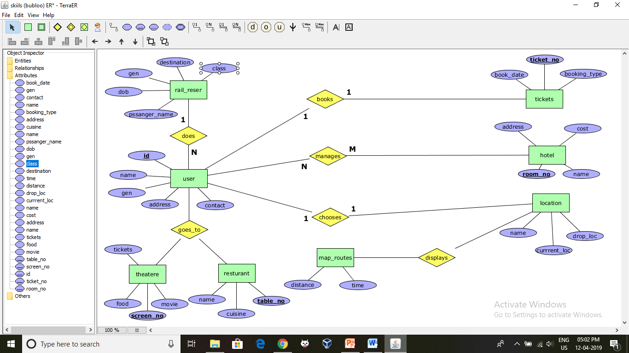

SCHEMA

Reservation (Class,destination,gender,dob,name)
User (Id, name, dob, address,contact)
Ticket (Ticket_no,book_date,booking_type)
Hotel (Room_no,name,cost,address)
Maproutes (Distance,time)
Theatere (Screen_no,tickets,movie,food)
Resturant (Table_no,name,cuisine)

CREATE & INSERT SQL QUERIES
User:
create table user(Id int primary key, name varchar(10) not null, dob date, address varchar(50),contact int not null);

Reservation:
create table reservation(class varchar(2) not null,destination varchar(20),gender varchar(2),dob date,name varchar(20));

Ticket:
create table ticket(tikid int, serviceno int, total int, available int, fare int, primary key (tikid), foreign key(serviceno) references bus(serviceno));

Hotel:
create table Hotel ( (Room_no int primary key , name varchar(20) not null,cost float not null,address varchar(20));

Theatere:
create table Theatere(screeen_no int primary key,tickets int not null,movie varchar(20) not null,food varchar(20));

Resturant:
create table resturant (table_no int primary key,name varchar(20),cuisine varchar(20));

Maproutes:
create table maproutes (distance int,time date);

INSERTION:

User:
insert into bus values(101,1201,'vijayawada','hyderabad','18:00');
insert into bus values(102,1202,'guntur','bangalore','19:45');
insert into bus values(103,1302,'vijayawada','chennai','16:30');
insert into bus values(104,1401,'vijayawada','bangalore','19:00');
insert into bus values(105,1503,'vijayawada','vizag','20:30');
insert into bus values(106,1601,'guntur','hyderabad','18:30');

Passenger:
insert into rail_reser('somu','1999-03-18','nuziwidu','A');
insert into rail_reser(passen_name,dob,dest,class) values('somu','1999-03-18','nuziwidu','A');
insert into rail_reser(passen_name,dob,dest,class) values('priya',date '1997-03-18','eliya','A');
insert into rail_reser(passen_name,dob,dest,class) values('aaliya',date '1997-12-24','romiya','A');
insert into rail_reser(passen_name,dob,dest,class)values('ashni',date '2014-09-6','newariya','B');
insert into rail_reser(passen_name,dob,dest,class) values('tina',date '1997-11-12','ireland','A');

Theatere
insert into theatere(screen_no,movie,food,tickets)values(1,'alexder','drink',2);
insert into theatere(screen_no,movie,food,tickets)values(2,'titanic','popcorn',3);
insert into theatere(screen_no,movie,food,tickets)values(3,'legend','samosa',3);
insert into theatere(screen_no,movie,food,tickets)values(4,'marley','pizza',4);

Hotel
insert into hotel(room_no,address,cost,name)values(1001,'delhi',5000,'priya');
insert into hotel(room_no,address,cost,name)values (1002,'delhi',10000,'swapna');
insert into hotel(room_no,address,cost,name)values(1003,'delhi',15000,'swapna');
insert into hotel(room_no,address,cost,name)values(1004,'ludhiana',15000,'swathi');

Tickets
insert into tickets(sc_no,book_date,booking_type)values('1',date '2019-05-12','online');
insert into ticket(sc_no,book_date,booking_type)values('2',date '2017-01-06','offline');
insert into ticket(sc_no,book_date,booking_type)values('2',date '2014-11-11','online');
insert into ticket(sc_no,book_date,booking_type)values('2',date '2019-07-30','online');

Worker:
insert into worker values(101,'tarun','1978-11-10',5000,101);
insert into worker values(102,'ram','1975-10-21',4500,102);
insert into worker values(103,'krishna','1982-06-19',6000,103);
insert into worker values(104,'prabhu','1979-04-18',7000,104);
insert into worker values(105,'kishore','1985-02-28',5500,105);
insert into worker values(106,'charan','1980-12-02',5000,106);

Reservation:
insert into rail_reser values(1,1103,'2017-01-04','ticket',1200);
insert into rail_reser values(2,1101,'1985-02-28','ticket',1000);
insert into rail_reser values(3,1102,'2017-04-07','cargo',2400);
insert into rail_reser values(4,1104,'2015-05-15','ticket',950);
insert into rail_reser values(5,1105,'2016-10-20','cargo',800);
insert into rail_reser values(6,1106,'2016-12-18','ticket',1000);

OUTPUTS:

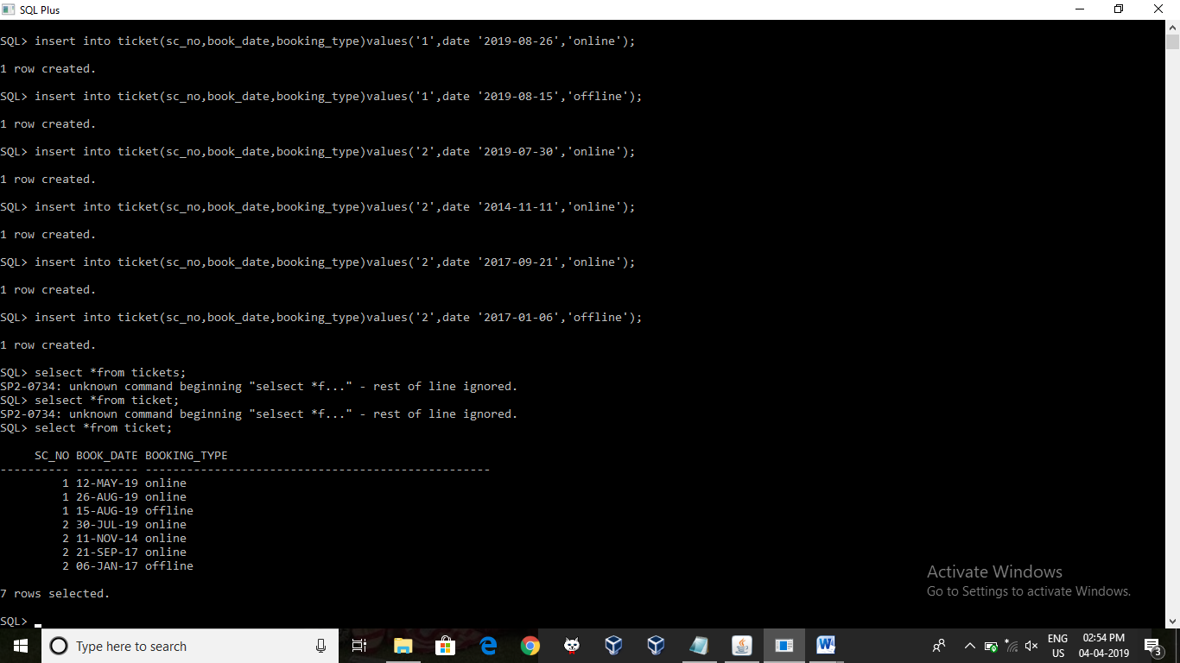

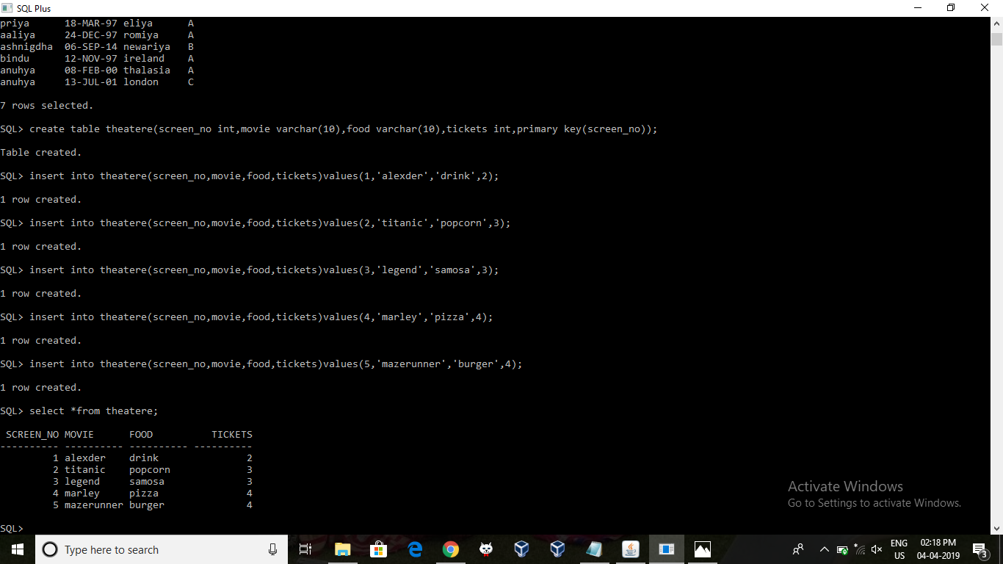

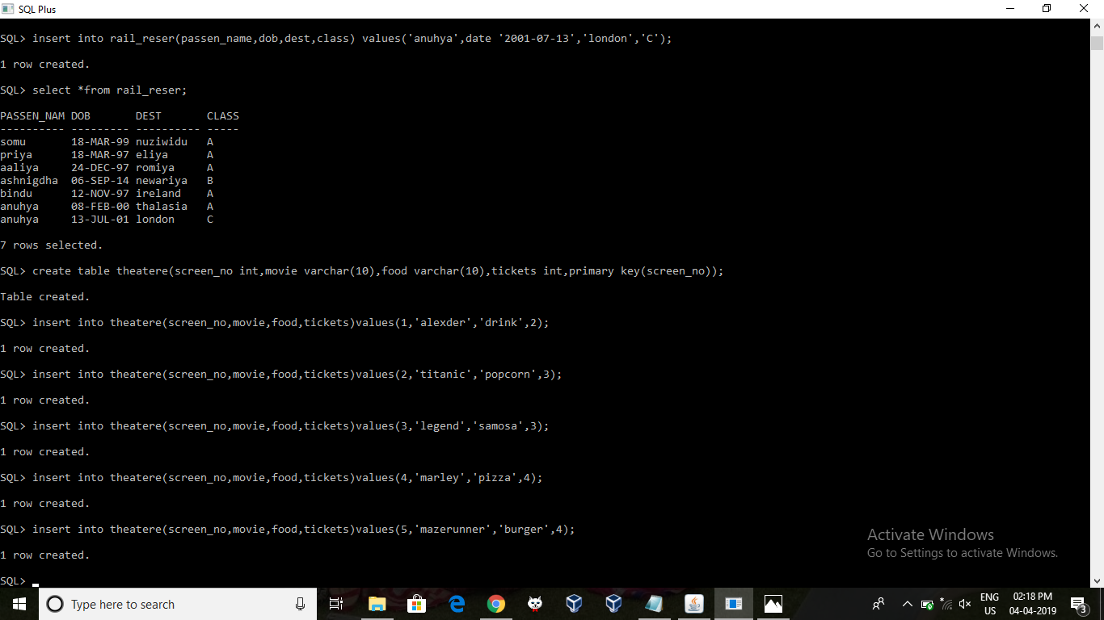
SQL QUERIES RELATED TO DATABASE

->List of user details .
Select * from user;
->Details of the railway reservation of passengers who has taken class A tickets
Select * from rail_way where class =’A’;
->Details of buses whose source is guntur.
select b.serviceno,b.busno,b.destination,b.dpttime from bus b where b.source='guntur';
->Details of bills that are done after 2015-12-31.
select b.billno,b.billdate,b.passid,s.source,s.destination,b.fare from bill b inner join bus s on b.serviceno=s.serviceno where b.billdate>'2015-12-31';
->Details of users whose screen no is 2.
Select * from tickets where screnn_no=2;
->List of users whose name starts with the letter 'k'.
select uname,address from user where w_name like 'k%';
->Total number of users booked tickets.
select count(uid) as total_users from Tickets;
->Total salary given to workers who work in buses that start from Vijayawada.
select sum(salary) as salary from worker w inner join bus b on w.serviceno=b.serviceno where b.source='vijayawada'

QUERIES OUTPUTS:

+

CONCLUSION
Hence this database of Babloo helps in maintaining the records of his booking tickets, hotel details, user details, movie details etc. This helps in reducing the effort in retrieving or searching for particular information regarding the company. This helps in increasing the efficiency in accessing the data in the company and helps in faster access to the information.

REFERENCES

- https://prezi.com/i70r-579sehw/bus-management-system/
- https://www.freeprojectz.com/entity-relationship/bus-ticket-booking-system-er-diagram
- https://www.academia.edu/9183312/Bus_Ticket_Reservation

